Table of Contents
UNITED STATES
SECURITIES AND EXCHANGE COMMISSION
Washington, D.C. 20549
FORM 10-Q
x |  |  | QUARTERLY REPORT PURSUANT TO SECTION 13 OR 15(d) OF THE SECURITIES EXCHANGE ACT OF 1934
For the quarterly period ended June 30, 2024
or
o |  |  | TRANSITION REPORT PURSUANT TO SECTION 13 OR 15(d) OF THE SECURITIES EXCHANGE ACT OF 1934
Commission file number 001-04177
American Oncology Network, Inc.
(Exact name of registrant as specified in its charter)
Delaware |  |  | 85-3984427
(State or other jurisdiction of incorporation or organization) |  |  | (I.R.S. Employer Identification No.)
14543 Global Parkway, Suite 110, Fort Myers, Florida |  |  | 33913
(Address of Principal Executive Offices) |  |  | (Zip Code)
(833) 886-1725
Registrant's telephone number, including area code
Securities registered pursuant to Section 12(b) of the Act:
Title of each class |  |  | Trading Symbol |  |  | Name of each exchange on which registered
Class A common stock, par value $0.0001, per share |  |  | AONC |  |  | NONE
Warrants, each whole warrant exercisable for one share of Class A common stock at an exercise price of $11.50 per share |  |  | AONCW |  |  | NONE
Indicate by check mark whether the registrant: (1) has filed all reports required to be filed by Section 13 or 15(d) of the Securities Exchange Act of 1934 during the preceding 12 months (or for such shorter period that the registrant was required to file such reports); and (2) has been subject to such filing requirements for the past 90 days. Yes x No o
Indicate by check mark whether the registrant has submitted electronically and posted on its corporate web site, if any, every Interactive Data File required to be submitted and posted pursuant to Rule 405 of Regulation S-T (§232.405 of this chapter) during the preceding 12 months (or for such shorter period that the registrant was required to submit and post such files). Yes x No o
Indicate by check mark whether the registrant is a large accelerated filer, an accelerated filer, a non-accelerated filer, or a smaller reporting company. See the definitions of “large accelerated filer,” “accelerated filer” and “smaller reporting company” in Rule 12b-2 of the Exchange Act.:
Large accelerated filer |  |  | o |  |  | Accelerated filer |  |  | o
Non-accelerated filer |  |  | x |  |  | Smaller reporting company |  |  | x
 |  |  |  |  |  | Emerging growth company |  |  | o
If an emerging growth company, indicate by check mark if the registrant has elected not to use the extended transition period for complying with any new or revised financial accounting standards provided pursuant to Section 13(a) of the Exchange Act. o
Indicate by check mark whether the registrant is a shell company (as defined in Rule 12b-2 of the Act). Yes o No x
As of August 12, 2024, the registrant had outstanding 15,871,684 shares of Class A common stock, inclusive of the Sponsor Earnout shares, and 20,445,123 shares of Class B common stock.

Table of Contents
TABLE OF CONTENTS
 |  |  | PAGE
Cautionary Note Regarding Forward-Looking Statements |  |  | i
Part I - Financial Information |  |  | 1
Item 1. Financial Statements |  |  | 1
Condensed Consolidated Balance Sheets |  |  | 1
Condensed Consolidated Statements of Operations and Comprehensive Income (Loss) |  |  | 3
Condensed Consolidated Statements of Mezzanine and Stockholders’ Deficit |  |  | 5
Condensed Consolidated Statements of Cash Flows |  |  | 7
Notes to Consolidated Financial Statements |  |  | 9
Item 2. Management's Discussion and Analysis of Financial Condition and Results of Operations |  |  | 47
Item 3. Quantitative and Qualitative Disclosures About Market Risk |  |  | 59
Item 4. Controls and Procedures |  |  | 60
Part II - Other Information |  |  | 61
Item 1. Legal Proceedings |  |  | 61
Item 1A. Risk Factors |  |  | 61
Item 2. Unregistered Sales of Equity Securities, Use of Proceeds and Issuer Purchases of Equity Securities |  |  | 61
Item 3. Defaults Upon Senior Securities |  |  | 62
Item 4. Mine Safety Disclosures |  |  | 62
Item 5. Other Information |  |  | 62
Item 6. Exhibits |  |  | 62
Signatures |  |  | 64

Table of Contents
Cautionary Note Regarding Forward-Looking Statements

This Quarterly Report on Form 10-Q (this “Form 10-Q”), including, without limitation, statements under the headings “Management's Discussion and Analysis of Financial Condition and Results of Operations,” contains forward-looking statements for purposes of the safe harbor provisions under the United States Private Securities Litigation Reform Act of 1995, including statements about the financial condition, results of operations, earnings outlook and prospects of American Oncology Network, Inc. (“AON”, “New AON”, “AON Inc.”, or the “Company”). Any statements that refer to projections, forecasts or other characterizations of future events or circumstances, including any underlying assumptions, are forward-looking statements. Forward-looking statements are typically identified by words such as “plan,” “believe,” “expect,” “anticipate,” “intend,” “outlook,” “estimate,” “forecast,” “project,” “continue,” “could,” “may,” “might,” “possible,” “potential,” “predict,” “should,” “would” and other similar words and expressions, but the absence of these words does not mean that a statement is not forward-looking. The forward-looking statements are based on current expectations and projections about future events and various assumptions. AON cannot guarantee that it will actually achieve the plans, intentions, or expectations disclosed in its forward-looking statements and you should not place undue reliance on AON’s forward-looking statements.

These forward-looking statements involve a number of risks, uncertainties (many of which are beyond the control of AON), or other assumptions that may cause actual results or performance to differ materially from those expressed or implied by these forward-looking statements. The forward-looking statements contained herein are also subject generally to other risks and uncertainties that are described from time to time in AON’s filings with the Securities and Exchange Commission, including “Risk Factors” in the Company’s most recent Annual Report on Form 10-K, Quarterly Reports on Form 10-Q and Current Reports on Form 8-K. The risks described in the “Risk Factors” sections are not exhaustive. New risk factors emerge from time to time, and it is not possible to predict all such risk factors, nor can AON assess the impact of all such risk factors on the business of AON, or the extent to which any factor or combination of factors may cause actual results to differ materially from those contained in any forward-looking statement. The statements made herein are made as of the date of this Quarterly Report and, except as may be required by law, AON undertakes no obligation to update them, whether as a result of new information, developments, or otherwise.

i
Table of Contents
Part I - Financial Information

Item 1. Financial Statements

American Oncology Network, Inc.
Condensed Consolidated Balance Sheets
(Unaudited)
($ in thousands, except share and per share data)
 |  |  |  |  |  | As of June 30,  2024 |  |  |  |  |  | As of December 31,  2023
Assets
Current assets
Cash and cash equivalents |  |  |  |  |  | $ | 33,818 |  |  |  |  | $ | 28,539
Short-term marketable securities |  |  |  |  |  | 21,391 |  |  |  |  |  | 35,389
Patient accounts receivable, net |  |  |  |  |  | 125,421 |  |  |  |  |  | 129,151
Inventories |  |  |  |  |  | 54,280 |  |  |  |  |  | 44,569
Other receivables |  |  |  |  |  | 60,928 |  |  |  |  |  | 34,274
Prepaid expenses and other current assets |  |  |  |  |  | 8,250 |  |  |  |  |  | 4,277
Current portion of notes receivable - related parties |  |  |  |  |  | 2,174 |  |  |  |  |  | 1,604
Total current assets |  |  |  |  |  | 306,262 |  |  |  |  |  | 277,803
Property and equipment, net |  |  |  |  |  | 42,510 |  |  |  |  |  | 40,439
Operating lease right-of-use assets, net (1) |  |  |  |  |  | 50,609 |  |  |  |  |  | 43,349
Notes receivable - related parties |  |  |  |  |  | - |  |  |  |  |  | 1,150
Other assets |  |  |  |  |  | 18,005 |  |  |  |  |  | 7,588
Goodwill |  |  |  |  |  | 10,900 |  |  |  |  |  | 1,230
Intangibles, net |  |  |  |  |  | 2,476 |  |  |  |  |  | -
Deferred tax asset, net |  |  |  |  |  | - |  |  |  |  |  | 2,894
Total assets |  |  |  |  |  | $ | 430,762 |  |  |  |  | $ | 374,453
Liabilities, Mezzanine Equity, and Stockholders' Equity
Current liabilities
Accounts payable (2) |  |  |  |  |  | $ | 189,483 |  |  |  |  | $ | 127,645
Accrued compensation related costs |  |  |  |  |  | 11,640 |  |  |  |  |  | 11,410
Accrued other |  |  |  |  |  | 18,202 |  |  |  |  |  | 22,327
Income tax payable |  |  |  |  |  | 971 |  |  |  |  |  | 971
Current portion of operating lease liabilities (3) |  |  |  |  |  | 7,450 |  |  |  |  |  | 6,692
Current portion of long-term debt |  |  |  |  |  | 3,809 |  |  |  |  |  | -
Total current liabilities |  |  |  |  |  | 231,555 |  |  |  |  |  | 169,045
Long-term debt, net |  |  |  |  |  | 88,241 |  |  |  |  |  | 80,641
Long-term operating lease liabilities (4) |  |  |  |  |  | 46,167 |  |  |  |  |  | 39,803
Other long-term liabilities |  |  |  |  |  | 10,948 |  |  |  |  |  | 14,251
Total liabilities |  |  |  |  |  | $ | 376,911 |  |  |  |  | $ | 303,740
Mezzanine equity
1
Table of Contents
Series A convertible preferred stock; $0.0001 par value; 7,500,000 shares authorized; 6,651,610 issued and outstanding at June 30, 2024 and December 31, 2023, with an aggregate liquidation preference of $70,744,488 and $68,009,015 at June 30, 2024 and December 31, 2023, respectively. |  |  |  |  |  | 64,986 |  |  |  |  |  | 64,986
Redeemable noncontrolling interest |  |  |  |  |  | 28,331 |  |  |  |  |  | 167,025
Stockholders' equity
Class A Common Stock; $0.0001 par value; 200,000,000 shares authorized; 13,495,847 and 9,517,816 shares issued and outstanding at June 30, 2024 and December 31, 2023, respectively. |  |  |  |  |  | 1 |  |  |  |  |  | 1
Class B Common Stock; $0.0001 par value; 100,000,000 shares authorized; 20,571,323 and 25,109,551 shares issued and outstanding at June 30, 2024 and December 31, 2023, respectively. |  |  |  |  |  | 3 |  |  |  |  |  | 3
Additional paid-in capital |  |  |  |  |  | 27,074 |  |  |  |  |  | -
Treasury stock, at cost, 122,743 shares at June 30, 2024 and 14,729 shares at December 31, 2023 |  |  |  |  |  | (368) |  |  |  |  |  | -
Accumulated other comprehensive income |  |  |  |  |  | 26 |  |  |  |  |  | 81
Retained deficit |  |  |  |  |  | (66,720) |  |  |  |  |  | (161,812)
Total AON stockholders' deficit |  |  |  |  |  | (39,984) |  |  |  |  |  | (161,727)
Noncontrolling interest |  |  |  |  |  | 518 |  |  |  |  |  | 429
Total deficit |  |  |  |  |  | $ | (39,466) |  |  |  |  | $ | (161,298)
Total liabilities, mezzanine equity, noncontrolling interest, and stockholders' equity |  |  |  |  |  | $ | 430,762 |  |  |  |  | $ | 374,453
(1)Includes related party operating right-of-use assets, net of $15,605 and $10,931 at June 30, 2024 and December 31, 2023, respectively
(2)Includes amounts due to related party of $178,460 and $120,857 at June 30, 2024 and December 31, 2023, respectively
(3)Includes related party current portion of operating lease liabilities of $3,524 and $1,888 at June 30, 2024 and December 31, 2023, respectively
(4)Includes related party long-term operating lease liabilities of $10,712 and $9,472 at June 30, 2024 and December 31, 2023, respectively

The accompanying notes are an integral part of these condensed consolidated financial statements.

2
Table of Contents
American Oncology Network, Inc.
Condensed Consolidated Statements of Operations and Comprehensive Income (Loss)
(Unaudited)
($ in thousands, except share and per share data)
 |  |  | Three Months Ended June 30, |  |  |  |  |  |  |  |  |  |  |  | Six Months Ended June 30,
 |  |  | 2024 |  |  |  |  |  | 2023 |  |  |  |  |  | 2024 |  |  |  |  |  | 2023
Revenue
Patient service revenue, net |  |  | $ | 431,750 |  |  |  |  | $ | 311,713 |  |  |  |  | $ | 793,258 |  |  |  |  | $ | 613,486
Other revenue |  |  | 2,232 |  |  |  |  |  | 3,254 |  |  |  |  |  | 5,063 |  |  |  |  |  | 5,212
Total revenue |  |  | 433,982 |  |  |  |  |  | 314,967 |  |  |  |  |  | 798,321 |  |  |  |  |  | 618,698
Costs and expenses
Cost of revenue (1) |  |  | 404,589 |  |  |  |  |  | 291,399 |  |  |  |  |  | 759,537 |  |  |  |  |  | 569,933
General and administrative expenses (2) |  |  | 36,738 |  |  |  |  |  | 23,915 |  |  |  |  |  | 65,015 |  |  |  |  |  | 47,633
Transaction expenses |  |  | 664 |  |  |  |  |  | 3,312 |  |  |  |  |  | 1,016 |  |  |  |  |  | 5,282
Total costs and expenses |  |  | 441,991 |  |  |  |  |  | 318,626 |  |  |  |  |  | 825,568 |  |  |  |  |  | 622,848
Loss from operations |  |  | (8,009) |  |  |  |  |  | (3,659) |  |  |  |  |  | (27,247) |  |  |  |  |  | (4,150)
Other income (expense)
Interest expense |  |  | (1,833) |  |  |  |  |  | (1,551) |  |  |  |  |  | (3,596) |  |  |  |  |  | (2,968)
Interest income |  |  | 1,025 |  |  |  |  |  | 68 |  |  |  |  |  | 1,818 |  |  |  |  |  | 126
Other (expense) income, net |  |  | 5,547 |  |  |  |  |  | (4,846) |  |  |  |  |  | 3,639 |  |  |  |  |  | (4,380)
Loss before income taxes, equity loss in affiliate, and noncontrolling interest |  |  | (3,270) |  |  |  |  |  | (9,988) |  |  |  |  |  | (25,386) |  |  |  |  |  | (11,372)
Income tax expense (benefit) |  |  | (324) |  |  |  |  |  | - |  |  |  |  |  | 2,570 |  |  |  |  |  | -
Loss before equity loss in affiliate and noncontrolling interest |  |  | (2,946) |  |  |  |  |  | (9,988) |  |  |  |  |  | (27,956) |  |  |  |  |  | (11,372)
Equity in loss of affiliate |  |  | (179) |  |  |  |  |  | (118) |  |  |  |  |  | (130) |  |  |  |  |  | (219)
Net loss before noncontrolling interest |  |  | $ | (3,125) |  |  |  |  | $ | (10,107) |  |  |  |  | $ | (28,086) |  |  |  |  | $ | (11,591)
Net loss attributable to noncontrolling interest |  |  | (334) |  |  |  |  |  | - |  |  |  |  |  | (291) |  |  |  |  |  | -
Net loss before redeemable noncontrolling interest |  |  | (2,791) |  |  |  |  |  | (10,107) |  |  |  |  |  | (27,795) |  |  |  |  |  | (11,591)
Net loss and noncontrolling interest attributable to Legacy AON Stockholders prior to the reverse recapitalization |  |  | - |  |  |  |  |  | (10,107) |  |  |  |  |  | - |  |  |  |  |  | (11,591)
Net loss attributable to redeemable noncontrolling interest |  |  | (6,412) |  |  |  |  |  | - |  |  |  |  |  | (23,575) |  |  |  |  |  | -
Net income (loss) attributable to AON Inc. |  |  | $ | 3,621 |  |  |  |  | $ | - |  |  |  |  | $ | (4,220) |  |  |  |  | $ | -
Series A Preferred Cumulative Dividends |  |  | (1,375) |  |  |  |  |  | - |  |  |  |  |  | (2,735) |  |  |  |  |  | -
Undistributed net income to participating securities |  |  | (856) |  |  |  |  |  | - |  |  |  |  |  | - |  |  |  |  |  | -
Net income (loss) attributable to Class A Common Stockholders |  |  | $ | 1,390 |  |  |  |  | $ | - |  |  |  |  | $ | (6,955) |  |  |  |  | $ | -
Reallocation of net income (loss) attributable to Class A Common Stockholders as a result of the impact and conversion of dilutive securities |  |  | (5,556) |  |  |  |  |  | - |  |  |  |  |  | (23,575) |  |  |  |  |  | -
Net income (loss) attributable to Class A Common Stockholders for diluted earnings per share |  |  | $ | (4,166) |  |  |  |  | $ | - |  |  |  |  | $ | (30,530) |  |  |  |  | $ | -
Income (loss) per share of Class A Common Stock:
Basic |  |  | $ | 0.12 |  |  |  |  | $ | - |  |  |  |  | $ | (0.74) |  |  |  |  | $ | -
Diluted |  |  | $ | (0.11) |  |  |  |  | $ | - |  |  |  |  | $ | (0.84) |  |  |  |  | $ | -
3
Table of Contents
Weighted average shares of Class A Common Stock Outstanding:
Basic |  |  | 11,377,407 |  |  |  |  |  | - |  |  |  |  |  | 9,457,518 |  |  |  |  |  | -
Diluted |  |  | 37,089,605 |  |  |  |  |  | - |  |  |  |  |  | 36,430,441 |  |  |  |  |  | -
Other comprehensive income (loss):
Unrealized (loss) gain on marketable securities |  |  | (167) |  |  |  |  |  | 24 |  |  |  |  |  | (189) |  |  |  |  |  | 88
Other comprehensive (loss) gain |  |  | (167) |  |  |  |  |  | 24 |  |  |  |  |  | (189) |  |  |  |  |  | 88
Comprehensive loss |  |  | $ | (2,958) |  |  |  |  | $ | (10,083) |  |  |  |  | $ | (27,984) |  |  |  |  | $ | (11,503)
Other comprehensive loss attributable to Legacy AON Shareholders |  |  | — |  |  |  |  |  | (10,083) |  |  |  |  |  | — |  |  |  |  |  | (11,503)
Other comprehensive loss attributable to noncontrolling interests |  |  | (6,528) |  |  |  |  |  | — |  |  |  |  |  | (23,708) |  |  |  |  |  | —
Total comprehensive income (loss) attributable to AON Inc. |  |  | $ | 3,570 |  |  |  |  | $ | - |  |  |  |  | $ | (4,276) |  |  |  |  | $ | -
(1)Includes related party inventory expense of $364,664 and $253,083 and $675,541 and $500,569 for the three and six months ended June 30, 2024 and 2023, respectively.
(2)Includes related party rent of $672 and $679 and $1,378 and $1,358 for the three and six months ended June 30, 2024 and 2023, respectively.

The accompanying notes are an integral part of these condensed consolidated financial statements.

4
Table of Contents
American Oncology Network, Inc.
Condensed Consolidated Statements of Mezzanine and Stockholders’ Deficit
(Unaudited)($ in thousands, except share and per share data)
 |  |  | Mezzanine Equity - Series A Preferred Stock |  |  |  |  |  | NCI(1) |  |  |  |  |  | Class A Common  Stock |  |  |  |  |  | Class B Common Stock
In thousands (except share and per share data) |  |  | Stock |  |  | $ |  |  |  |  |  |  |  |  | Stock |  |  | $ |  |  | Stock |  |  | $ |  |  | APIC(1) |  |  | Treasury Stock |  |  | AOCI(1) |  |  | Noncontrolling Interest |  |  | Retained  Deficit |  |  | Total  Equity (Deficit)
Balances at March 31, 2024 |  |  | 6,652 |  |  | $ | 64,986 |  | $ | 157,716 |  |  |  |  | 10,334,734 |  |  | $ | 1 |  | 23,725,998 |  |  | $ | 3 |  | $ | 8,164 |  | (97) |  |  | $ | 77 |  | $ | 852 |  | $ | (175,594) |  | $ | (166,594)
Other comprehensive income |  |  |  |  |  |  |  |  | (116) |  |  |  |  |  |  |  |  |  |  |  |  |  |  |  |  |  |  |  |  |  |  |  | (51) |  |  |  |  |  |  |  |  | (51)
Equity based compensation & NCI rebalancing |  |  |  |  |  |  |  |  | 30 |  |  |  |  |  | 116,725 |  |  | — |  |  |  |  |  |  |  |  | 1,276 |  |  |  |  |  |  |  |  |  |  |  |  |  |  | 1,276
Repurchases of Class A Common Stock |  |  |  |  |  |  |  |  |  |  |  |  |  |  | (110,287) |  |  |  |  |  |  |  |  |  |  |  |  |  |  | (271) |  |  |  |  |  |  |  |  |  |  |  | (271)
Capital contribution from noncontrolling interest member |  |  |  |  |  |  |  |  |  |  |  |  |  |  | — |  |  |  |  |  |  |  |  |  |  |  |  |  |  |  |  |  |  |  |  |  |  |  |  |  |  | —
Net loss |  |  |  |  |  |  |  |  | (6,412) |  |  |  |  |  |  |  |  |  |  |  |  |  |  |  |  |  |  |  |  |  |  |  |  |  |  | (334) |  |  | 3,621 |  |  | 3,287
Fair value adjustment to redeemable noncontrolling interest |  |  |  |  |  |  |  |  | (114,949) |  |  |  |  |  |  |  |  |  |  |  |  |  |  |  |  |  | 9,696 |  |  |  |  |  |  |  |  |  |  |  | 105,253 |  |  | 114,949
Redemptions of Class B Common Stock to Class A Common Stock |  |  |  |  |  |  |  |  | (7,938) |  |  |  |  |  | 3,154,675 |  |  |  |  |  | (3,154,675) |  |  |  |  |  | 7,938 |  |  |  |  |  |  |  |  |  |  |  |  |  |  | 7,938
Balances at June 30, 2024 |  |  | 6,652 |  |  | $ | 64,986 |  | $ | 28,331 |  |  |  |  | 13,495,847 |  |  | $ | 1 |  | 20,571,323 |  |  | $ | 3 |  | $ | 27,074 |  | (368) |  |  | $ | 26 |  | $ | 518 |  | $ | (66,720) |  | $ | (39,466)
Balances at December 31, 2023 |  |  | 6,652 |  |  | 64,986 |  |  | 167,025 |  |  |  |  |  | 6,678,441 |  |  | 1 |  |  | 25,109,551 |  |  | 3 |  |  | — |  |  | — |  |  | 81 |  |  | 429 |  |  | (161,812) |  |  | (161,298)
Other comprehensive income |  |  | — |  |  | — |  |  | (133) |  |  |  |  |  | — |  |  | — |  |  | — |  |  | — |  |  | — |  |  | — |  |  | (55) |  |  | — |  |  | — |  |  | (55)
Equity based compensation & NCI rebalancing |  |  | — |  |  | — |  |  | 429 |  |  |  |  |  | 2,405,906 |  |  | — |  |  | — |  |  | — |  |  | 10,972 |  |  | — |  |  | — |  |  | — |  |  | — |  |  | 10,972
Repurchases of Class A Common Stock |  |  | — |  |  | — |  |  | — |  |  |  |  |  | (126,728) |  |  | — |  |  | — |  |  | — |  |  | — |  |  | (368) |  |  | — |  |  | — |  |  | — |  |  | (368)
Capital contribution from noncontrolling interest member |  |  | — |  |  | — |  |  | — |  |  |  |  |  | — |  |  | — |  |  | — |  |  | — |  |  | — |  |  | — |  |  | — |  |  | 380 |  |  | — |  |  | 380
Net loss |  |  | — |  |  | — |  |  | (23,575) |  |  |  |  |  | — |  |  | — |  |  | — |  |  | — |  |  | — |  |  | — |  |  | — |  |  | (291) |  |  | (4,221) |  |  | (4,512)
Fair value adjustment to redeemable noncontrolling interest |  |  | — |  |  | — |  |  | (99,313) |  |  |  |  |  | — |  |  | — |  |  | — |  |  | — |  |  | — |  |  | — |  |  | — |  |  | — |  |  | 99,313 |  |  | 99,313
Redemptions of Class B Common Stock to Class A Common Stock |  |  | — |  |  | — |  |  | (16,102) |  |  |  |  |  | 4,538,228 |  |  | — |  |  | (4,538,228) |  |  | — |  |  | 16,102 |  |  | — |  |  | — |  |  | — |  |  | — |  |  | 16,102
Balances at June 30, 2024 |  |  | 6,652 |  |  | $ | 64,986 |  | $ | 28,331 |  |  |  |  | 13,495,847 |  |  | $ | 1 |  | 20,571,323 |  |  | $ | 3 |  | $ | 27,074 |  | (368) |  |  | $ | 26 |  | $ | 518 |  | $ | (66,720) |  | $ | (39,466)
5
Table of Contents
In thousands (except share and unit data) |  |  |  |  |  | Mezzanine Equity - Convertible Preferred Class C |  |  |  |  |  |  |  |  |  |  |  | Class A |  |  |  |  |  |  |  |  |  |  |  | Class A-1 |  |  |  |  |  |  |  |  |  |  |  | Class B
Three Months Ended June 30, 2023 |  |  |  |  |  | Units |  |  |  |  |  | $ |  |  |  |  |  | Units |  |  |  |  |  | $ |  |  |  |  |  | Units |  |  |  |  |  | $ |  |  |  |  |  | $ |  |  |  |  |  | AOCI(1) |  |  |  |  |  | Retained  Earnings (Deficit) |  |  |  |  |  | Noncontrolling Interest |  |  |  |  |  | Total  Equity (Deficit)
Balances at March 31, 2023 |  |  |  |  |  | - |  |  |  |  |  | $ | - |  |  |  |  | 19,495,376 |  |  |  |  |  | $ | 7,725 |  |  |  |  | 1,842,520 |  |  |  |  |  | $ | 28,500 |  |  |  |  | $ | 80 |  |  |  |  | $ | (53) |  |  |  |  | $ | 24,342 |  |  |  |  | $ | - |  |  |  |  | $ | 60,594
Net loss |  |  |  |  |  |  |  |  |  |  |  |  |  |  |  |  |  |  |  |  |  |  |  |  |  |  |  |  |  |  |  |  |  |  |  |  |  |  |  |  |  |  |  |  |  |  |  |  |  |  |  |  |  | $ | (10,105) |  |  |  |  |  |  |  |  |  |  | (10,105)
Issuance of Class C Units, net of offering costs |  |  |  |  |  | 2,459 |  |  |  |  |  | 64,246 |  |  |  |  |  |  |  |  |  |  |  |  |  |  |  |  |  |  |  |  |  |  |  |  |  |  |  |  |  |  |  |  |  |  |  |  |  |  |  |  |  |  |  |  |  |  |  |  |  |  |  |  |  | -
Class C derivative liability |  |  |  |  |  |  |  |  |  |  |  | (1,349) |  |  |  |  |  |  |  |  |  |  |  |  |  |  |  |  |  |  |  |  |  |  |  |  |  |  |  |  |  |  |  |  |  |  |  |  |  |  |  |  |  |  |  |  |  |  |  |  |  |  |  |  |  | -
Class A and A-1 preferred returns |  |  |  |  |  |  |  |  |  |  |  |  |  |  |  |  |  |  |  |  |  |  |  |  |  |  |  |  |  |  |  |  |  |  |  |  |  |  |  |  |  |  |  |  |  |  |  |  |  |  |  |  |  | (8,174) |  |  |  |  |  |  |  |  |  |  |  | (8,174)
Derivative liability on Class A-1 anti-dilution feature |  |  |  |  |  |  |  |  |  |  |  |  |  |  |  |  |  |  |  |  |  |  |  |  |  |  |  |  |  |  |  |  |  |  |  | 2,540 |  |  |  |  |  |  |  |  |  |  |  |  |  |  |  |  |  |  |  |  |  |  |  |  |  |  |  |  |  | 2,540
Tax distributions |  |  |  |  |  |  |  |  |  |  |  |  |  |  |  |  |  |  |  |  |  |  |  |  |  |  |  |  |  |  |  |  |  |  |  |  |  |  |  |  |  |  |  |  |  |  |  |  |  |  |  |  |  | (260) |  |  |  |  |  |  |  |  |  |  |  | (260)
Capital contribution from noncontrolling interest member |  |  |  |  |  |  |  |  |  |  |  |  |  |  |  |  |  |  |  |  |  |  |  |  |  |  |  |  |  |  |  |  |  |  |  |  |  |  |  |  |  |  |  |  |  |  |  |  |  |  |  |  |  |  |  |  |  |  |  | 134 |  |  |  |  |  | 134
Class A-1 distribution |  |  |  |  |  |  |  |  |  |  |  |  |  |  |  |  |  |  |  |  |  |  |  |  |  |  |  |  |  | 439,176 |  |  |  |  |  |  |  |  |  |  |  |  |  |  |  |  |  |  |  |  |  |  |  |  |  |  |  |  |  |  |  |  |  |  |  | -
Other comprehensive income |  |  |  |  |  |  |  |  |  |  |  |  |  |  |  |  |  |  |  |  |  |  |  |  |  |  |  |  |  |  |  |  |  |  |  |  |  |  |  |  |  |  |  |  |  |  |  | 24 |  |  |  |  |  |  |  |  |  |  |  |  |  |  |  |  |  | 24
Balances at June 30, 2023 |  |  |  |  |  | 2,459 |  |  |  |  |  | $ | 62,897 |  |  |  |  | 19,495,376 |  |  |  |  |  | $ | 7,725 |  |  |  |  | 2,281,696 |  |  |  |  |  | $ | 31,040 |  |  |  |  | $ | 80 |  |  |  |  | $ | (29) |  |  |  |  | $ | 5,803 |  |  |  |  | $ | 134 |  |  |  |  | $ | 44,753
Six Months Ended June 30, 2023
Balances at December 31, 2022 |  |  |  |  |  | - |  |  |  |  |  | $ | — |  |  |  |  | 19,495,376 |  |  |  |  |  | $ | 7,725 |  |  |  |  | 1,842,520 |  |  |  |  |  | $ | 28,500 |  |  |  |  | $ | 80 |  |  |  |  | $ | (117) |  |  |  |  | $ | 25,828 |  |  |  |  | $ | - |  |  |  |  | $ | 62,016
Activity prior to reverse recapitalization
Net loss |  |  |  |  |  | - |  |  |  |  |  | - |  |  |  |  |  | - |  |  |  |  |  | - |  |  |  |  |  | - |  |  |  |  |  | - |  |  |  |  |  | - |  |  |  |  |  | - |  |  |  |  |  | (11,591) |  |  |  |  |  | - |  |  |  |  |  | (11,591)
Issuance of Class C Units, net of offering costs |  |  |  |  |  | 2,459 |  |  |  |  |  | 64,246 |  |  |  |  |  | - |  |  |  |  |  | - |  |  |  |  |  | - |  |  |  |  |  | - |  |  |  |  |  | - |  |  |  |  |  | - |  |  |  |  |  | - |  |  |  |  |  | - |  |  |  |  |  | -
Class C derivative liability |  |  |  |  |  | - |  |  |  |  |  | (1,349) |  |  |  |  |  | - |  |  |  |  |  | - |  |  |  |  |  | - |  |  |  |  |  | - |  |  |  |  |  | - |  |  |  |  |  | - |  |  |  |  |  | - |  |  |  |  |  | - |  |  |  |  |  | -
Class A and A-1 preferred returns |  |  |  |  |  | - |  |  |  |  |  | - |  |  |  |  |  | - |  |  |  |  |  | - |  |  |  |  |  | - |  |  |  |  |  | - |  |  |  |  |  | - |  |  |  |  |  | - |  |  |  |  |  | (8,174) |  |  |  |  |  | - |  |  |  |  |  | (8,174)
Derivative liability on Class A-1 anti-dilution feature |  |  |  |  |  | - |  |  |  |  |  | - |  |  |  |  |  | - |  |  |  |  |  | - |  |  |  |  |  | - |  |  |  |  |  | 2,540 |  |  |  |  |  | - |  |  |  |  |  | - |  |  |  |  |  | - |  |  |  |  |  | - |  |  |  |  |  | 2,540
Tax distributions |  |  |  |  |  | - |  |  |  |  |  | - |  |  |  |  |  | - |  |  |  |  |  | - |  |  |  |  |  | - |  |  |  |  |  | - |  |  |  |  |  | - |  |  |  |  |  | - |  |  |  |  |  | (260) |  |  |  |  |  | - |  |  |  |  |  | (260)
Capital contribution from noncontrolling interest member |  |  |  |  |  | - |  |  |  |  |  | - |  |  |  |  |  | - |  |  |  |  |  | - |  |  |  |  |  | - |  |  |  |  |  | - |  |  |  |  |  | - |  |  |  |  |  | - |  |  |  |  |  | - |  |  |  |  |  | 134 |  |  |  |  |  | 134
Class A-1 distribution |  |  |  |  |  | - |  |  |  |  |  | - |  |  |  |  |  | - |  |  |  |  |  | - |  |  |  |  |  | 439,176 |  |  |  |  |  | - |  |  |  |  |  | - |  |  |  |  |  | - |  |  |  |  |  | - |  |  |  |  |  | - |  |  |  |  |  | -
Other comprehensive income |  |  |  |  |  | - |  |  |  |  |  | - |  |  |  |  |  | - |  |  |  |  |  | - |  |  |  |  |  | - |  |  |  |  |  | - |  |  |  |  |  | - |  |  |  |  |  | 88 |  |  |  |  |  | - |  |  |  |  |  | - |  |  |  |  |  | 88
Balances at June 30, 2023 |  |  |  |  |  | 2,459 |  |  |  |  |  | $ | 62,897 |  |  |  |  | 19,495,376 |  |  |  |  |  | $ | 7,725 |  |  |  |  | 2,281,696 |  |  |  |  |  | $ | 31,040 |  |  |  |  | $ | 80 |  |  |  |  | $ | (29) |  |  |  |  | $ | 5,803 |  |  |  |  | $ | 134 |  |  |  |  | $ | 44,753
(1) The acronyms in the table above are defined as follows:
APIC - Accumulated paid in capital
AOCI - Accumulated other comprehensive income
NCI - Mezzanine equity classified noncontrolling interest

The accompanying notes are an integral part of these condensed consolidated financial statements.

6
Table of Contents
American Oncology Network, Inc.
Condensed Consolidated Statements of Cash Flows
(Unaudited)
($ in thousands, except share and per share data)
 |  |  | Six Months Ended June 30,
 |  |  | 2024 |  |  |  |  |  | 2023
Cash flows from operating activities
Net loss |  |  | $ | (28,086) |  |  |  |  | $ | (11,591)
Adjustments to reconcile net loss to net cash provided by (used in) operating activities
Depreciation and amortization |  |  | 4,890 |  |  |  |  |  | 4,308
Amortization of debt issuance costs |  |  | 430 |  |  |  |  |  | 353
Amortization of postcombination compensation |  |  | 352 |  |  |  |  |  | -
Provision for income taxes |  |  | 2,894 |  |  |  |  |  | -
Equity in loss of affiliate |  |  | 130 |  |  |  |  |  | 219
Amortization of operating right-of-use assets (1) |  |  | 4,330 |  |  |  |  |  | 4,309
Changes in fair value adjustments of warrants and derivative liabilities |  |  | (2,888) |  |  |  |  |  | 5,066
Equity-based compensation |  |  | 11,400 |  |  |  |  |  | -
Loss (gain) on sale and abandonment of property and equipment |  |  | 760 |  |  |  |  |  | (2)
Bargain purchase gain on acquisition of physician practice |  |  | (1,040) |  |  |  |  |  | -
Deferred taxes |  |  | (324) |  |  |  |  |  | -
Changes in operating assets and liabilities, net of business combinations:
Patient accounts receivable, net |  |  | 3,730 |  |  |  |  |  | (9,061)
Inventories (2) |  |  | (7,239) |  |  |  |  |  | (5,410)
Prepaid expenses and other current assets |  |  | (3,713) |  |  |  |  |  | (728)
Other receivables |  |  | (23,346) |  |  |  |  |  | (4,728)
Other assets |  |  | (4,948) |  |  |  |  |  | (2,430)
Accounts payable (3) |  |  | 60,964 |  |  |  |  |  | 15,673
Accrued compensation related costs |  |  | 2,944 |  |  |  |  |  | 2,710
Accrued other |  |  | (2,972) |  |  |  |  |  | 1,199
Operating lease liabilities (4) |  |  | (4,467) |  |  |  |  |  | (3,784)
Other long-term liabilities |  |  | (2,590) |  |  |  |  |  | 1,626
Net cash provided by (used in) operating activities |  |  | 11,210 |  |  |  |  |  | (2,271)
Cash flows from investing activities
Purchases of property and equipment and intangible assets |  |  | (8,176) |  |  |  |  |  | (6,899)
Proceeds from disposals of property and equipment |  |  | 141 |  |  |  |  |  | 5
Acquisition of physician practices, net of cash acquired |  |  | (6,712) |  |  |  |  |  | -
Purchases of marketable securities |  |  | (17,710) |  |  |  |  |  | (2,280)
Proceeds from sales of marketable securities |  |  | 31,961 |  |  |  |  |  | 2,235
Collections on notes receivable - related parties |  |  | 305 |  |  |  |  |  | 630
Net cash used in investing activities |  |  | (191) |  |  |  |  |  | (6,309)
Cash flows from financing activities
7
Table of Contents
Issuance of redeemable convertible Class C Units |  |  | - |  |  |  |  |  | 64,996
Class A and A-1 preferred returns |  |  | - |  |  |  |  |  | (8,174)
Repayments on debt |  |  | (1,521) |  |  |  |  |  | -
Contribution from noncontrolling interest |  |  | - |  |  |  |  |  | 134
Repurchases of Class A Common Stock |  |  | (368) |  |  |  |  |  | -
Payment of tax withholding obligation on net RSU settlement |  |  | (3,258) |  |  |  |  |  | -
Tax distributions |  |  | - |  |  |  |  |  | (260)
Repayments on finance lease liabilities |  |  | (593) |  |  |  |  |  | (233)
Cash paid for debt financing costs |  |  | - |  |  |  |  |  | (446)
Cash paid for offering costs on Class C issuance |  |  | - |  |  |  |  |  | (750)
Cash paid for offering costs on business combination |  |  | - |  |  |  |  |  | (905)
Net cash (used in) provided by financing activities |  |  | (5,740) |  |  |  |  |  | 54,362
Net increase in cash and cash equivalents |  |  | 5,279 |  |  |  |  |  | 45,782
Cash and cash equivalents
Beginning of period |  |  | 28,539 |  |  |  |  |  | 26,926
End of period |  |  | $ | 33,818 |  |  |  |  | $ | 72,708
Supplemental noncash investing and financing activities
Right-of-use assets and lease liabilities removed in termination of lease |  |  | $ | - |  |  |  |  | $ | 1,023
Promissory note issued in connection with acquisition of physician practices |  |  | (6,550) |  |  |  |  |  | -
Promissory note issued in connection with asset acquisition |  |  | (1,420) |  |  |  |  |  | -
Changes in accounts payable for capital additions to property and equipment |  |  | (581) |  |  |  |  |  | -
Noncash consideration paid by assumption of note for purchase of physician practice |  |  | (4,530)
Contribution from noncontrolling interest |  |  | (380) |  |  |  |  |  | -
Derivative liability on issuance of Class C Units |  |  | - |  |  |  |  |  | 1,349
Derivative liability on Class A-1 anti-dilution feature |  |  | - |  |  |  |  |  | 2,540
(1)Includes related party amortization of operating right-of-use assets of $1,053 and $1,062 for the six months ended June 30, 2024 and 2023, respectively.
(2)Includes changes in related party balances of ($9,225) and $(5,140) for the six months ended June 30, 2024 and 2023, respectively.
(3)Includes changes in related party balances of $57,603 and $15,718 for the six months ended June 30, 2024 and 2023, respectively.
(4)Includes changes in related party balances of ($1,313) and ($1,303) for the six months ended June 30, 2024 and 2023, respectively.

The accompanying notes are an integral part of these condensed consolidated financial statements.

8
Table of Contents
Notes to Consolidated Financial Statements

1.Business

American Oncology Network, Inc. (“AON”, “New AON”, “AON Inc.”, or the “Company”), through its subsidiary companies and variable interest entities (together, “its subsidiaries”), is an alliance of physicians and seasoned healthcare leaders who provide comprehensive oncology services across 35 oncology practices located in twenty states (Arizona, Arkansas, Florida, Georgia, Hawaii, Iowa, Idaho, Indiana, Louisiana, Maryland, Missouri, Michigan, North Carolina, Nevada, Nebraska, Ohio, South Carolina, Texas, Virginia, Washington, and the District of Columbia). The Company also provides expertise in drug procurement and payor contracting, along with practice diversification through centralized laboratory and pathology services, as well as specialty pharmacy services, clinical research, radiation oncology, and imaging. During the six months ended June 30, 2024, the Company entered into affiliation agreements with or acquired the following oncology practices. The Company did not enter into any affiliation agreements or complete any acquisitions of oncology practices during the six months ended June 30, 2023.
Six Months Ended June 30, 2024
State
Maryland (a)
Texas (a)
Hawaii (b)
Georgia (b)
(a)The Company entered into affiliation agreements with the physicians for these respective practices. The Company evaluated each of the affiliation agreements and determined that the transactions did not represent a business combination.
(b)The Company completed acquisitions which were accounted for as business combinations with the physicians for these respective practices (See Note 5 for further discussion).
The operations of the practices above have been included in the Company’s condensed consolidated financial statements.
Business Combination Agreements

Digital Transformation Opportunities Corp. (“DTOC”), American Oncology Network, LLC (“AON LLC”), GEF AON Holdings Corp. (“AON Class C Preferred Investor”), and DTOC Merger Sub, Inc., a direct, wholly owned subsidiary of DTOC (“Merger Sub”) entered into a Business Combination Agreement (the “Business Combination Agreement”), dated as of June 14, 2023 (which further amended and restated the Business Combination Agreement entered into by DTOC and AON as of October 5, 2022, and amended and restated on January 6, 2023, and April 27, 2023), pursuant to which, among other transactions, on September 20, 2023 (the “Closing Date”), DTOC and AON undertook a series of transactions (the “Business Combination” or “Reverse Recapitalization”) resulting in the organization of the combined post-business combination company as an umbrella partnership C corporation, in which substantially all of the assets and the business of the combined company are held by AON LLC, and DTOC became a member of AON LLC. In connection with the closing of the Business Combination (“the Closing”), DTOC changed its name to “American Oncology Network, Inc.”. The Business Combination was completed on September 20, 2023.

As a result of, and in connection with, the Closing, among other things, (i) AON LLC amended and restated its operating agreement (the “Amended and Restated AON LLC Agreement”) to reclassify its existing Class A units, Class A-1 units and Class B units into a single class of AON LLC common units (“AON LLC Common Units”) that can be exchanged on a one-to-one basis for shares of New AON Class A common stock (“New AON Class A Common Stock”) and its existing AON LLC Class C units into AON LLC Series A preferred units (AON LLC Series A Preferred Units”); (ii) AON LLC converted profit pool units of certain of AON LLC’s subsidiaries into an equal number of AON LLC Common Units and shares of New AON Class B common stock (“New AON Class B Common Stock”), which together are exchangeable into shares of New AON Class A Common Stock (together with the New AON Class B Common Stock, the “New AON Common Stock”); (iii) New AON amended and
9
Table of Contents
restated its charter (the “Charter”) to provide for (a) the conversion of all existing shares of DTOC Class B common stock into shares of New AON Class A Common Stock on a one-to-one basis, (b) amendment of the terms
of New AON Class B Common Stock to provide holders voting rights but no economic rights and (c) designation of a new series of New AON preferred stock as Series A convertible preferred stock (the “New AON Series A
Preferred Stock” or “Series A Preferred Stock") with such rights and preferences as provided for in the certificate of designation of the New Aon Series A Preferred Stock (the “New AON Series A Certificate of Designation”); and (iv) among other things, (a) AON LLC issued common units to New AON in exchange for a combination of cash and shares of New AON Class B Common Stock and warrants to acquire shares of New AON Class B Common Stock (the “Class B Prefunded Warrants”), (b) New AON was admitted as a member of AON LLC, (c) AON LLC distributed shares of New AON Class B common stock or Class B Prefunded Warrants, as applicable, to AON LLC equity holders, (d) New AON reserved a specified number of additional shares of New AON Class A Common Stock after the Closing for issuance to eligible participants, (e) Merger Sub merged with and into the AON Class C Preferred Investor whereby the separate existence of Merger Sub ceased and New AON issued a number of shares of New AON Series A Preferred Stock equal to the number of AON LLC Series A preferred units held by the AON Class C Preferred Investor to AEA Growth Management LP, the parent of AON Class C Preferred Investor (“AEA Growth”) in exchange for all the shares of common stock held by AEA Growth in the AON Class C Preferred Investor (the “First Step”), (f) promptly after the First Step, the AON Class C Preferred Investor merged with and into New AON whereby the separate existence of the AON Class C Preferred Investor ceased and New AON held all the AON LLC Series A preferred units and (g) from and after the Closing (but subject to lock-up restrictions), the AON LLC common equity holders (other than New AON), referred to herein as “Legacy AON Shareholders” (former AON LLC Class A, Class A-1, and Class B unit holders), will have the right (but not the obligation) to exchange AON LLC Common Units together with an equal number of shares of New AON Class B Common Stock (whether held directly or indirectly through Class B Prefunded Warrants) for shares of New AON Class A Common Stock.

In addition, in connection with the Closing, DTOC completed the offer to the holders of AON LLC Class B-1 units to exchange their AON LLC Class B-1 units for such number of newly issued shares of New AON Class A Common Stock equal to the ratio set forth in the Business Combination Agreement (such offer, the “Exchange Offer”). DTOC and AON LLC solicited consents from the holders of AON LLC Class B-1 units to make certain amendments to the terms of the awards and the unit grant agreements pursuant to which the AON LLC Class B-1 units were granted, which provided for the automatic exchange, as of immediately prior to the adoption of the Amended and Restated AON LLC Agreement, of all outstanding AON LLC Class B-1 units into shares of New AON Class A Common Stock (collectively, the “Proposed Amendments”). The requisite number of holders of Class B-1 units provided their consent to the Proposed Amendments, and as a result, in connection with the Closing, all AON LLC Class B-1 units were exchanged for an aggregate of 1,047,343 shares of New AON Class A Common Stock.

Upon the consummation of the Business Combination, the outstanding membership units in AON LLC and the outstanding shares in AON Inc. (New AON) are as follows:
•AON LLC Common Units held by the Legacy AON Shareholders - 28,109,796
•AON LLC Common Units held by New AON - 9,532,354
•AON LLC Series A Preferred Units held by New AON - 6,651,610

•Class A Common Stock held by the former AON LLC Class B-1 unit holders - 1,047,343
•Class A Common Stock held by the DTOC unredeemed shareholders - 147,511
•Class A Common Stock held by the DTOC Sponsor and their permitted transferees - 5,498,125(a)
•Class B Common Stock held by Legacy AON Shareholders - 25,109,551(b)
•New AON Series A Preferred Stock held by AEA Growth Management LP - 6,651,610

(a) Sponsor Earnout Shares of 2,839,375 are subject to vesting and forfeiture provisions and are not outstanding for GAAP purposes as of the Closing Date.

(b) Certain Legacy AON Shareholders hold 3,000,245 Class B Prefunded Warrants, which underlying shares of Class B common stock are not outstanding as of the Closing Date.

Accounting Treatment for the Business Combination

10
Table of Contents
As AON LLC does not meet any of the characteristics of a VIE under Accounting Standards Codification (“ASC”) 810, Consolidations (“ASC 810”) the Business Combination was evaluated under ASC 805, Business Combinations (“ASC 805”). Notwithstanding the legal form of the Business Combination pursuant to the Business Combination Agreement, the Business Combination was accounted for as a reverse recapitalization in accordance with GAAP. Under this method of accounting, DTOC was treated as the acquired company and AON LLC was considered the acquirer for financial statement reporting purposes. AON LLC was determined to be the accounting acquirer based on, in summary, an evaluation of the following primary facts and circumstances:

•AON LLC’s directors will represent a majority of the board seats for New AON’s board of directors;

•AON LLC’s senior management will be the senior management of the combined company;

•AON LLC’s operations comprising the ongoing operations of the post-combination company; and

•AON LLC’s relative size (i.e., assets, revenues, and earnings) is significantly larger compared to DTOC.

Accordingly, for accounting purposes, the financial statements of the post-combination entity will represent a continuation of the financial statements of AON LLC with the acquisition being treated as the equivalent of AON LLC issuing stock for the net assets of DTOC, accompanied by a recapitalization. The net assets of DTOC are stated at historical cost, with no goodwill or other intangible assets recorded. Refer to Note 3 for additional information.

Accounting for the Earnout Shares

Following the Closing and for five years thereafter, the DTOC Sponsor agreed to subject 35%, or 2,839,375 shares of New AON Class A common stock held by it as of the Closing (the “Sponsor Earnout Shares”) to the following vesting and forfeiture provisions:

•the Sponsor Earnout Shares will vest when the volume-weighted average price of the New AON Class A common stock equals or exceeds $13.50 per share for any 20 trading days within any 30 trading day period beginning after the Closing and ending 60 months following the Closing;

•the Sponsor Earnout Shares will be released immediately upon the consummation of a change of control transaction within the 60-month period following the Closing; and

•if the Sponsor Earnout Shares are not released pursuant to the foregoing provisions on or before the date that is 60 months after the Closing, then the Sponsor Earnout Shares will be forfeited immediately following such date.

As the Business Combination was accounted for as a reverse recapitalization, the issuance of the Sponsor Earnout Shares to the Company’s existing shareholders will be accounted for as an equity transaction. The accounting for the Sponsor Earnout Shares was evaluated under ASC Topic 480, Distinguishing Liabilities from Equity, and ASC Subtopic 815-40, Derivatives and Hedging — Contracts in Entity’s Own Equity, to determine if the Sponsor Earnout Shares should be classified as a liability or within equity. As part of that analysis, it was determined that the Sponsor Earnout Shares are freestanding, do not meet the criteria within ASC 480 to be classified as a liability, and meet the criteria in ASC 815-40 to be considered indexed to the post-combination entity’s common stock and classified within equity.

Warrants

As of the Closing Date, New AON assumed the outstanding warrants (Public Warrants and Private Placement Warrants) that were issued by DTOC as part of DTOC’s IPO. Further, New AON issued the Class B Prefunded Warrants to former Class A-1 unit holders, in lieu of New AON Class B Common Stock. The accounting treatment for the Public Warrants, the Private Placement Warrants, and the Class B Prefunded Warrants, collectively referred to as “the Warrants”, is disclosed in Note 2.

Public Warrants

11
Table of Contents
As of the Closing Date, New AON assumed 8,337,500 public warrants (the “Public Warrants”) issued by DTOC in its IPO. Each whole warrant entitles the holder to purchase one share of New AON Class A Common Stock at a price of $11.50 per share, subject to adjustment. The warrants will become exercisable on the later of 12 months from the closing of the DTOC Initial Public Offering or 30 days after the completion of its initial business combination and will expire five years after the Closing of the Business Combination, or earlier upon redemption or liquidation.

Private Warrants

As of the Closing Date, New AON assumed 6,113,333 Private Placement Warrants held by the DTOC Sponsor (the “Private Placement Warrants” or “Private Warrants”). The Private Placement Warrants will be non-redeemable in certain circumstances so long as they are held by the Sponsor or its permitted transferees. The Private Placement Warrants may also be exercised by the Sponsor and its permitted transferees for cash or on a cashless basis. Otherwise, the Private Placement Warrants have terms and provisions that are identical to those of the Public Warrants, including as to exercise price, exercisability, and exercise period.

Class B Prefunded Warrants

As of the Closing Date, New AON issued 3,000,245 of Class B Prefunded Warrants to former AON Class A-1 unitholders. Because the Class B Warrants are prefunded, there was not any cash consideration exchanged as part of the Class B Warrant issuance. Each Class B Prefunded Warrant entitles the holder to purchase one share of New AON Class B common stock at a price of $0.01 per share. The exercise term of the Class B Warrant shall continue indefinitely so long as the holder of the Class B Warrant is also the holder of an AON LLC Common Unit, provided that the number of shares of Common Stock that this Warrant is exercisable for shall not exceed the number of AON LLC Common Units held by holder.

Transaction Expenses

In connection with the Reverse Recapitalization, AON LLC and New AON incurred costs of $0.7 million and $3.3 million during the three months ended June 30, 2024 and 2023, respectively. AON LLC and New AON incurred costs of $1.0 million and $5.3 million during the six months ended June 30, 2024 and 2023, respectively. These costs were reported as transaction expenses in the condensed consolidated statements of operations and comprehensive income (loss).

12
Table of Contents
2.Basis of Presentation and Significant Accounting Policies
Basis of Presentation
The accompanying unaudited condensed consolidated financial statements of the Company were prepared in accordance with U.S. generally accepted accounting principles (“GAAP”) for interim financial information and in accordance with the rules and regulations of the U.S. Securities and Exchange Commission (“SEC”) regarding interim financial reporting. Certain information and footnote disclosures normally included in financial statements prepared in accordance with GAAP have been condensed or omitted pursuant to such rules and regulations, although the Company believes that the disclosures are adequate to make the information presented not misleading. Management believes the unaudited condensed consolidated financial statements for the interim periods presented contain all necessary adjustments, of a normal recurring nature, to state fairly, in all material respects, the Company’s financial position, results of operations and cash flows for the interim periods presented. These unaudited condensed consolidated financial statements were prepared on the same basis as and should be read in conjunction with such audited consolidated financial statements and related notes thereto of AON Inc. and its wholly-owned subsidiaries, included in the Annual Report on Form 10-K, dated and filed on March 28, 2024 with the SEC (the “Annual Report 2023"). Operating results for the three and six months ended June 30, 2024 are not necessarily indicative of the results the Company expects for the entire year.

For the three and six months ended June 30, 2024, these unaudited condensed consolidated financial statements reflect the consolidated results of operations, comprehensive (income) loss, cash flows and changes in equity of AON Inc. and its wholly-owned subsidiaries. The condensed consolidated balance sheet at June 30, 2024 presents the financial condition of AON Inc. and its consolidated subsidiaries.

For the three and six months ended June 30, 2023, these unaudited condensed consolidated financial statements present the consolidated results of operations, comprehensive (income) loss, cash flows and changes in equity of AON LLC. The condensed consolidated balance sheet as of December 31, 2023 presents the financial condition of AON Inc. and its consolidated subsidiaries after the Reverse Recapitalization. All intercompany balances and transactions of AON LLC have been eliminated.

In accordance with ASC 805 the historical equity of AON LLC has been recasted in all periods up to the Closing Date, to reflect the number of shares of New AON’s Class A Common Stock and Class B Common Stock issued to Legacy AON Shareholders in connection with the Reverse Recapitalization. The Company recasted the units outstanding related to the historical AON LLC Class A, Class A-1, and Class B units prior to the Reverse Recapitalization (“Historical AON LLC Equity”) as common equity of New AON, equal to the Per Company Class Unit Exchange Ratio, pursuant to the Business Combination Agreement.

The Per Company Unit Exchange Ratio at which AON LLC Class A units and Class A-1 units were reclassified is equal to 2,524 AON Common Units. The Per Company Unit Exchange Ratio at which AON LLC Class B units were reclassified varied depending on participation threshold, and is equal to 2,524, 2,453, or 1,976, AON Common Units. The Per Company Unit Exchange Ratio at which Class C units were reclassified is equal to 2,705 AON LLC Series A Preferred Units.

The condensed consolidated financial statements and related notes thereto give effect to the conversion for all periods presented, without any change to par value or per unit amounts. The condensed consolidated financial statements do not necessarily represent the capital structure of New AON had the Reverse Recapitalization occurred in prior periods. The Company has not made retroactive adjustments related to the historical book values of Historical AON LLC Equity as the adjustments were considered immaterial.

For the three and six months ended June 30, 2024, $3.6 million of the consolidated net income of AON LLC and $4.2 million of the consolidated net loss of AON LLC, respectively, were attributable to the Class A Common Stockholders, and reflects the Class A Common Stockholders’ absorption of 30.7% and 25.9%, respectively, of the consolidated net income and loss of AON LLC. For the three and six months ended June 30, 2024, $6.4 million and $23.6 million, respectively, of the consolidated net losses of AON LLC were attributable to noncontrolling interest, and reflects the Legacy AON Stockholders’ absorption of 69.3% and 74.1% of the consolidated net losses of AON LLC.

13
Table of Contents
For the three and six months ended June 30, 2023, $10.1 million and $11.6 million, respectively, of the consolidated net losses of AON LLC were attributable to the Legacy AON Stockholders, to reflect their absorption of 100% of the consolidated net losses of AON LLC pertaining to the days prior to the Reverse Recapitalization.

Principles of Consolidation
For the period of January 1, 2024 through June 30, 2024, the condensed consolidated financial statements include the accounts of the Company, American Oncology Network, LLC (“AON LLC”), and its wholly owned subsidiary American Oncology Management Company, LLC (“AOMC”), and its consolidated variable interest entities (“VIEs”) American Oncology Partners, P.A. (“AON Partners”), American Oncology Partners of Maryland, P.A. (“Partners of Maryland”), AON Central Services, LLC (“AON Central Services”), and Meaningful Insights Biotech Analytics, LLC (“MIBA”). All intercompany accounts and transactions between the entities have been eliminated in consolidation.

The accounting treatment of the Business Combination was a Reverse Recapitalization.

For the periods prior to the Reverse Recapitalization, the consolidated financial statements of the Company comprise the accounts of AON LLC and its wholly-owned subsidiaries. All intercompany accounts and transactions among AON LLC and its consolidated subsidiaries were eliminated.
The Company accounts for American Oncology Network, LLC, AON Partners, Partners of Maryland, AON Central Services, and MIBA in accordance with Financial Accounting Standards Board (“FASB”) ASC 810. The Company determines whether it has a controlling financial interest in an entity by first evaluating whether the entity is a VIE. A VIE is broadly defined as an entity that has any of the following three characteristics: (i) the equity investment at risk is insufficient to finance the entity’s activities without additional subordinated financial support; (ii) substantially all of the entity’s activities either involve or are conducted on behalf of an investor that has disproportionately few voting rights; or (iii) the equity investors as a group lack any of the following, the power through voting or similar rights to direct the activities of the entity that most significantly impact the entity’s economic performance, the obligation to absorb the expected losses of the entity, or the right to receive the expected residual returns of the entity. The Company consolidates a VIE if it has both the power to direct the activities of the VIE that most significantly impact the VIE’s economic performance and an obligation to absorb losses or the right to receive benefits that could potentially be significant to the VIE. Management performs ongoing reassessments of whether changes in the facts and circumstances regarding the Company’s involvement with a VIE will cause the consolidation conclusion to change. Changes in consolidation status are applied prospectively, if any.

AON LLC has contractual relationships with AON Partners, Partners of Maryland and AON Central Services and the physician owners through management service agreements (“MSAs”) and other contractual agreements to provide all practice management services outside of medical services provided by the physicians. In addition, despite not being required by the contractual relationships, AON LLC regularly provides funding to support AON Partners and Partners of Maryland’s operations and acquisitions of physician practices. AON Central Services was formed July 15, 2022 and, effective January 1, 2023, entered into an agreement with AOMC to provide qualified non-clinical and non-medical employees to AOMC to support the operation of the physician practices. MIBA was established during the first quarter of 2023 for the purpose of developing intellectual property to synergize the collection, de-identification, and dissemination of the Company’s patient data for sale to external parties for research, development, and clinical decisions. In May 2023, the Company contributed $0.2 million for a 56% interest in the equity of MIBA. As of June 30, 2024, MIBA had no significant operating activity. The Company concluded that AON LLC had a controlling financial interest in MIBA and has consolidated the entity at June 30, 2024 and recorded the noncontrolling interest in equity.
The Company has concluded that AON Partners, Partners of Maryland, AON Central Services, and MIBA are all VIEs in which AON LLC has the characteristics of a controlling financial interest and is deemed to be the primary beneficiary. The variable interest subjects AON LLC to all potential losses in the entities and, therefore, requires AON LLC, and in turn AON Inc., to consolidate the results of AON Partners, Partners of Maryland, AON Central Services, and MIBA in its condensed consolidated financial statements.
Refer to Note 4 for further information on the VIEs.
14
Table of Contents
Significant Accounting Policies
The accounting policies included below should be read in conjunction with the annual consolidated financial statements.
Accounting Estimates and Assumptions
The preparation of financial statements in conformity with GAAP requires management to make estimates and assumptions that affect the reported amounts of assets and liabilities and disclosure of contingent assets and liabilities at the date of the financial statements and the reported amounts of revenue and expenses during the reporting periods. Actual results could differ from those estimates.
Segments
Operating segments are identified as components of an enterprise about which separate discrete financial information is available for evaluation by the chief operating decision-maker (the “CODM”). The Company’s CODM is its chief executive officer who reviews financial information together with certain operating metrics principally to make decisions about how to allocate resources and to measure the Company’s performance. The Company has one operating segment and one reportable segment that are structured around the organizational management of oncology practice operations. All revenue and assets are in the United States.
Revenue Recognition
Revenue is recognized under Accounting Standards Update (“ASU”) 2014-09 Revenue from Contracts with Customers (“Topic 606”). The Company determines the transaction price based upon standard charges for goods and services with anticipated consideration due from patients, third-party payors (including health insurers and government agencies) and others. The Company’s revenue is primarily derived from patient service revenues, which encompass oncology services provided during patient visits and shipments of pharmacy prescriptions. Performance obligations for the Company’s services provided to patients and most procedures, are satisfied over the time of visit which is the same day services are performed. Performance obligations relating to pharmacy revenue are considered fully satisfied at a point in time upon the customer receiving delivery of the prescription. Accordingly, the Company does not anticipate a significant amount of revenue from performance obligations satisfied (or partially satisfied) in previous periods, and any such revenue recognized during the three and six month periods ended June 30, 2024 and 2023 was immaterial. Additionally, the Company does not expect to recognize material revenue in the future related to performance obligations that are unsatisfied (or partially satisfied) as of June 30, 2024 and December 31, 2023. Approximately $229.5 million and $227.0 million and $545.6 million and $444.8 million of the Company’s revenues are generated from services performed during patient visits with the remainder primarily generated from shipments of pharmacy prescriptions for the three and six month periods ended June 30, 2024 and 2023, respectively.
As services are performed and prescriptions are shipped, timely billing occurs for services rendered and prescriptions shipped less discounts provided to uninsured patients and contractual adjustments to third-party payors based upon prospectively determined rates and discounted charges. Payment is requested at the time of service for self-paying patients and for patients covered by third-party payors that are responsible for paying deductibles and coinsurance.
The Company monitors revenue and receivables to prepare estimated contractual allowances for the anticipated differences between billed and reimbursed amounts. Payments from third-party payors and Government programs including Medicare and Medicaid may be subject to audit and other retrospective adjustments. Such amounts are considered on an estimated basis when net patient revenue is recorded and are adjusted as final adjustments are determined. For the three and six month periods ended June 30, 2024 and 2023, such resulting historic adjustments have been immaterial to the condensed consolidated financial statements.
In assessing who is the principal in providing patient services and pharmacy prescriptions, the Company considered who controls the provision of services and prescriptions. The Company has determined they are acting as a principal in these relationships.
In April 2022, the Company entered into an arrangement to sponsor and manage a clinical trial. The Company subsequently contracted with a third-party to provide the clinical research services and is the principal in this arrangement. The performance of clinical research services are considered a single performance obligation because
15
Table of Contents
the Company provides a highly-integrated service. Revenue is recognized for the single performance obligation over time due to the Company’s right to payment for work performed to date. The contract provides for invoices based on predetermined milestones.

The Company uses the cost-to-cost measure of progress for the Company’s contract because it best depicts the transfer of control to the customer as the performance obligation is fulfilled. For this method, the Company compares the contract costs incurred to date to the estimated total contract costs through completion. As part of the client proposal and contract negotiation process, the Company develops a detailed project budget for the direct costs and reimbursable costs based on the scope of the work, the complexity of the study, the geographical location involved and the Company’s historical experience. The estimated total contract costs at the project level are reviewed and revised periodically throughout the life of the contract, with adjustments to revenue resulting from such revisions being recorded on a cumulative basis in the period in which the revisions are identified. Contract costs consist primarily of direct labor and other reimbursable project-related costs such as travel, third-party vendor costs and investigator fees. The Company establishes pricing based on the Company’s internal pricing guidelines, discount agreements, if any, and negotiations with the client. The transaction price is the contractually defined amount. Revenue related to the clinical trial, which is included within other revenue, was $0.0 million and $1.5 million and $0.5 million and $1.5 million for the three and six months ended June 30, 2024 and 2023, respectively. This arrangement concluded during the three months ended June 30, 2024.
The Company has a system and estimation process for recording Medicare net patient service revenue and estimated recoupments as it relates to value-based care (“VBC”) revenue included in patient service revenue in the condensed consolidated statements of operations and comprehensive (income) loss. The Company’s VBC revenue is primarily generated through its participation in the CMS Oncology Care Model (“OCM”) which is an episode-based payment model to promote high-quality cancer care. Participants enter six-month episode periods, and the Company bills a monthly fee during the six-month period based on a fixed rate per participant per month and the total number of participants. Certain quality and compliance metrics are tracked as part of the program and submitted to CMS at the end of the episode period which may result in recoupment of funds. The Company estimates the recoupment amount by developing a recoupment percentage for each period based on historical known recoupment from CMS and applies the recoupment percentage against total fees for the period. Based on the estimate, the Company accrues a liability representing the expected final recoupments based on historical settlement trends.
Short-term Marketable Securities
Investments in marketable securities consist of corporate bonds and U.S. Treasury securities.
Management determines the appropriate classification of investments at the time of purchase and reevaluates such determination at each balance sheet date. Marketable securities are classified as available-for-sale and are carried at fair value in the consolidated balance sheets. The marketable securities are classified as short-term based on management’s intent to convert such securities within one year and the ability to convert them within two to three days.
Certain of our available-for-sale securities are debt securities. For an available-for-sale debt security with an amortized cost that exceeds its fair value, the Company first determines if it intends to sell or will more-likely-than-not be required to sell the security before the expected recovery of its amortized cost. If it intends to sell or will more-likely-than-not be required to sell the security, then the Company recognizes the impairment as a credit loss in the condensed consolidated statements of operations and comprehensive (income) loss by writing down the security’s amortized cost to its fair value. If it does not intend to sell or it is not more-likely-than-not that it will be required to sell the security before the expected recovery of its amortized cost, the Company recognizes the portion of the impairment that is due to a credit loss, if any, in the condensed consolidated statements of operations and comprehensive (income) loss through an allowance. The portion of the impairment that is due to factors other than a credit loss is recognized in other comprehensive income (loss) in the condensed consolidated statements of operations and comprehensive (income) loss as an unrealized loss.
Equity Investment in Affiliate
In January 2023, the Company contributed noncash consideration, with a fair value of approximately $2.3 million, in return for a 49% equity interest in OCP Management Arizona, LLP. Investments in entities over which the Company has the ability to exercise significant influence but does not control the entity are accounted for using the
16
Table of Contents
equity method. Equity method investments are included with other assets in the condensed consolidated balance sheets. The carrying amount of the investment is adjusted to reflect the Company’s proportionate share of the net earnings or losses and reduced by any dividends received. The Company’s share of income or loss related to this investment is reported as an equity in loss of affiliate in the condensed consolidated statements of operations and comprehensive (income) loss.
Noncontrolling Interests
The Company consolidates the results of entities in which it has a controlling financial interest. Refer to Note 15 for additional considerations and presentation for noncontrolling interest.
Mezzanine Equity

New AON Series A Preferred Stock is redeemable for cash or the value of the property, rights or securities to be paid or distributed in the event of a Deemed Liquidation Event (which is outside of the Company’s control). As a result, Management has determined that the New AON Series A Preferred Stock should be classified as mezzanine equity. As of June 30, 2024, the Preferred Stock are recorded at their initial carrying value, net of offering costs of $0.8 million. The Series A Preferred Stock are not being accreted to redemption value, as the redemption is not probable. The Series A Preferred Stock are classified outside of members’ equity on the consolidated balance sheets. Refer to Note 14 for mezzanine equity presentation considerations for redeemable noncontrolling interest.
Treasury Stock

We account for treasury stock purchased under the cost method and include treasury stock as a component of
accumulated paid in capital. Treasury stock purchased with intent to retire (whether or not the retirement is actually accomplished) is charged to common stock. The company repurchased 14,729 shares of Class A common stock at the spot rate as of each transaction date for a total cost of less than $0.1 million for the year ended December 31, 2023. For the three and six months ended June 30, 2024 the Company repurchased an additional 16,441 and 91,573 shares of Class A common stock, respectively, at the spot rate as of each transaction date for a total cost of less than $0.4 million. To date, the Company has repurchased a total of 122,743 shares.
Equity-Based Compensation

The Company issues stock-based awards to employees and directors in the form of stock options and restricted stock units. The Company measures and recognizes compensation expense for its stock-based awards granted to its employees and directors based on the estimated grant date fair value in accordance with ASC 718, Compensation-Stock Compensation, and determines the fair value of restricted stock units based on the fair value of its common stock. The Company measures all share-based options granted to employees and directors based on the fair value on the date of grant using the Black-Scholes option-pricing model. Compensation expense of those awards is recognized over the requisite service period, which is generally the vesting period of the respective award. The Company records the expense for awards with service-based conditions using the straight-line method over the requisite service period, net of any actual forfeitures. The Company classifies share-based compensation expense in its consolidated statements of operations and comprehensive (income) loss in the same manner in which the award recipient’s payroll costs are classified or in which the award recipient’s service payments are classified.
Business Combinations
The Company evaluates acquired practices in accordance with ASU 2017-01, Business Combinations (Topic 805)-Clarifying the Definition of a Business. This standard clarifies the definition of a business with the objective of adding guidance to assist entities with evaluating whether transactions should be accounted for as acquisitions or disposals of assets or businesses. Because substantially all of the value of each acquired practice did not relate to a similar group of assets and as each acquired practice contained both inputs and processes necessary to provide economic benefits to the Company, it was determined that each acquisition represents a business combination. Therefore, the transactions have been accounted for using the acquisition method of accounting, which requires, with limited exceptions, that assets acquired, and liabilities assumed be recognized at their estimated fair values as of the acquisition date. Any excess of the consideration transferred over the estimated fair values of the net assets acquired is recorded as goodwill. Transaction costs related to business combinations are expensed in the period in which they are incurred.
17
Table of Contents
Offering Costs
The Company defers specific incremental costs directly attributable to proposed offerings of securities. These costs consist of legal, accounting, and other similar expenses incurred through the balance sheet date that are directly related to a potential offering. If the offering is completed, these costs will be charged against the gross proceeds of the offering. These offering costs will be allocated to the separable financial instruments issued in the transaction on a relative fair value basis of the securities issued, compared to total proceeds received. Offering costs associated with any instruments classified as liabilities will be expensed as incurred, presented as non-operating expenses in the condensed consolidated statement of operations and comprehensive (income) loss.

Goodwill and Intangible Assets

Goodwill and indefinite-lived identifiable intangible assets

Goodwill represents the fair value of acquired businesses in excess of the fair value of the individually identified net assets acquired. Goodwill is not amortized but is tested for impairment annually or whenever indications of impairment exist. Impairment exists when the carrying amount, including goodwill, of the reporting unit exceeds its fair value, resulting in an impairment charge for this excess. The Company can elect to qualitatively assess goodwill for impairment if it is more likely than not that the fair value of its reporting unit exceeds its carrying value. When performing a qualitative assessment, the Company considers relevant events or circumstances that affect the fair value or carrying amount of a reporting unit. If goodwill is more likely than not impaired, the Company must then complete a quantitative analysis. When performing a quantitative impairment test, the Company utilizes the market approach in estimating the fair values of its reporting unit. If the carrying value of a reporting unit exceeds its fair value, an impairment charge is recognized equal to the difference between the carrying amount of the reporting unit and its fair value, not to exceed the carrying value of goodwill of the reporting unit. The Company has determined that it has only one reporting unit for purposes of evaluating goodwill impairment. The Company’s annual impairment testing date is October 1.

Other indefinite-lived intangible assets consist of a certificate of need acquired in an asset acquisition and is not subject to amortization. The Company has concluded that the certificate of need has an indefinite life because there are no legal, regulatory, contractual, economic or other factors that would limit the useful life, and the Company intends to renew and operate the certificate of need indefinitely. Indefinite-lived intangible assets are reviewed annually for impairment or more frequently if circumstances indicate impairment may have occurred.

Finite-lived identifiable intangible assets

Finite-lived intangible assets consist of trade names acquired in business combinations and are recorded at fair value. Finite-lived intangible assets are amortized using the straight-line method over the estimated economic life of the assets, which best reflects the pattern of use. Trade names are amortized over an estimated useful life of ten years. The Company’s finite-lived intangible assets are reviewed for impairment whenever events or changes in circumstances indicate that the carrying amount of those assets or asset groups may not be recoverable. If the expected undiscounted future cash flows are less than the carrying amount of such assets or asset groups, the Company recognizes an impairment loss to the extent the carrying amount exceeds its estimated fair value
Professional Liability
The Company maintains insurance policies for exposure to professional malpractice insurance risk. The limits of malpractice insurance provide each physician/advanced practice provider with a dedicated $1.0 million limit per claim and a $3.0 million limit in the aggregate per policy period – on a first dollar basis, as no deductible applies. The policy further then extends coverage to the Company, by providing a $2.0 million limit per claim and a $4.0 million limit in the aggregate per policy period - on a first dollar basis, additionally, as no deductible applies. Reserves are established for estimates of the loss that will ultimately be incurred on claims that have been reported but not paid and claims that have been incurred but not reported. These reserves are established based on consultation with a third-party actuary. The actuarial valuations consider a number of factors, including historical claims payment patterns, changes in case reserves and the assumed rate of increase in healthcare costs. Management believes the use of actuarial methods to account for these reserves provides a consistent and effective way to measure these subjective accruals. However, due to the sensitive nature of this estimation technique, recorded reserves could differ from ultimate costs related to these claims due to changes in claims reporting, claims
18
Table of Contents
payment and settlement practices and differences in assumed future cost increases. All accrued unpaid claims and expenses and the associated insurance recoveries are classified as short-term and long-term liabilities and assets based on when they are expected to be paid or collected.
Fair Value of Financial Instruments
Fair value is the price that would be received to sell an asset or paid to transfer a liability in the principal or most advantageous market in an orderly transaction between market participants on the measurement date.
Accounting guidance establishes a three-level hierarchy, which requires an entity to maximize the use of observable inputs and minimize the use of unobservable inputs when measuring fair value. The valuation hierarchy is based upon the transparency of inputs to the valuation of an asset or liability on the measurement date. The three levels are defined as follows:
Level 1 |  |  | Inputs to the valuation methodology are quoted prices (unadjusted) for an identical asset or liability in an active market.
Level 2 |  |  | Inputs to the valuation methodology include quoted prices for a similar asset or liability in an active market or model-derived valuations in which all significant inputs are observable for substantially the full term of the asset or liability.
Level 3 |  |  | Inputs to the valuation methodology are unobservable and significant to the fair value measurement of the asset or liability. This includes certain pricing models, discounted cash flow methodologies and similar techniques that use significant unobservable inputs.
Assets and liabilities are classified in their entirety based on the lowest level of input that is significant to the fair value measurement. The Company’s assessment of the significance of a particular input to the fair value measurement requires judgment and may affect the placement of assets and liabilities being measured within the fair value hierarchy.
Our financial instruments include cash, short-term marketable securities, accounts receivable, notes receivable, accounts payable, accrued expenses, long-term debt and contractual agreements that resulted in derivative liabilities. Our nonfinancial assets such as property and equipment are not measured at fair value on a recurring basis; however, they are subject to fair value adjustments in certain circumstances, such as when there is evidence that impairment may exist.
The carrying amounts of cash, accounts receivable, accounts payable, notes receivable, and accrued expenses approximate their fair value because of the short-term maturity and highly liquid nature of these instruments. We determine the fair value of long-term debt and marketable securities based on various factors including maturity schedules and current market rates.
See Note 6 for a discussion of the Company’s Level 1 and Level 2 Marketable Securities as of June 30, 2024. See below for a discussion of the Company’s Level 1 and Level 3 warrant liabilities as of June 30, 2024. As of June 30, 2024 and December 31, 2023, there were no Level 3 financial instruments. There were no transfers between any levels of the hierarchy during any periods presented.

Warrant Liabilities

Upon Closing of the Business Combination, on September 20, 2023, the Company evaluated the Public Warrants and Private Placement Warrants and the Class B Prefunded Warrants, collectively referred to herein as “Warrants”, in accordance with ASC 815-40, Derivatives and Hedging — Contracts in Entity’s Own Equity, and concluded that a provision in the warrant agreements related to potential net cash settlement of the warrants upon an exchange or tender offer that may not result in a change in control of the entity precludes the warrants from being accounted for as components of equity. As the Warrants meet the definition of a derivative as contemplated in ASC 815, the Warrants are recorded as current liabilities within accrued other on the condensed consolidated balance sheets and measured at fair value at inception and at each reporting date in accordance with ASC 820, Fair Value Measurement, with changes in fair value recognized in other income (expense), net on the condensed consolidated statements of operations and comprehensive (income) loss in the period of change.

19
Table of Contents
As of June 30, 2024, the Public Warrants were trading separately from the Class A Common Stock and the quoted market price was used to establish fair value. As such, the Public Warrants fair value was determined using a Level 1 input. The fair value of the Public Warrants as of June 30, 2024 is $0.3 million and recorded in accrued other on the condensed consolidated balance sheets.

Management has utilized the public warrant price to value the private warrants and believes the public and private warrants have materially consistent fair values given the existence of the make-whole redemption feature. As of June 30, 2024, a valuation of the private warrants was performed which confirmed the private warrant value was materially consistent with the public warrants. The details of this valuation are included in the paragraph below.

The fair value of the Private Placement warrants was determined using Level 3 inputs. As of June 30, 2024, the fair value of the Private Placement Warrants was estimated to be $0.2 million and recorded in accrued other on the condensed consolidated balance sheets. The fair value was estimated at June 30, 2024, using the Black-Scholes Option Pricing model using the following assumptions:
Expected annual dividend yield – 0.0%
Expected volatility – 55.00%
Risk-free rate of return – 4.39%
Expected Option Term – 5.0 years

The AON Class B Prefunded Warrants are exercisable into one share of New AON Class B Common Stock. A share of New AON Class B Common Stock, together with an AON LLC Common Unit, may be exchanged for one share of New AON Class A Common Stock. Considering New AON Class B Common Stock has no economic rights and limited liquidity or value if the holder does not also possess an AON LLC Common Unit, and because the AON Class B Prefunded Warrants are exercisable into New AON Class B Common Stock, the Company has estimated fair value of the Class B Prefunded Warrants to be immaterial.
Earnings Per Share

The Company recast Historical AON LLC Equity as AON Inc. common equity for all periods prior to the Reverse Recapitalization, refer to Note 2. However, as 100% of the net losses of AON LLC prior to the Reverse Recapitalization were absorbed by the Legacy AON Shareholders, basic and diluted earnings (loss) per share is zero for the three and six months ended June 30, 2023. Basic and diluted earnings (loss) per share for the three and six months ended June 30, 2024 represents the period where the Company had earnings (loss) attributable to Class A Common Stockholders. Class B Common Stock does not have economic rights in AON Inc., including rights to dividends or distributions upon liquidation, and as a result, is not considered a participating security for basic and diluted earnings (loss) per share. As such, basic and diluted earnings (loss) per share of Class B Common Stock has not been presented.

The Company has issued and outstanding Sponsor Earnouts, which are subject to forfeiture if the achievement of certain stock price thresholds are not met. In accordance with ASC Topic 260, “Earnings Per Share,” the Sponsor Earnouts are excluded from weighted-average shares outstanding to calculate basic earnings (loss) per share as they are considered contingently issuable shares due to their potential forfeiture. Sponsor Earnouts will be included in weighted-average shares outstanding to calculate basic earnings (loss) per share as of the date of their stock price thresholds are met and they are no longer subject to forfeiture.

Basic and diluted earnings (loss) per share is computed by use of the two-class method as a result of outstanding Series A Preferred Stock, which accrue dividends at the annual rate of 8% of the original price per share, participate with common stock on all other dividends, and accordingly have participation rights in undistributed earnings as if all such earnings had been distributed during the period (see Note 12). Under such method income available to common shareholders is computed by deducting both dividends declared or, if not declared, accumulated on Series A Preferred Stock from net income. Loss attributable to common shareholders is computed by increasing net loss by such dividends. Since the participating Series A Preferred Stock has no contractual obligation to share in the losses of the Company, there is no loss allocation between Class A Common Stock and Series A Preferred Stock.

Basic earnings (loss) per share is based on the weighted-average number of shares of Class A Common Stock outstanding during the period. Diluted earnings (loss) per share is based on the weighted-average number of shares
20
Table of Contents
of Class A Common Stock used for the basic earnings (loss) per share calculation, adjusted for the dilutive effect of the Public and Private Warrants, Restricted Stock Units, and Sponsor Earnout, if any, using the “treasury stock” method and the convertible Series A Preferred Stock and, exchangeable Class B Common Stock and Class B Prefunded Warrants, if any, using the “if-converted” method. Net earnings (loss) for diluted loss per share is adjusted for the Company’s share of AON LLC’s consolidated net earnings (loss), net of AON Inc. taxes, after giving effect to the Class B Common Stock and Class B Prefunded Warrants that are exchanged into potential shares of Class A Common Stock, Public and Private Warrants that are liability classified, and Series A Preferred Stock, to the extent it is dilutive.
Recently Adopted Accounting Pronouncements
In June 2016, the FASB issued ASU 2016-13, Financial instruments-Credit Losses (“ASU 2016- 13”). ASU 2016-13 requires entities to report ‘‘expected’’ credit losses on financial instruments and other commitments to extend credit rather than the current ‘‘incurred loss’’ model. These expected credit losses for financial assets held at the reporting date are to be based on historical experience, current conditions, and reasonable and supportable forecasts. This ASU will also require enhanced disclosures relating to significant estimates and judgments used in estimating credit losses, as well as the credit quality. ASU 2016-13 is effective for the Company for annual reporting periods beginning after December 15, 2022. ASU 2016-13 was adopted by the Company effective January 1, 2023, with no material impact on the Company’s consolidated financial statements and related disclosures.
In October 2021, the FASB issued ASU 2021-08, Business Combinations: Accounting for Contract Assets and Contract Liabilities from Contracts with Customers, which provides that an acquirer must recognize, and measure contract assets and contract liabilities acquired in a business combination in accordance with ASC 606. The guidance is effective for the Company for annual reporting periods beginning after December 15, 2023, with early adoption permitted. The adoption of this standard as of January 1, 2024, did not have an impact on the Company’s consolidated financial statements and related disclosures.
Recently Issued Accounting Pronouncements

In November 2023, the FASB issued ASU 2023-07, Segment Reporting (Topic 280): Improvements to Reportable Segment Disclosures. The amendments in this update are intended to improve reportable segment disclosure requirements, primarily through enhanced disclosures about significant expenses. The ASU requires disclosures to include significant segment expenses that are regularly provided to the chief operating decision maker, a description of other segment items by reportable segment, and any additional measures of a segment's profit or loss used by the chief operating decision maker when deciding how to allocate resources. The ASU also requires all annual disclosures currently required by Topic 280, “Segment Reporting,” to be included in interim periods. This update is effective for fiscal years beginning after December 15, 2023, and interim periods within fiscal years beginning after December 15, 2024. Early adoption is permitted and retrospective application is required for all periods presented. The Company is evaluating the impact this will have on the Company's consolidated financial statements and related disclosures.

In December 2023, the FASB issued ASU 2023-09, Income Taxes (Topic 740): Improvements to Income Tax Disclosures. The amendments in this upgrade enhance the transparency and decision usefulness of income tax disclosures. This ASU requires disclosures of specific categories and disaggregation of information in the rate reconciliation table. The ASU also requires disclosure of disaggregated information related to income taxes paid, income or loss from continuing operations before income tax expense or benefit, and income tax expense or benefit from continuing operations. The requirements of the ASU are effective for annual periods beginning after December 15, 2024. Early adoption is permitted and the amendments should be applied on a prospective basis. Retrospective application is permitted. The Company is currently evaluating the effect that ASU 2023-09 will have on its disclosures.

21
Table of Contents
3.Reverse Recapitalization

As discussed in Note 1, AON LLC merged with DTOC, with AON LLC surviving the Merger. AON LLC is governed by a board of managers composed of three (3) persons that were designated by New AON and two (2) persons that were designated by holders of a majority of the AON LLC Common Units, held by members of AON LLC other than New AON. Management determined AON LLC was not a variable interest entity (Refer to Note 2), and as result, identified AON LLC as the accounting acquirer of the Merger in accordance ASC Topic 805. Management concluded that AON LLC was the accounting acquirer due to (i) the Legacy AON Shareholders, defined as the former AON Class A, Class A-1, and Class B unit holders, receiving the largest portion of the voting rights in the combined company, New AON, (ii) significantly all of the Legacy AON Shareholders retained their equity interest as stockholders in New AON, (iii) AON LLC’s operations prior to the Reverse Recapitalization comprising the only ongoing operations of New AON, (iv) the Legacy AON Shareholders have the right to appoint a majority of the directors of New AON, (v) the executive management of AON LLC will become the executive management of New AON and (vi) AON LLC is significantly larger than DTOC in terms of revenue, total assets, and employees. Therefore, the Merger was accounted for as a reverse recapitalization, with no goodwill or other intangible assets recorded, in accordance with ASC 805. DTOC was treated as the “acquired” company for financial reporting purposes, and for accounting purposes, the Reverse Recapitalization was treated as the equivalent of AON LLC issuing stock for the net assets of DTOC, accompanied by a recapitalization. The net assets of DTOC were recorded at historical cost on the condensed consolidated balance sheet as of September 20, 2023, the Closing Date of the Reverse Recapitalization, with no goodwill or other intangible assets recorded. For additional information on the capitalization of New AON and AON LLC immediately following the Closing of the Reverse Recapitalization, see Note 1.

The following table provides the historical cost of assets and liabilities of DTOC. as of September 20, 2023.

 |  |  | As of September 20, 2023
Cash and Cash Equivalents |  |  | $ | 1,493
Current Liabilities |  |  | (13,295)
Long Term Liabilities |  |  | (6,791)
Total Net Liabilities |  |  | $ | (18,593)

The Company recorded a Day 1 expense as of the Closing of the Business Combination equal to $18.2 million. Of that total amount, $13.0 million was recorded in transaction expenses on the condensed consolidated statement of operations and comprehensive (income) loss. The remaining $5.2 million was recorded in other income (expense) net on the condensed consolidated statement of operations and comprehensive (income) loss. This amount represented the loss on the issuance of Public and Private Warrants, as of the Closing, net of cash received. The Company also recorded a $4.3 million gain in other income (expense), net related to the change in the fair value of the Public and Private Warrants during the period of September 21, 2023 through September 30, 2023.

22
Table of Contents
4.Variable Interest Entities
AOMC is a wholly owned subsidiary of AON LLC and neither AOMC nor AON LLC has ownership interest in AON Partners and Partners of Maryland. Both AON Partners and Partners of Maryland are fully owned by physicians. AON LLC operates its physician practices through the MSAs and other contractual agreements between AOMC, AON Partners, and Partners of Maryland. The responsibilities of AOMC include, but are not limited to, negotiating provider and payor contracts, employment and compensation decisions, billing and collections, furnishing all supplies and equipment necessary for the respective practice’s operations as well as, necessary real estate, contracting on behalf of AON Partners and Partners of Maryland, entering into leases, holding a power of attorney to perform the above activities, preparing, maintaining and administering all accounting records (including financial reporting), expense payment, and maintenance of all information systems/software. AON LLC is paid a management fee to compensate AOMC for the services provided. AON Central Services is 80% physician owned and 20% owned by AON LLC. AOMC entered into an agreement with AON Central Services, effective January 1, 2023, to provide qualified non-clinical and non-medical employees to AOMC to support the operation of the physician practices. AOMC pays a monthly management fee to AON Central Services equal to the aggregate cost of compensation, benefits and all other costs related to these employees. AON LLC invested $0.2 million in MIBA, a newly formed LLC, during the second quarter of 2023 in exchange for 56% equity ownership. The Company evaluated AON LLC’s relationship with MIBA under the VIE model and determined it was a VIE and the Company is the primary beneficiary based on its financial controlling interest.

Based on various quantitative and qualitative factors, including assessment of certain services performed and relationships held above, management has determined that AON Partners, Partners of Maryland, AON Central Services, and MIBA are all variable interest entities and AOMC is the primary beneficiary who holds the decision-making rights over the activities that most significantly impact the economic performance of AON Partners, Partners of Maryland, AON Central Services, and MIBA through the MSAs and other contractual agreements. Accordingly, the results of AON Partners, Partners of Maryland, AON Central Services, and MIBA have been consolidated with the Company for the three and six month periods ended June 30, 2024. The results of AON Partners, Partners of Maryland, and AON Central Services have been consolidated with the Company for the three and six month periods ended June 30, 2023.
The assets of AON Partners, Partners of Maryland, AON Central Services, and MIBA as of June 30, 2024 and December 31, 2023, are as follows:
 |  |  | As of June 30,  2024 |  |  |  |  |  | As of December 31,  2023
Assets
Cash and cash equivalents |  |  | $ | 34,046 |  |  |  |  | $ | 26,574
Accounts receivable |  |  | 125,421 |  |  |  |  |  | 129,151
Inventories |  |  | 54,280 |  |  |  |  |  | 44,569
Prepaid expenses and other current assets |  |  | 17,894 |  |  |  |  |  | 895
Goodwill |  |  | 9,850 |  |  |  |  |  | —
Intangibles, net |  |  | 2,476 |  |  |  |  |  | 180
Other receivables |  |  | 47,784 |  |  |  |  |  | 33,809
Other assets |  |  | 13,887 |  |  |  |  |  | 2,091
Total assets |  |  | $ | 305,638 |  |  |  |  | $ | 237,269
23
Table of Contents
The liabilities of AON Partners, Partners of Maryland, AON Central Services, and MIBA as of June 30, 2024 and December 31, 2023, are as follows:
 |  |  | As of June 30,  2024 |  |  |  |  |  | As of December 31,  2023
Liabilities
Accounts payable |  |  | $ | 181,180 |  |  |  |  | $ | 122,324
Accrued compensation and benefits |  |  | 28,708 |  |  |  |  |  | 21,380
Accrued other |  |  | 13,233 |  |  |  |  |  | 16,723
Other long-term liabilities |  |  | 764 |  |  |  |  |  | 273
Due to AON LLC and subsidiaries, net |  |  | 118,169 |  |  |  |  |  | 117,194
Total liabilities |  |  | $ | 342,054 |  |  |  |  | $ | 277,894
All intercompany transactions and balances with the VIEs are eliminated in consolidation.

24
Table of Contents
5.Business Combinations
2024 Acquisitions

During the six months ended June 30, 2024, the Company closed on two business combinations (the “Transactions”), allowing the Company to expand its domestic reach related to its comprehensive oncology and practice management services.

For the acquisition of the clinical practices, the Company applied the acquisition method of accounting, where the total purchase price was allocated, or preliminarily allocated, to the tangible and intangible assets acquired and liabilities assumed, based on their fair values as of the acquisition dates.

Central Georgia Practice Acquisition

On April 1, 2024 ("Central Georgia Acquisition Date"), AOMC acquired certain non-clinical assets of Central Georgia Cancer Care, P.C., (the “Central Georgia Practice” or “CGCC”) from the CGCC Shareholders. In addition, AOP acquired certain clinical assets of the Central Georgia Practice from the CGCC Shareholders. In conjunction with the acquisition, AOP entered into Physician Employment Agreements with the selling CGCC Shareholders covering an initial period of five years. Intangible assets were recognized pursuant to the acquisition in the form of trade names of $1,300 with an amortization period of 10 years. The Company transferred total consideration of $13,462.

The Central Georgia Practice Acquisition was determined to constitute a business combination in accordance with ASC 805.

Hawaii Practice Acquisition

On April 1, 2024 ("Hawaii Acquisition Date"), AOMC acquired certain non-clinical assets of Hawaii Cancer Care, Inc. (the “Hawaii Practice” or “HCC”) from the HCC Shareholders. In addition, American Oncology Partners of Hawaii, LLC (“AOPH”), a wholly owned subsidiary of AOP, acquired certain clinical assets of the Hawaii Practice from the HCC Shareholders. In conjunction with the acquisition, AOP entered into Physician Employment Agreements with the HCC Shareholders. Intangible assets were recognized pursuant to the acquisition in the form of trade names of $520 with an amortization period of 10 years. The Company transferred total consideration of $(4,530).

The Hawaii Practice Acquisition was determined to constitute a business combination in accordance with ASC 805.

In connection with each of the Transactions, the Company acquired 100% of both the clinical and nonclinical assets of the respective seller. The clinical assets, acquired by AON Partners, primarily consist of medical supplies and drugs. Nonclinical assets, acquired by AOMC, primarily consist of tangible fixed assets and equipment. The following table summarizes the preliminary amounts of the assets acquired and consideration transferred recognized on respective acquisition dates.

25
Table of Contents
 |  |  | Central Georgia |  |  |  |  |  | Hawaii
Consideration
Cash |  |  | $ | 6,912 |  |  |  |  | $ | —
Seller note |  |  | 6,550 |  |  |  |  |  | —
Debt assumed |  |  | — |  |  |  |  |  | (4,530)
Fair value of consideration transferred |  |  | 13,462 |  |  |  |  |  | (4,530)
Estimated fair values of identifiable assets acquired and liabilities assumed:
Cash |  |  | $ | — |  |  |  |  | $ | 200
Patient accounts receivable |  |  | — |  |  |  |  |  | 3,183
Inventories |  |  | 2,312 |  |  |  |  |  | 159
Prepaid expenses and other current assets |  |  | — |  |  |  |  |  | 58
Property and equipment |  |  | — |  |  |  |  |  | 223
Other assets |  |  | — |  |  |  |  |  | 202
Intangible assets - trade names |  |  | 1,300 |  |  |  |  |  | 520
Right of use asset - operating |  |  | 3,159 |  |  |  |  |  | 2,711
Goodwill |  |  | 9,850 |  |  |  |  |  | —
Total assets acquired |  |  | $ | 16,621 |  |  |  |  | $ | 7,256
Account Payable |  |  | — |  |  |  |  |  | 1,453
Accrued compensation related costs |  |  | — |  |  |  |  |  | 544
Accrued other |  |  | — |  |  |  |  |  | 733
Income taxes payable |  |  | — |  |  |  |  |  | 452
Operating lease liability - current portion |  |  | 189 |  |  |  |  |  | 375
Deferred income taxes |  |  | — |  |  |  |  |  | 324
Note payable |  |  | — |  |  |  |  |  | 4,530
Operating lease liability - long-term |  |  | 2,970 |  |  |  |  |  | 2,335
Total liabilities acquired |  |  | 3,159 |  |  |  |  |  | 10,745
Net assets (liabilities) acquired |  |  | $ | 13,462 |  |  |  |  | $ | (3,489)
Bargain purchase gain |  |  | $ | — |  |  |  |  | $ | (1,040)

At the time of each acquisition, the Company developed an estimate of fair values of assets for the purpose of allocating the estimated purchase price. In developing these estimates, Management utilized a specialist and determined the applicable fair values for any acquired intangible assets utilizing the relief-from-royalty method, a commonly accepted valuation technique which is an application of the income approach. This method employs various assumptions such as discount rates, forecasted revenues and growth rates. These fair value measurements were based on significant inputs not observable in the market and thus represent Level 3 fair value measurements.

The purchase price allocations are subject to further change when additional information is obtained. The Company intends to finalize the purchase price allocations as soon as practicable within the measurement period, but in no event later than one year following the respective closing date of the acquisitions referenced above. The final purchase price allocation may result in additional adjustments to the net assets acquired, including the residual amount allocated to goodwill during the measurement period. Transaction expenses related to the above acquisitions were not material.

Goodwill reflects the expected synergies and other benefits that the Company believes will result from the combination of the Central Georgia Practice and expanded market opportunities along with the value of the assembled workforce. The goodwill is expected to be tax deductible. A bargain purchase gain of $1,040 for the Hawaii Practice Acquisition was recorded within Other (expense) income, net in the condensed consolidated statement of operations and comprehensive income (loss). The bargain purchase gain was driven by the asset purchase agreement containing certain provisions requiring repayment of the assumed debt, cash paid, and seller note by the HCC Shareholders and the in-substance service period.
26
Table of Contents

As the business combinations occurred on April 1, 2024, the following table presents revenue for the six months ended June 30, 2024 and the three and six months ended June 30, 2023, as if the 2024 acquisitions had occurred as of January 1, 2023. Prior to the acquisition date, expenses were recognized on the cash basis of accounting. CGCC’s and HCC’s historical books and records did not contain the information required to prepare financial statements on a basis that would be comparable to us. Thus, the required pro-forma financial disclosures related to net income are not presented herein.
Pro Forma
 |  |  | Three months ended June 30, |  |  |  |  |  | Six months ended June 30,
 |  |  | 2023 |  |  |  |  |  | 2024 |  |  |  |  |  | 2023
Revenue |  |  | $ | 343,558 |  |  |  |  | $ | 826,912 |  |  |  |  | $ | 675,881

From the dates of acquisition through June 30, 2024, revenue attributable to the 2024 acquired businesses was $32.7 million. Net income (loss) has not been included as the Company recognizes expenses on the cash basis of accounting at the practice level.

2023 Acquisitions

The Company did not have any ASC 805 acquisitions during the year ended December 31, 2023.

27
Table of Contents
6.Marketable Securities
The following table summarizes the Company’s marketable securities financial assets that are measured at fair value on a recurring basis and cash equivalents:
 |  |  | As of June 30, 2024
 |  |  | Amortized  Cost |  |  |  |  |  | Gross Unrealized  Gains |  |  |  |  |  | Gross Unrealized  Losses |  |  |  |  |  | Estimated Fair  Value
Cash equivalents (1)
Level 1:
Overnight repurchase agreements (2) |  |  | $ | 31,954 |  |  |  |  | $ | - |  |  |  |  | $ | - |  |  |  |  | $ | 31,954
Money market funds |  |  | 245 |  |  |  |  |  | - |  |  |  |  |  | - |  |  |  |  |  | 245
Level 1 total |  |  | $ | 32,199 |  |  |  |  | $ | — |  |  |  |  | $ | — |  |  |  |  | $ | 32,199
Marketable securities
Level 2:
Corporate bonds |  |  | 11,298 |  |  |  |  |  | 129 |  |  |  |  |  | (4) |  |  |  |  |  | 11,423
U.S. Treasury securities |  |  | 9,891 |  |  |  |  |  | 80 |  |  |  |  |  | (3) |  |  |  |  |  | 9,968
Level 2 total |  |  | 21,189 |  |  |  |  |  | 209 |  |  |  |  |  | (7) |  |  |  |  |  | 21,391
Total |  |  | $ | 53,388 |  |  |  |  | $ | 209 |  |  |  |  | $ | (7) |  |  |  |  | $ | 53,590
 |  |  | As of December 31, 2023
 |  |  | Amortized  Cost |  |  |  |  |  | Gross Unrealized  Gains |  |  |  |  |  | Gross Unrealized  Losses |  |  |  |  |  | Estimated Fair  Value
Cash equivalents (1)
Level 1:
Overnight repurchase agreements (2) |  |  | $ | 28,593 |  |  |  |  | $ | - |  |  |  |  | $ | - |  |  |  |  | $ | 28,593
Money market funds |  |  | 723 |  |  |  |  |  | - |  |  |  |  |  | - |  |  |  |  |  | 723
Level 1 total |  |  | 29,316 |  |  |  |  |  | — |  |  |  |  |  | — |  |  |  |  |  | 29,316
Marketable securities
Level 2:
Corporate bonds |  |  | 13,678 |  |  |  |  |  | 191 |  |  |  |  |  | (9) |  |  |  |  |  | 13,860
U.S. Treasury securities |  |  | 21,318 |  |  |  |  |  | 211 |  |  |  |  |  | — |  |  |  |  |  | 21,529
Level 2 total |  |  | 34,996 |  |  |  |  |  | 402 |  |  |  |  |  | (9) |  |  |  |  |  | 35,389
Total |  |  | $ | 64,312 |  |  |  |  | $ | 402 |  |  |  |  | $ | (9) |  |  |  |  | $ | 64,705
(1)Included in cash and cash equivalents in the condensed consolidated balance sheets at June 30, 2024 and December 31, 2023.
(2)Cash equivalents as of June 30, 2024 included overnight repurchase agreements in which cash from the Company's main operating checking account is invested overnight in highly liquid, short-term investments sponsored by a large financial institution.
The Company uses quoted prices in active markets for identical assets to determine the fair value of its Level 1 investments. The fair value of the Company’s Level 2 investments is determined using pricing based on quoted market prices or alternative market observable inputs.

The fair value of the Company’s marketable securities as of June 30, 2024, by remaining contractual maturities, were as follows:
 |  |  | Corporate Bonds |  |  |  |  |  | U.S. Treasuries |  |  |  |  |  | Total
Due in one year or less |  |  | $ | 6,333 |  |  |  |  | $ | 7,352 |  |  |  |  | $ | 13,685
Due in one to five years |  |  | 5,090 |  |  |  |  |  | 2,616 |  |  |  |  |  | 7,706
Total |  |  | $ | 11,423 |  |  |  |  | $ | 9,968 |  |  |  |  | $ | 21,391

28
Table of Contents
7. Supplemental Condensed Balance Sheet Information
Other receivables
Other receivables consisted of the following at June 30, 2024 and December 31, 2023:
 |  |  | As of June 30,  2024 |  |  |  |  |  | As of December 31,  2023
Rebates receivable |  |  | $ | 44,340 |  |  |  |  | $ | 33,708
Other |  |  | 16,588 |  |  |  |  |  | 566
Total other receivables |  |  | $ | 60,928 |  |  |  |  | $ | 34,274
Inventory
Inventory consisted of the following purchased finished goods at June 30, 2024 and December 31, 2023:
 |  |  | As of June 30,  2024 |  |  |  |  |  | As of December 31, 2023
Intravenous drugs |  |  | $ | 44,026 |  |  |  |  | $ | 32,388
Oral pharmaceuticals |  |  | 10,254 |  |  |  |  |  | 12,181
Total inventories |  |  | $ | 54,280 |  |  |  |  | $ | 44,569

Property and Equipment, net
Property and equipment, net consisted of the following at June 30, 2024 and December 31, 2023:
 |  |  | As of June 30,  2024 |  |  |  |  |  | As of December 31,  2023
Leasehold improvements |  |  | $ | 34,520 |  |  |  |  | $ | 32,490
Furniture, fixtures and equipment |  |  | 2,851 |  |  |  |  |  | 2,607
Medical equipment |  |  | 16,771 |  |  |  |  |  | 15,666
Computer equipment |  |  | 3,524 |  |  |  |  |  | 3,285
Signs |  |  | 179 |  |  |  |  |  | 153
Automobiles |  |  | 101 |  |  |  |  |  | 59
Software |  |  | 9,674 |  |  |  |  |  | 7,829
Construction-in-progress |  |  | 3,817 |  |  |  |  |  | 2,985
Property and equipment, gross |  |  | 71,437 |  |  |  |  |  | 65,074
Accumulated depreciation and amortization |  |  | (28,927) |  |  |  |  |  | (24,635)
Property and equipment, net |  |  | $ | 42,510 |  |  |  |  | $ | 40,439
Other Assets

Other assets consisted of the following at June 30, 2024 and December 31, 2023:

 |  |  | As of June 30,  2024 |  |  |  |  |  | As of December 31,  2023
Physician deferred compensation |  |  | $ | 9,913 |  |  |  |  | $ | -
Insurance recovery receivable |  |  | 2,830 |  |  |  |  |  | 2,830
Equity investment in OCP Management Arizona, LLC |  |  | 1,327 |  |  |  |  |  | 1,754
Other |  |  | 3,935 |  |  |  |  |  | 3,004
Total other assets |  |  | $ | 18,005 |  |  |  |  | $ | 7,588
29
Table of Contents

Accrued Other

Accrued other consisted of the following at June 30, 2024 and December 31, 2023:
 |  |  | As of June 30,  2024 |  |  |  |  |  | As of December 31,  2023
Refund liability |  |  | $ | 10,703 |  |  |  |  | $ | 15,078
Warrant liability |  |  | 434 |  |  |  |  |  | -
Excise taxes payable |  |  | 2,700 |  |  |  |  |  | 2,700
Current portion of finance lease liabilities |  |  | 1,253 |  |  |  |  |  | 1,189
Other |  |  | 3,112 |  |  |  |  |  | 3,360
Total accrued other |  |  | $ | 18,202 |  |  |  |  | $ | 22,327

30
Table of Contents
8. Long-term Debt
Debt consisted of the following at June 30, 2024 and December 31, 2023:
 |  |  | As of June 30,  2024 |  |  |  |  |  | As of December 31, 2023
PNC Facility |  |  | $ | 81,250 |  |  |  |  | $ | 81,250
Notes payable |  |  | 10,979 |  |  |  |  |  | —
Total |  |  | 92,229 |  |  |  |  |  | 81,250
Unamortized debt issuance costs |  |  | (179) |  |  |  |  |  | (609)
Less current portion |  |  | (3,809) |  |  |  |  |  | —
Total debt |  |  | $ | 88,241 |  |  |  |  | $ | 80,641
Credit Facilities
On April 30, 2021, the Company entered into a Loan Facility with PNC (“PNC Loan Facility”) collateralized by the Company’s assets and outstanding patient accounts receivable. The PNC Loan Facility is guaranteed on a limited basis by the Company and shareholder of AON Partners and Partners of Maryland. $34.6 million of proceeds from the PNC Loan Facility was used to pay off the Company’s previous term loans and revolver with Truist Bank. The remaining funds were made available for working capital and acquisition of additional physician practices.
The PNC Loan Facility is interest-only with total principal due at an initial maturity on April 30, 2024. Interest originally accrued at one-month LIBOR or an alternate base rate plus 1.45%. The maximum balance of the PNC Loan Facility (“Borrowing Base”) is limited to the lesser of the Facility Limit ($65.0 million) or the fair value of the Company’s patient accounts receivable. The Company must maintain a balance of the lesser of the Borrowing Base or 65% of the Facility Limit in the first year and 75% of the Facility Limit in subsequent years (“minimum funding threshold”). The Company can repay the PNC Loan Facility up to the minimum funding threshold at any time without penalty. In accordance with the PNC Loan Facility, the Company pledged $10.0 million of collateral as restricted cash to be released quarterly in increments of $2.5 million. The restricted cash was fully released as of June 30, 2024 and December 31, 2023.
On April 30, 2021, the Company entered into a $5.0 million revolving line of credit agreement (“PNC Line of Credit”). The PNC Line of Credit has an expiration date of April 30, 2025 and originally bore interest at a rate per annum equal to the sum of the daily LIBOR rate plus 1.65% or an alternate base rate plus 0.65% and is due on the first day of each month beginning June 1, 2021. Any outstanding principal and accrued interest will be due on the expiration date. Beginning July 1, 2021, quarterly bank fees equal to 1.65% per day per annum are due in arrears and will continue on the first day of each quarter thereafter. All debt related to the PNC Line of Credit is collateralized by the Company’s assets. As of June 30, 2024 and December 31 2023, no draws had been made on the PNC Line of Credit. The Company is also subject to a 0.20% unused line fee calculated per annum on the unused balance of the PNC Line of Credit.
On July 29, 2021, the Company amended the PNC Loan Facility increasing the Facility Limit to $75.0 million. On February 14, 2022, the Company further amended the PNC Loan Facility and Line of Credit agreements. The primary changes included an increase of the Facility limit from $75.0 million to $125.0 million, an increase of the PNC Line of Credit availability from $5.0 million to $10.0 million, interest charges to be calculated based on the Bloomberg Short-Term Bank Yield Index plus 1.65% and certain financial covenants. As part of the amendment, the Company drew an additional $16.3 million in proceeds under the Loan Facility. On August 15, 2022, the PNC Loan Facility and Line of Credit agreements were amended again to reduce the availability under the PNC Line of Credit from $10.0 million to $1.0 million.
Effective November 23, 2022, the Company entered into Waiver and Amendment No. 6 (“Waiver and Amendment”) under its PNC Loan Facility as the Company was not in compliance with the Delinquency Ratio financial covenant for the period ending October 31, 2022 and the requirement to provide certain annual financial statements. The Waiver and Amendment waives each event of default and also revised future delinquency percentages and financial statement requirements.
31
Table of Contents
On June 30, 2023, the Company entered into Amendment No. 7 (“Amendment 7”) to its PNC Loan Facility which extended the maturity date from April 30, 2024 to June 30, 2026. In connection with Amendment 7, the Company paid additional debt issuance costs of $0.4 million which will be amortized over the revised remaining life of the Loan Facility. In addition, Amendment 7 revised the definition of the minimum funding threshold to limit the threshold multiplier to 65% of the Facility Limit.

On January 1, 2024, the Company entered into Amendment No. 8 (“Amendment 8”) to its PNC Loan Facility to modify certain definitions such as “change in control”. In addition, the Amendment 8 also amended the delinquency ratio threshold used to calculate certain debt covenants. The effective date of Amendment 8 was January 16, 2024.

On January 16, 2024, the Company also entered into Amendment No. 3 (“Amendment 3”) to its PNC Line of Credit to modify certain definitions such as “change in control”. In addition, the Amendment 3 also amended certain debt covenants, such as EBITDA thresholds. The effective date of Amendment 3 was December 31, 2023.

The PNC Loan Facility and PNC Line of Credit nonfinancial covenants include restrictions related to unpermitted property liens and the requirement of audited financial statements. Both agreements also contain several financial covenants, including the following ratios: accounts receivable default, delinquency, dilution, days sales outstanding, leverage, and fixed charge coverage. As of June 30, 2024, the Company was in compliance with all financial and nonfinancial debt covenants as required by both loan agreements.

Notes Payable

As a result of the acquisition of HCC, the Company assumed a note payable with a face value of $4.7 million and fair value of $4.5 million. A payment of $1.0 million was made upon closing of the acquisition with the remaining payments being due in 18 monthly installments of $0.2 million representing principal and interest at the Company’s variable cost of borrowing. As of June 30, 2024, $2.5 million of the note is included within current portion of long-term debt on the condensed consolidated balance sheet and $0.6 million is included within long-term debt, net.

Additionally, the Company entered into a note to the CGCC Shareholders with a face value of $6.4 million and fair value of $6.5 million. The note is payable in 60 installments of $0.1 million and bears interest at the Company’s variable cost of borrowing. As of June 30, 2024, $1.3 million of the note is included within current portion of long-term debt on the condensed consolidated balance sheets and $5.1 million is included within long-term debt, net.

32
Table of Contents
9. Income Taxes

The Company is a member of American Oncology Network, LLC, which is treated as a partnership for U.S. federal and certain state and local income taxes. As a partnership, American Oncology Network, LLC is not subject to U.S. federal and certain state and local income taxes. Any taxable income or loss generated by American Oncology Network, LLC is passed through to and included in the taxable income or loss of its members, including the Company.

The Company is subject to U.S. federal income taxes, in addition to state and local income taxes with respect to the allocable share of any taxable income of American Oncology Network, LLC. Additionally, other corporate entities within the Company's structure are subject to income taxes. These corporate entities continue to generate losses and continue to maintain a valuation allowance against their net deferred tax assets.

The Company’s effective income tax rate was 9.9% and 0.0% for the three months ended June 30, 2024 and 2023, respectively. The provision for income taxes was $(324) and $0 for the three months ended June 30, 2024 and 2023, respectively.

The Company’s effective income tax rate was (10.1)% and 0.0% for the six months ended June 30, 2024 and 2023, respectively. The provision for income taxes was $2,570 and $0 for the six months ended June 30, 2024 and 2023, respectively.

The change to the income tax provision for the six months ended June 30, 2024 compared to the income tax provision for the six months ended June 30, 2023 was primarily a result of the transaction closing on September 20, 2023, resulting in a portion of the Company's consolidated pre-tax earnings, which were previously not subject to income taxes, flowing into a taxable corporation included in the Company's post transaction structure. As of December 31, 2023, the Company recognized a deferred tax asset related to its investment in the American Oncology Network, LLC partnership. As of June 30, 2024, the Company updated its valuation allowance assessment based on new factors including its year-to-date loss and forecasted loss at the American Oncology Network, LLC partnership legal entity. Based on its updated valuation allowance assessment, the Company recorded a discrete valuation allowance against its investment in partnership deferred tax asset during the six months ending June 30, 2024.

The effective income tax rate for the three and six months ended June 30, 2024 and 2023 differed from the federal statutory rate primarily due to certain legal entities in the Company's structure being treated as partnerships for income tax purposes and, therefore, a significant portion of its income not being subject to income tax. Additionally, the corporate entities within the Company's structure maintain a full valuation allowance against their net deferred tax assets.

33
Table of Contents
10. Leases
The Company currently leases office facilities and equipment for its practices under noncancelable operating and finance lease agreements expiring on various dates through 2038. Certain of the leases contain renewal options which are exercisable at the Company’s discretion. These renewal options are considered in determining the lease term if it is reasonably certain that the Company will exercise such options. Additionally, the Company leases certain other office and medical equipment under month-to-month lease agreements.
Right-of-use assets and lease liabilities consist of the following at June 30, 2024 and December 31, 2023:
 |  |  | As of June 30,  2024 |  |  |  |  |  | As of December 31,  2023
Assets
Operating lease right-of-use assets, net |  |  | $ | 50,609 |  |  |  |  | $ | 43,349
Finance lease right-of-use assets, net (included in property and equipment, net) |  |  | 5,342 |  |  |  |  |  | 5,794
Total right-of-use assets |  |  | $ | 55,951 |  |  |  |  | $ | 49,143
Liabilities
Current
Current portion of operating lease liabilities |  |  | $ | 7,450 |  |  |  |  | $ | 6,692
Current portion of finance lease liabilities (included in accrued other) |  |  | 1,253 |  |  |  |  |  | 1,189
Long-term |  |  | 8,703 |  |  |  |  |  | 7,881
Long-term operating lease liabilities |  |  | 46,167 |  |  |  |  |  | 39,803
Long-term finance lease liabilities (included in other long-term liabilities) |  |  | 4,009 |  |  |  |  |  | 4,548
Total lease liabilities |  |  | $ | 58,879 |  |  |  |  | $ | 52,232
The components of lease costs recognized in the condensed consolidated statements of operations and comprehensive (income) loss consist of the following for the three and six month periods ended June 30, 2024 and 2023 and are included in selling, general, and administrative expenses unless otherwise noted:
 |  |  | Three months ended June 30, |  |  |  |  |  |  |  |  |  |  |  | Six Months Ended June 30,
 |  |  | 2024 |  |  |  |  |  | 2023 |  |  |  |  |  | 2024 |  |  |  |  |  | 2023
Operating lease costs |  |  | $ | 3,234 |  |  |  |  | $ | 2,931 |  |  |  |  | $ | 5,970 |  |  |  |  | $ | 5,630
Finance lease costs
Amortization of finance lease right-of-use assets |  |  | 289 |  |  |  |  |  | 233 |  |  |  |  |  | 571 |  |  |  |  |  | 233
Interest on finance lease liabilities (included in interest expense) |  |  | 84 |  |  |  |  |  | 44 |  |  |  |  |  | 170 |  |  |  |  |  | 44
Variable lease costs |  |  | 655 |  |  |  |  |  | 584 |  |  |  |  |  | 1,241 |  |  |  |  |  | 1,162
Total lease costs |  |  | $ | 4,262 |  |  |  |  | $ | 3,792 |  |  |  |  | $ | 7,952 |  |  |  |  | $ | 7,069
34
Table of Contents
The following table reconciles the undiscounted cash flows expected to be paid in each of the next five years and thereafter recorded in the condensed consolidated balance sheets for operating and finance leases as of June 30, 2024:
 |  |  | Operating  Leases |  |  |  |  |  | Finance  Leases
2024 (remainder of year after June 30, 2024) |  |  | $ | 4,855 |  |  |  |  | $ | 773
2025 |  |  | 11,725 |  |  |  |  |  | 1,523
2026 |  |  | 11,365 |  |  |  |  |  | 1,285
2027 |  |  | 10,073 |  |  |  |  |  | 1,220
2028 |  |  | 7,733 |  |  |  |  |  | 948
Thereafter |  |  | 23,733 |  |  |  |  |  | 262
Total lease payments |  |  | 69,484 |  |  |  |  |  | 6,011
Less: amount representing interest |  |  | (15,867) |  |  |  |  |  | (749)
Present value of lease liabilities |  |  | 53,617 |  |  |  |  |  | 5,262
Less: current portion of lease liabilities |  |  | (7,450) |  |  |  |  |  | (1,253)
Long-term lease liabilities, net of current portion |  |  | $ | 46,167 |  |  |  |  | $ | 4,009
The weighted-average remaining lease term as of June 30, 2024 and December 31, 2023 was 6.83 years and 6.93 years for operating leases and 4.31 years and 4.76 years for finance leases, respectively. The weighted-average discount rate as of June 30, 2024 and December 31, 2023 was 6.81% and 6.64% for operating leases and 6.36% and 6.30% for finance leases, respectively.
The cash paid for amounts included in the measurement of lease liabilities for the six months ended June 30, 2024 and 2023 is as follows:
Six Months Ended
June 30,
 |  |  | 2024 |  |  |  |  |  | 2023
Cash paid for amounts included in the measurement of lease liabilities:
Operating cash flows from operating leases |  |  | $ | 5,961 |  |  |  |  | $ | 4,984
Operating cash flows from finance leases |  |  | 170 |  |  |  |  |  | 44
Financing cash flows from finance leases |  |  | 593 |  |  |  |  |  | 233
ROU assets obtained in exchange for new operating lease liabilities |  |  | 5,720 |  |  |  |  |  | 4,885
ROU assets obtained in exchange for new finance lease liabilities |  |  | 120 |  |  |  |  |  | 1,103

35
Table of Contents
11. Related Parties
Transactions Notes Receivable
The Company enters into promissory notes with physicians of the Company. The notes receivable balances are satisfied through cash payments or settlements through the physicians’ compensation as part of their employee agreement. The notes receivable are amortized over a 60-month period as a reduction of compensation. The notes bear interest at the Company’s incremental borrowing rate (7.13% at June 30, 2024 and 7.18% at December 31, 2023, respectively).
 |  |  | As of June 30,  2024 |  |  |  |  |  | As of  December 31,  2023 |  |  |  |  |  | Original  Principal |  |  |  |  |  | Issue  Date |  |  |  |  |  | Maturity  Date
Notes receivable
Note 2* |  |  | $ | 381 |  |  |  |  | $ | 656 |  |  |  |  | $ | 5,355 |  |  |  |  | 5/1/2019 |  |  |  |  |  | 4/30/2024
Note 3 |  |  | - |  |  |  |  |  | 17 |  |  |  |  |  | 491 |  |  |  |  |  | 6/1/2019 |  |  |  |  |  | 5/31/2024
Note 8 |  |  | 1,792 |  |  |  |  |  | 2,081 |  |  |  |  |  | 2,816 |  |  |  |  |  | 5/1/2020 |  |  |  |  |  | 5/1/2025
Total notes receivables |  |  | 2,174 |  |  |  |  |  | 2,754
Less: Current portion of notes receivable |  |  | (2,174) |  |  |  |  |  | (1,604)
Notes receivable, less current portion |  |  | $ | - |  |  |  |  | $ | 1,150
*The Company is in the process of extending maturity date for this note.
Leases
The Company has operating leases for twelve of the office facilities owned by employees of the Company. Total cash was approximately $0.7 million and $1.3 million paid for leases to related parties for the three and six months ended June 30, 2024.

The Company has operating leases for ten of the office facilities owned by employees of the Company. Total cash was approximately $0.7 million and $1.3 million paid for leases to related parties for the three and six months ended June 30, 2023.
Inventory Purchases/Concentration Risk
The Company purchases the majority of pharmaceuticals inventory from a subsidiary under common control of a Legacy AON Shareholder. During the three months ended June 30, 2024 and 2023, the Company purchased approximately $374.0 million and $262.8 million, respectively, from the related party. These purchases were approximately 92% and 90% as a percentage of cost of revenue for the three months ended June 30, 2024 and 2023, respectively. During the six months ended June 30, 2024 and 2023, the Company purchased approximately $685.7 million and $506.0 million, respectively, from the related party. These purchases were approximately 90% and 89% as a percentage of cost of revenue for the six months ended June 30, 2024 and 2023, respectively. At June 30, 2024 and December 31, 2023, the Company had $178.0 million and $120.9 million, respectively, included in accounts payable for invoices from the related party, representing 94% of accounts payable at each period-end.

36
Table of Contents
12. Equity-Based Compensation

The Company maintains a single equity incentive plan, the “2023 Incentive Equity Plan”, which was adopted by the Board of Directors and approved by stockholders in connection with the Business Combination. A total of 5,300,000 shares were authorized under the 2023 Incentive Equity Plan. The number of shares of common stock available for issuance under the 2023 Incentive Equity Plan will be increased annually on the first day of each fiscal year during the term of the 2023 Incentive Equity Plan by an amount equal to the lesser of (a) 5% of the shares of common stock outstanding on the final day of the immediately preceding calendar year or (b) such smaller number of shares as determined by the Company’s board of directors. At June 30, 2024, 2,014,432 shares were available for grant under the 2023 Incentive Equity Plan. The purpose of the 2023 Incentive Equity Plan is to attract and retain personnel for positions with the Company, to provide additional incentive to employees, directors, and consultants, and to promote the success of the Company’s business. The Plan permits the grant of Incentive Stock Options (“ISO”) to any ISO Employee and the grant of Non statutory stock options, Stock Appreciation Rights, Restricted Stock, Restricted Stock Units, and Performance Awards to any Service Provider.

Restricted Stock Units

The Company granted 3,789,421 Restricted Stock Units (“RSUs”) to employees during the six months ended June 30, 2024.

A summary of the RSU activity during the six month period ending June 30, 2024 is as follows:

 |  |  |  |  |  | Six Months Ended June 30, 2024
 |  |  |  |  |  | Restricted Stock Units |  |  |  |  |  | Weighted Average Grant Date Fair Value
Outstanding as of December 31, 2023 |  |  |  |  |  | — |  |  |  |  |  | $ | —
Granted |  |  |  |  |  | 3,789,421 |  |  |  |  |  | $ | 5.72
Vested |  |  |  |  |  | (2,405,906) |  |  |  |  |  | $ | 5.76
Forfeited/Cancelled |  |  |  |  |  | (18,714) |  |  |  |  |  | $ | —
Outstanding as of June 30, 2024 |  |  |  |  |  | 1,364,801 |  |  |  |  |  | $ | 5.65

The Company recognized $1.3 million and $14.6 million in stock-based compensation expense related to outstanding RSUs during the three and six months ended June 30, 2024, respectively.

As of June 30, 2024, there was approximately $7.0 million of total unrecognized compensation expense related to RSUs, which is expected to be recognized over a weighted-average period of approximately 1.47 years.

The fair value of the RSUs is determined on the date of the grant based on the market price of the Company’s common stock on that date. Each RSU represents the right to receive one share of the Company’s common stock, upon vesting. Portions of the RSUs granted vest immediately with others vesting over one to two years following the grant date, subject to the individual’s continued service to the Company through the applicable vesting date, and are subject to the terms and conditions on the Company’s form of RSU agreement under the 2023 Incentive Equity Plan.

37
Table of Contents
13. Equity

Prior Period Presentation

For periods prior to the Reverse Recapitalization, AON LLC had equity and stock-based compensation described below authorized, issued and outstanding. As discussed in Note 1, upon the Closing of the Business Combination, Legacy AON Shareholders received Class A Common Stock, Class B Common Stock, or Class B Prefunded Warrants and AON LLC reclassified their existing Class A, Class A-1, and Class B Units into AON LLC Common Units, pursuant to the terms of the Business Combination Agreement.

The Company recasted Historical AON LLC Equity outstanding for the periods prior to the Reverse Recapitalization, equal to the Per Company Unit Exchange Ratio, pursuant to the Business Combination, that was applied to the Class A, Class A-1, and Class B Units. The historical AON LLC units disclosed in this note give effect to the conversion for all periods presented, as follows.

Class A Units

AON LLC had authorized 19,495,376 units of Class A Units, of which 19,495,376 units were issued and were outstanding as of December 31, 2022.

Class A-1 Units

AON LLC had authorized 3,000,245 units of Class A-1 Units, of which 1,842,520 units were issued and were outstanding as of December 31, 2022.

Class B Units (Profit Interest)

The Class B units were issued through the 2017 Profits Interest Plan adopted by the Company in October 2017. The Class B Units represented a non-voting equity interest in AON LLC that entitled the holder to appreciation in the equity value of AON LLC arising after the date of grant and after such time as an applicable hurdle amount is met. AON LLC recognized the cost of services received in exchange for Class B Units based on the grant-date fair value. That cost was recognized over the period during which the service provider is required to provide service in exchange for the award over the requisite service period or based on performance. AON LLC used the Black-Scholes-Merton pricing model to estimate the fair value of profits interest unit awards. On an as converted basis, as of December 31, 2022, AON LLC issued 5,614,176 Class B Units, of which 4,703,628 were vested and outstanding; the remaining 910,548 of Class B units vested upon consummation of the Business Combination.

The following table summarizes the changes to AON LLC’s Class A, Class A-1, and Class B Units for the three and six months ended June 30, 2023.
38
Table of Contents
in thousands, except for share and per share amounts |  |  |  |  |  | Three Months Ended  June 30, |  |  |  |  |  | Six Months Ended  June 30,
 |  |  |  |  |  | 2023 |  |  |  |  |  | 2023
Class A Units, value
Beginning of Period |  |  |  |  |  | $ | 7,725 |  |  |  |  | $ | 7,725
Issuance of Units |  |  |  |  |  | — |  |  |  |  |  | —
Impact of the Reverse Recapitalization |  |  |  |  |  | — |  |  |  |  |  | —
End of Period |  |  |  |  |  | $ | 7,725 |  |  |  |  | $ | 7,725
Class A Units, units
Beginning of Period |  |  |  |  |  | 19,495,376 |  |  |  |  |  | 19,495,376
Issuance of Units |  |  |  |  |  | — |  |  |  |  |  | —
Impact of the Reverse Recapitalization |  |  |  |  |  | — |  |  |  |  |  | —
End of Period |  |  |  |  |  | 19,495,376 |  |  |  |  |  | 19,495,376
Class A-1 Units, value
Beginning of Period |  |  |  |  |  | $ | 28,500 |  |  |  |  | $ | 28,500
Issuance of Units |  |  |  |  |  | — |  |  |  |  |  | —
Impact of the Reverse Recapitalization |  |  |  |  |  | — |  |  |  |  |  | —
Impact of Derivative liability on Class A-1 anti-dilution feature |  |  |  |  |  | 2,540 |  |  |  |  |  | 2,540
End of Period |  |  |  |  |  | $ | 31,040 |  |  |  |  | $ | 31,040
Class A-1 Units, units
Beginning of Period |  |  |  |  |  | 1,842,520 |  |  |  |  |  | 1,842,520
Issuance of Units
Impact of the Reverse Recapitalization |  |  |  |  |  | — |  |  |  |  |  | —
Distribution |  |  |  |  |  | 439,176 |  |  |  |  |  | 439,176
End of Period |  |  |  |  |  | 2,281,696 |  |  |  |  |  | 2,281,696
Class B Units, value
Beginning of Period |  |  |  |  |  | $ | 80 |  |  |  |  | $ | 80
Equity based compensation |  |  |  |  |  | — |  |  |  |  |  | —
Impact of the Reverse Recapitalization |  |  |  |  |  | —
End of Period |  |  |  |  |  | $ | 80 |  |  |  |  | $ | 80
Class B Units, units
Beginning of Period |  |  |  |  |  | 4,703,628 |  |  |  |  |  | 4,703,628
Units Vested |  |  |  |  |  | — |  |  |  |  |  | —
Impact of the Reverse Recapitalization |  |  |  |  |  | — |  |  |  |  |  | —
End of Period |  |  |  |  |  | 4,703,628 |  |  |  |  |  | 4,703,628

39
Table of Contents
Class B-1 Units

In June and July of 2023, the Company granted a total of 415 AON LLC Class B-1 Units to certain employees under the 2017 Profits Interest Plan (the “Plan”). Upon the closing of the Business Combination, the vested Class B-1 Units were reclassified to AON LLC Common Units and exchanged for newly issued shares of Class A Common Stock equal to the Per Company Unit Exchange Ratio, pursuant to the Business Combination Agreement, which resulted in the issuance of 1,047,343 shares of New AON Class A Common Stock.

Mezzanine Equity Class C Units

As described in Note 1, the AON LLC Class C Units were converted into AON LLC Series A Preferred Units as of the Closing Date. Concurrently, New AON issued a number of shares of New AON Series A Preferred Stock equal to the number of AON LLC Series A Preferred Units held by the AON Class C Preferred Investor to AEA Growth Management LP, the parent of AON Class C Preferred Investor (“AEA Growth”) in exchange for all the shares of common stock held by AEA Growth in the AON Class C Preferred Investor. Promptly after the First Step, the AON Class C Preferred Investor merged with and into New AON whereby the separate existence of the AON Class C Preferred Investor ceased and New AON held all the AON LLC Series A Preferred Units. On an as converted basis, as of September 20, 2023, 6,651,610 Series A Preferred Stock were issued to AEA Growth Management LP.

The AON LLC Class C Units were contingently redeemable convertible preferred units and classified as mezzanine equity on the condensed consolidated balance sheet as of June 30, 2023 because the units were redeemable five years from the issuance date, at the option of the holder. As of June 30, 2023, the AON LLC Class C Units were recorded at their initial carrying value, net of offering costs. The Class C Units were not being accreted to redemption value, as the redemption was not probable due to the removal of the redemption right pursuant to the Business Combination. See discussion below.

The Class C Units had materially the same rights as the Series A Preferred Stock issued by the Company to AEA Growth Management LP, the parent of the AON Class C Preferred Investor, with the exception of the “AON LLC Class C Unit Redemption Right” and the “Class C Option to Purchase Additional Shares”, discussed below. Further, the Class C Units did not contain a mandatory conversion feature that allowed AON LLC to force the Class C Investor to convert the Class C Units into another equity unit in AON LLC and the Class C Units did not have a one time conversion price adjustment.

Class C Unit Redemption Right

After the fifth anniversary of the Effective Date (June 7, 2028), the holders of a majority of the Class C Units had the right to cause the Company to redeem all of the Class C Units. The redemption price per Class C Unit was equal to the greater of (i) the Class C Liquidation Preference and (ii) the Fair Market Value of a Class C Unit (the “Class C Redemption Price”). The Class C Liquidation Preference is defined as an amount equal to the sum of (a) the Class C Preferred Return of such Class C Member and (b) the amount of such Class C Member’s Net Invested Capital Contributions of $65.0 million. The Class C Unit Preferred Return is defined as the cumulative, semiannually-compounded return of 8% per annum based on the original Net Invested Capital Contributions of $65.0 million. The Class C Unit Redemption Right was removed as of the Closing of the Business Combination.

Class C Unit Option to Purchase Additional Units

In accordance with the terms of the Amended and Restated Class C Convertible Preferred Unit Purchase Agreement dated June 7, 2023, the Class C Preferred Investor had an option to purchase an additional 378 AON Class C Units until the Closing of the Business Combination at a purchase price of $26,423 per Unit (“Option Feature”). The Company determined that this Option Feature was required to be accounted for as a derivative in accordance with ASC 815. The fair value of the derivative was estimated to be $1.4 million as of June 30, 2023.

Series A Preferred Stock (Mezzanine Equity)

New AON Series A Preferred Stock is redeemable for cash or the value of the property, rights or securities to be paid or distributed in the event of a Deemed Liquidation Event (which outside of the Company’s control). As a result, the Company has determined that the New AON Series A Preferred Stock should be classified as mezzanine equity. At the closing of the Business Combination, the Company exchanged existing AON LLC Class C Units for
40
Table of Contents
Series A Preferred Stock in the Company. Based on the qualitative changes to the instrument, this exchange is considered an extinguishment for accounting purposes, with the Company recording a deemed dividend of $2.1 million to account for the difference between the carrying value of the Class C Units and the fair value of the Series A Preferred Stock at the transaction date. This amount is reflected in the December 31, 2023 condensed consolidated statements of mezzanine and stockholders’ equity as part of the reverse recapitalization, net. See further discussion on the PIK Dividend discussed below.

The Series A Preferred Stock are not being accreted to redemption value, as the Series A Preferred Stock are not redeemable, nor are they probable of becoming redeemable.

Dividends

The Series A Preferred Stock accrue dividends at a cumulative, semiannually-compounded return of 8% per annum based on the original Net Invested Capital Contributions from the Class C Units of $65.0 million. These dividends may be paid in cash or accumulate into the Accrued Value at the option of New AON. The accrual shall be calculated on June 30 and December 31 and with respect to the semiannually-compounded return, no interest is required to be paid on any present or future Series A Preferred Stock accrued dividends. The Series A Preferred Stock also participate in distributions with the Class A Common stockholders.

On September 20, 2023, the Company issued 6,651,610 Series A Preferred Stock to AEA Growth Management LP. The number of Series A Preferred Stock shares issued at the Closing of the Business Combination was equal to the aggregate Class C Liquidation Preference pursuant to the Business Combination Agreement. As a result, the issuance of the Series A Preferred Stock effectively included an in-kind payout (“PIK”) of the accrued dividend since the calculation of the amount issued was based on the Class C Liquidation Preference. As of the Closing, the Company recorded a dividend of 151,610 Series A Preferred Stock PIK shares with respect to the accrued dividends on the Series A Preferred Stock (the "PIK Dividend") in the December 31, 2023 condensed consolidated statements of mezzanine and stockholders’ equity.

Voting

The holders of the Preferred Stock are entitled to elect and appoint one of the directors (“Series A Director”) to the Board of Directors. All other directors are appointed by the Class A and Class B Common stockholders. There are no restrictions on which matters the Series A Preferred stockholders are entitled to vote. The Series A Preferred stockholders are entitled to the number of votes equal to the number of shares of Common Stock into which the Series A Preferred Stock would be convertible on the record date of the vote.

Conversion Rights

The Series A Preferred Stock is convertible, at the option of the holder, at any time, and without the payment of additional consideration by the holder, into such number of fully-paid Class A Common Stock as is determined by dividing the Accrued Value by the Conversion Price in effect at the time of conversion (“Conversion Ratio”). The Accrued Value is the Original Issue Price (which is $10.00 per share of Preferred Stock, as adjusted for any stock split, stock dividend, combination, or other recapitalization) plus any unpaid dividends, compounded semi-annually. The Conversion Price is initially $10.00 per Preferred Share subject to adjustment for dilutive issuances of additional shares, dividends to common stockholders, stock splits, mergers, and a five-year anniversary special adjustment based on the volume weighted average price of the common stock. These dividends may be paid in cash or accumulate into the Accrued Value, at the option of New AON, on June 30 and December 31 of each year. The Conversion Rights shall terminate at the close of business on the day prior to the date of a Change of Control.

If at any time on or after the 30th day after the five-year anniversary of the issue date, any of the Series A Preferred Stock remain outstanding and the 30-Day volume weighted average price (”VWAP”) of the Common Stock is less than $10.00 (as adjusted for any stock split, stock dividend, combination, or other recapitalization or reclassification), then the Conversion Price shall be adjusted to the greater of (x) the 30-Day VWAP on such date of determination and (y) $5.00 (as adjusted for any stock split, stock dividend, combination, or other recapitalization or reclassification).

New AON also has the right on or after the third-year anniversary of the date of issuance to cause all (but not less than all) of the outstanding shares of Series A Preferred Stock to be converted into shares of Class A Common
41
Table of Contents
Stock for each share of Series A Preferred Stock at the Conversion Ratio detailed above. The Company may only convert shares of Series A Preferred Stock into shares of Common Stock if the 30-Day VWAP of the Common Stock immediately prior to the Company Conversion Date is greater than $16.00 (as adjusted for any stock split, stock dividend, combination, or other recapitalization).

Liquidation Preferences

In the event of voluntary or involuntary liquidation, dissolution or winding up of the Company or an Initial Public Offering (IPO) or Exit Event, the Series A Preferred Stock have preferential liquidation rights. If a Deemed Liquidation Event were to occur, each Series A Preferred stockholder is entitled to be paid out of the assets of the Company available for distribution, equal to the greater of the following:

(i) The Original Issue Price of $10 per Series A Preferred Stock multiplied by the Applicable Percentage plus any Accrued Dividends on such share of Series A Preferred Stock; or

(ii) Such amount per share as would have been payable had all shares of Series A Preferred Stock been converted into Common Stock immediately prior to such Deemed Liquidation Event.

The Series A Preferred Stock Applicable Percentage is defined as a percentage equal to (a) one hundred twenty-five percent (125%) if an Exit Event, dissolution, liquidation, or winding-up occurs prior to June 7, 2024, (b) one hundred twenty percent (120%) if an Exit Event, dissolution, liquidation, or winding up occurs after June 7, 2024, but prior to June 7, 2025, (c) one hundred fifteen percent (115%) if an Exit Event, dissolution, liquidation, or winding-up occurs after June 7, 2025, but prior to June 7, 2026, (d) one hundred ten percent (110%) if an Exit Event, dissolution, liquidation, or winding up occurs after June 7, 2026, but prior to June 7, 2027, (e) one hundred five percent (105%) if an Exit Event, dissolution, liquidation, or winding-up occurs after June 7, 2027, but prior to June 7, 2028, (f) one hundred percent (100%) if an Exit Event, dissolution, liquidation, or winding-up occurs after June 7, 2028.

Distributions to Class A and Class A-1 Members

On March 4, 2020, the AON LLC entered into the Second Amended and Restated Limited Liability Agreement (“Second Operating Agreement”) which established another class of equity, Class A-1 Units. The Second Operating Agreement provided, among other things, that the Class A and A-1 Units would receive a cumulative, annually-compounded, preferred return of 8.0% and 4.0%, respectively, on capital contributions when and if distributions are declared by the Board of the Company.

Prior to the issuance of the Class C Units on June 7, 2023 as discussed above, the Class A and A-1 unitholders were paid a cash distribution of $4.0 million and $4.1 million, respectively, representing the cumulative accrued preferred return to June 7, 2023.

On June 7, 2023, in connection with the issuance of the Class C Units, AON LLC entered into the Third Amended and Restated Limited Liability Agreement (“Third Operating Agreement”) which, among other things, eliminated any provisions for future preferred returns on Class A and A-1 units.

42
Table of Contents
14. Net Income (Loss) Per Share

The following table sets forth the computation of basic and diluted net loss per share of Class A Common Stock and represents the period from January 1, 2024 to June 30, 2024. Class B Common Stock does not have economic rights in AON Inc., including rights to dividends or distributions upon liquidation, and as a result, is not considered a participating security for basic and diluted loss per share. As such, basic and diluted loss per share of Class B Common Stock has not been presented. Series A Preferred Stock are considered participating securities for basic and diluted loss per share, but do not participate in losses. As such, basic and diluted loss per share is computed using the two-class method. For additional information, see Notes 1 and 2.

Basic loss per share is based on the weighted-average number of shares of Class A Common Stock outstanding during the period. Diluted loss per share is based on the weighted-average number of shares of Class A Common Stock used for the basic loss per share calculation, adjusted for the dilutive effect of Public and Private Warrants, Restricted Stock Units, and Sponsor Earnouts, if any, using the “treasury stock” method and the convertible Series A Preferred Stock, Class B Common Stock, and Class B Prefunded Warrants, if any, using the “if-converted” method. Net loss for diluted loss per share is adjusted for the Company’s share of AON LLC’s consolidated net loss, net of AON Inc. taxes, after giving effect to Class B Common Stock and Class B Prefunded Warrants that are exchanged into potential shares of Class A Common Stock, Public and Private Warrants that are liability classified, and Series A Preferred Stock that accrue dividends, to the extent it is dilutive.

 |  |  |  |  |  | Three Months Ended  June 30, |  |  |  |  |  | Six Months Ended  June 30,
 |  |  |  |  |  | 2024 |  |  |  |  |  | 2024
Net income (loss) attributable to AON Inc. |  |  |  |  |  | $ | 3,620,639 |  |  |  |  | $ | (4,220,410)
Less: Series A Preferred Cumulative Dividends |  |  |  |  |  | (1,375,293) |  |  |  |  |  | (2,735,473)
Less: Undistributed net income to participating securities |  |  |  |  |  | (855,688) |  |  |  |  |  | —
Net income (loss) attributable to Class A Common Stockholders |  |  |  |  |  | $ | 1,389,658 |  |  |  |  | $ | (6,955,883)
Less: Reallocation of net income (loss) attributable to Class A Common Stockholders as a result of the impact and conversion of dilutive securities |  |  |  |  |  | (5,555,951) |  |  |  |  |  | (23,574,645)
Net income (loss) attributable to Class A Common Stockholders for diluted earnings per share |  |  |  |  |  | $ | (4,166,293) |  |  |  |  | $ | (30,530,528)
Weighted-average shares for basic earnings per share |  |  |  |  |  | 11,377,407 |  |  |  |  |  | 9,457,518
Effect of dilutive securities:
Series A Preferred Stock |  |  |  |  |  | — |  |  |  |  |  | —
Class B Common Stock |  |  |  |  |  | 22,711,953 |  |  |  |  |  | 23,972,678
Class B Prefunded warrants |  |  |  |  |  | 3,000,245 |  |  |  |  |  | 3,000,245
Restricted Stock Units |  |  |  |  |  | — |  |  |  |  |  | —
Weighted-average shares for diluted earnings per share |  |  |  |  |  | 37,089,605 |  |  |  |  |  | 36,430,441
Basic income (loss) per share of Class A Common Stock |  |  |  |  |  | $ | 0.12 |  |  |  |  | $ | (0.74)
Dilutive income (loss) per share of Class A Common Stock |  |  |  |  |  | $ | (0.11) |  |  |  |  | $ | (0.84)

The following table details the securities that have been excluded from the calculation of weighted-average shares for diluted loss per share for the periods presented as they were anti-dilutive. Note that the Sponsor Earnouts are excluded from the calculation of weighted-average shares for diluted loss per share as the contingency had not been met as of the period end.

43
Table of Contents
 |  |  |  |  |  | Three Months Ended  June 30, |  |  |  |  |  | Six Months Ended  June 30,
 |  |  |  |  |  | 2024 |  |  |  |  |  | 2024
Series A Preferred Stock |  |  |  |  |  | 7,074,449 |  |  |  |  |  | 7,074,449
Class B Common Stock |  |  |  |  |  | — |  |  |  |  |  | —
Class B Prefunded Warrants |  |  |  |  |  | — |  |  |  |  |  | —
Public and Private Warrants |  |  |  |  |  | 14,450,833 |  |  |  |  |  | 14,450,833
Restricted Stock Units |  |  |  |  |  | 1,364,801 |  |  |  |  |  | 1,364,801

44
Table of Contents
15. Redeemable Noncontrolling Interest

Legacy AON Shareholders own 23,571,568 AON LLC Common Units, equal to a 74.1% of the economic interest in AON LLC as of June 30, 2024. Legacy AON Shareholders Common Units are comprised of 20,571,323 shares of Class B Common Stock and 3,000,245 Class B Prefunded Warrants, which, together with the AON LLC Common Units, may be redeemed at the option of the Legacy AON Shareholder on a one-for-one basis for shares of Class A Common Stock or the cash equivalent thereof (based on the market price of the shares of Class A Common Stock at the time of redemption) as determined by New AON. If New AON elects the redemption to be settled in cash, the cash used to settle the redemption must be funded through a private or public offering of Class A Common Stock no later than ten (10) business days after the redemption notice date. Upon the redemption of the AON LLC Common Units and Class B Common Stock for shares of Class A Common Stock or the equivalent thereof, all redeemed shares of Class B Common Stock will be cancelled. The redemption value is determined based on a five-day VWAP of the Class A common shares, subject to customary conversion rate adjustments for share splits, share dividends, and similar events affecting Class A Common Stock. After each redemption, AON LLC equity attributable to New AON and the Legacy AON Shareholders is adjusted to reflect New AON’s and the Legacy AON Shareholders’ ownership in AON LLC.

When applying SEC guidance concerning mezzanine classification, the Company understands that due to the NCI holders having control of the Board, if there is a sequence of remotely possible events that could trigger a redemption, this requires the instrument to be classified as temporary equity, without any regard to probability. Accordingly, though the redemption would require such a remotely possible sequence of events, and such remote sequence of events would also require, in management’s view, the Company to take extraordinary actions in order to allow such sequence of events to be remotely possible, the noncontrolling interest is currently classified as temporary equity. In the event that the Legacy AON Shareholders own less than 50% of the outstanding economic interest in AON LLC Common Units due to future redemptions, the noncontrolling interest will be presented as permanent equity.

The redeemable noncontrolling interest is recognized at the greater of (1) its initial fair value plus accumulated earnings/(losses) associated with the noncontrolling interest or (2) the redemption value as of the balance sheet date. At June 30, 2024, the redeemable noncontrolling interest was recorded based on its redemption value of $28.3 million which represented a decrease of $138.7 million from its redemption value as of December 31, 2023. This measurement adjustment decreased retained deficit by $99.3 million. Each time a change of interest occurs, AON LLC equity attributable to AON Inc. and the Legacy AON Shareholders is rebalanced to reflect the changes in AON Inc.’s and the Legacy AON Shareholder’s ownership in AON LLC that occurred throughout the period.

The following table summarizes the economic ownership of AON LLC, for the period beginning December 31, 2023 and ending June 30, 2024.

 |  |  | Period beginning December 31, 2023 and ending June 30, 2024
 |  |  | AON LLC Units
 |  |  | AON Inc. |  |  | Legacy AON Shareholders |  |  | Total
Beginning of Period |  |  | 13,330,051 |  |  | 28,109,796 |  |  | 41,439,847
Issuances |  |  | 2,405,906 |  |  | — |  |  | 2,405,906
Repurchases |  |  | (126,728) |  |  | — |  |  | (126,728)
Redemptions |  |  | 4,538,228 |  |  | (4,538,228) |  |  | —
Total Units Issued |  |  | 20,147,457 |  |  | 23,571,568 |  |  | 43,719,025
End of Period |  |  | 20,147,457 |  |  | 23,571,568 |  |  | 43,719,025
Allocation of income to controlling and noncontrolling interests |  |  | 37.4 |  | % | 62.6 |  | % | 100 |  | %
Allocation of losses to controlling and noncontrolling interests (1) |  |  | 25.9 |  | % | 74.1 |  | % | 100 |  | %
45
Table of Contents
(1) As discussed in Note 13, Series A Preferred Stock are considered participating securities for basic and diluted loss per share, but do not participate in losses. As a result, the consolidated net loss of AON LLC, during the period of January 1, 2024 through June 30, 2024, were allocated to the NCI to reflect the absorption of the Legacy AON Shareholders to a portion of the consolidated net loss of AON LLC. Net losses were not attributed to Series A Preferred Stock.

16. Subsequent Events

On July 19, 2024, affiliates of AEA Growth (collectively the “Bidders” or “AEA Parties”) tendered to purchase for cash up to a maximum of 19,511,807 of AON LLC Common Units from holders of such AON LLC Common Units at a price of $4.00 per unit less certain fees and expenses (the “Third Party Tender Offer”). The Third Party Tender Offer expires one minute after 11:59 p.m., Eastern time, on August 15, 2024 unless otherwise extended by the Bidders.

Neither AON Inc. nor AON LLC is a Bidder in the Third Party Tender Offer. AON Inc. and AON LLC are assisting with facilitating documentation between the Bidders and participants in the Third Party Tender Offer in order to maintain an orderly process between the participants in the Third Party Tender Offer and the Bidders.

Also on July 19, the Company and AEA Growth entered into a Stockholders Agreement that provides for certain customary shareholder protection in the event that AEA Parties collectively and beneficially own at least 40% of outstanding voting power of the Company (the “Stockholders Agreement Effectiveness Date”).

The shareholder protections include the following:

(i) Independent Board Members and Corporate Governance: Designation of two directors (the “Independent Directors”) for whom the AEA Parties have agreed to vote in director elections for election to the Company’s board of directors (the “Board”), including (i) at least one independent director by mutual agreement of the other then-sitting independent directors and (ii) one minority independent director (the “Minority Independent Director”), and maintenance of the Nominating and Governance Committee of the Board, which shall be comprised of at least two independent directors.

(ii) Co-sale right: In the event the AEA Parties propose to sell more than 10% of the Company’s outstanding equity securities, the other shareholders of the Company have the right to participate in such sale, subject to certain exceptions (such sale a “Co-Sale Transaction”).

(iii) Minority Independent Director Consent: For two years following the Stockholders Agreement Effectiveness Date, without the consent of the Minority Independent Director, the Company shall not (i) amend its charter, bylaws or organization documents of any of the Company’s subsidiaries that would adversely affect the rights of the minority stockholders in a disproportionate manner, nor (ii) enter into any transaction with the AEA Parties, other than (x) a Co-Sale Transaction, (y) any transaction expressly permitted under the Stockholders Agreement, and (z) standard employee benefits and director and officer indemnification agreements.

(iv) AEA Parties Standstill: The AEA Parties agree to refrain from taking any action that would directly or indirectly cause its ownership of the Company to exceed 80% of the Company’s outstanding voting power, without the consent in writing of the Minority Independent Director.

The Stockholder Agreement terminates upon the earliest of (i) the consummation of a short-form merger pursuant to Section 253 of the Delaware General Corporation Law, (ii) the date that the AEA Parties cease to beneficially own, directly or indirectly, at least 25% of the outstanding voting securities of the Company, (iii) the time at which none of the Company’s securities are owned by any person or entity other than the AEA Parties, and (iv) June 10, 2027, if the Stockholders Agreement Effectiveness Date has not occurred by then.

46
Table of Contents
Item 2. Management's Discussion and Analysis of Financial Condition and Results of Operations
The following discussion and analysis provides information which AON’s management believes is relevant to an assessment and understanding of AON’s results of operations and financial condition. You should read the following discussion and analysis of AON’s financial condition and results of operations together with AON’s condensed consolidated unaudited financial statements as of June 30, 2024 and for the three and six months ended June 30, 2024 and 2023 that are included in this Quarterly Report. This discussion should be read in conjunction with our audited consolidated financial statements as of and for the years ended December 31, 2023, 2022 and 2021, together with the related notes thereto, found in our Annual Report on Form 10-K, dated and filed with the SEC on March 28, 2024 and which is available on the SEC’s website at www.sec.gov.

In addition, the following discussion and analysis of AON Inc.’s financial condition and results of operations also contains forward-looking statements that involve risks, uncertainties and assumptions. Actual results may differ materially from those anticipated in these forward-looking statements as a result of a variety of factors. The following should be read in conjunction with the sections titled “Cautionary Note Regarding Forward-Looking Statements” and “Risk Factors.”
Unless otherwise indicated or the context otherwise requires, references in this AON Management’s Discussion and Analysis of Financial Condition and Results of Operations section to “AON,”, “AON, Inc.”, “New AON”, “we,” “us,” “our,” the “Company,” and other similar terms refers to American Oncology Network, Inc., its consolidated subsidiaries and variable interest entities.

Overview
Since its inception in 2018, AON has offered an innovative model of physician-led, community-based oncology management. AON preserves and elevates community oncology by helping its physicians navigate the complex healthcare landscape, providing them an efficient platform to work autonomously and thrive, and most importantly, improving the quality of patient care that is being delivered. We are an alliance of physicians and veteran healthcare leaders partnering to ensure the long-term success and viability of oncology diagnosis and treatment in community-based settings. As of June 30, 2024, we have approximately 244 physicians and advanced practice providers across 95 locations in 20 states and the District of Columbia. Our robust platform provides oncology practices with comprehensive support, access to revenue- diversifying adjacent services and practice management expertise to empower physicians to make cancer care better for every patient.
Our mission is to provide high quality, cost effective cancer care close to where patients live and work. We believe the key to accessible and equitable healthcare lies in the strength of community healthcare practices and we are committed to closing the gap in cancer care to ensure every patient has access to the optimal, comprehensive care needed to help in their fight against cancer. To accomplish this, we have practices in some of the most densely populated cities as well as rural areas where medical resources are scarce. We deliver cancer care innovation by bringing new treatments to the forum and also by ensuring access to the necessary adjacent services to provide comprehensive quality cancer care and preserving the delivery of personalized cancer care in the community oncology setting.
Through access to care-enhancing patient services such as a centralized specialty pharmacy, wide ranging clinical lab and pathology services, clinical research, diagnostic imaging, a fully integrated technology platform anchored by an oncology- specific electronic medical record system, as well as a caring management team and a variety of financial assistance programs, our patients receive expert cancer care at each of our clinics.
We provide patients a variety of services to enhance patient care throughout the healthcare journey: high-quality and timely laboratory services for routine and specialized testing; in-house professional and technical pathology services providing complete, accurate and timely pathology reports; in-house specialty pharmacy with patient education, financial assistance, and 24/7 patient assistance; and care management support services including nutrition guidance.
As the future of healthcare continues to transition from volume to value, we are at the forefront of this initiative by ensuring we remain focused on care quality over care quantity and maintaining a patient-first mentality. Through an integrated system of seamless communication, coordination and patient care for better health outcomes, AON practices benefit from decreased expenditures through the implementation of centralized administrative services, processes, and technologies designed to support effective decision- making such as optimal pricing on drugs and medical supplies. Our patients benefit through our 24/7 clinical care support leading to a reduction in unnecessary emergency room visits and admissions and enhanced care quality. Ultimately, the payors benefit from more efficient delivery of high-quality, comprehensive services comparable to any hospital system at a lower cost point.
47
Table of Contents
Though our network spans the country, our clinicians are interconnected and focused on driving change not just at their local clinics, but throughout our network. Our Network Practices not only unite in collaboration through a physician advisory board, but they also remain at the forefront of new discoveries and findings by expanding and improving cancer treatment options for every patient through a Pharmacy and Therapeutics Committee that continuously updates its formulary in real time as advanced therapeutics come to market and through participating in clinical research to ensure we remain on the cutting edge of cancer protocols. Patients benefit from convenient access to clinical trials that we participate in without the need to travel to large cities or tertiary cancer care facilities, and personalized care by matching a patient’s cancer to a tailored therapy using molecular profiling.
We have invested significantly in a resilient, integrated technology platform to support the practices which includes a fully integrated electronic health record and a robust decision support tool and analytics engine. Our development of compliance materials ensures consistency and optimal patient experiences that meets or exceeds the Office of Inspector General (“OIG”) guidelines.
We believe that our position in the market and focus on elevating the state of oncology care with our affiliated providers bodes well for future growth. Our proprietary technology platform supports this growth and enables the Network Practices to standardize and deliver consistent care at scale. We believe that our model will support growth into new markets and allow us to continue to service more patients across the United States.

The Business Combination
Digital Transformation Opportunities Corp. (“DTOC”), American Oncology Network, LLC (“AON LLC”), GEF AON Holdings Corp. (“AON Class C Preferred Investor”), and DTOC Merger Sub, Inc., a direct, wholly owned subsidiary of DTOC (“Merger Sub”) entered into a Business Combination Agreement (the “Business Combination Agreement” or “Reverse Recapitalization”), dated as of June 14, 2023 (which further amended and restated the Business Combination Agreement entered into by DTOC and AON as of October 5, 2022, and amended and restated on January 6, 2023, and April 27, 2023), pursuant to which, among other transactions, on September 20, 2023 (the “Closing Date”), DTOC and AON undertook a series of transactions (the “Business Combination”) resulting in the organization of the combined post-business combination company as an umbrella partnership C corporation, in which substantially all of the assets and the business of the combined company are held by AON LLC, and DTOC became a member of AON LLC. In connection with the closing of the Business Combination (“the Closing”), DTOC changed its name to “American Oncology Network, Inc.”. The Business Combination was completed on September 20, 2023.

As a result of, and in connection with, the Closing, among other things, (i) AON LLC amended and restated its operating agreement (the “Amended and Restated AON LLC Agreement”) to reclassify its existing Class A units, Class A-1 units and Class B units into a single class of AON LLC common units (“AON LLC Common Units”) that can be exchanged on a one-to-one basis for shares of New AON Class A common stock (“New AON Class A Common Stock”) and its existing AON LLC Class C units into AON LLC Series A preferred units (AON LLC Series A Preferred Units”); (ii) AON LLC converted profit pool units of certain of AON LLC’s subsidiaries into an equal number of AON LLC Common Units and shares of New AON Class B common stock (“New AON Class B Common Stock”), which together are exchangeable into shares of New AON Class A Common Stock (together with the New AON Class B Common Stock, the “New AON Common Stock”); (iii) New AON amended and restated its charter (the “Charter”) to provide for (a) the conversion of all existing shares of DTOC Class B common stock into shares of New AON Class A Common Stock on a one-to-one basis, (b) amendment of the terms of New AON Class B Common Stock to provide holders voting rights but no economic rights and (c) designation of a new series of New AON preferred stock as Series A convertible preferred stock (the “New AON Series A Preferred Stock” or “Series A Preferred Stock") with such rights and preferences as provided for in the certificate of designation of the New Aon Series A Preferred Stock (the “New AON Series A Certificate of Designation”); and (iv) among other things, (a) AON LLC issued common units to New AON in exchange for a combination of cash and shares of New AON Class B Common Stock and warrants to acquire shares of New AON Class B Common Stock (the “Class B Prefunded Warrants”), (b) New AON was admitted as a member of AON LLC, (c) AON LLC distributed shares of New AON Class B common stock or Class B Prefunded Warrants, as applicable, to AON LLC equity holders, (d) New AON reserved a specified number of additional shares of New AON Class A Common Stock after the Closing for issuance to eligible participants, (e) Merger Sub merged with and into the AON Class C Preferred Investor whereby the separate existence of Merger Sub ceased and New AON issued a number of shares of New AON Series A Preferred Stock equal to the number of AON LLC Series A preferred units held by the AON Class C Preferred Investor to AEA Growth Management LP, the parent of AON Class C Preferred Investor (“AEA Growth”) in exchange for all the shares of common stock held by AEA Growth in the AON Class C Preferred Investor (the “First Step”), (f) promptly after the First Step, the AON Class C Preferred Investor merged with and into New AON whereby the separate existence of the
48
Table of Contents
AON Class C Preferred Investor ceased and New AON held all the AON LLC Series A preferred units and (g) from and after the Closing (but subject to lock-up restrictions), the AON LLC common equity holders (other than New AON), referred to herein as “Legacy AON Stockholders” (former AON LLC Class A, Class A-1, and Class B unit holders), will have the right (but not the obligation) to exchange AON LLC Common Units together with an equal number of shares of New AON Class B Common Stock (whether held directly or indirectly through Class B Prefunded Warrants) for shares of New AON Class A Common Stock.

In addition, in connection with the Closing, DTOC completed the offer to the holders of AON LLC Class B-1 units to exchange their AON LLC Class B-1 units for such number of newly issued shares of New AON Class A Common Stock equal to the ratio set forth in the Business Combination Agreement (such offer, the “Exchange Offer”). DTOC and AON LLC solicited consents from the holders of AON LLC Class B-1 units to make certain amendments to the terms of the awards and the unit grant agreements pursuant to which the AON LLC Class B-1 units were granted, which provided for the automatic exchange, as of immediately prior to the adoption of the Amended and Restated AON LLC Agreement, of all outstanding AON LLC Class B-1 units into shares of New AON Class A Common Stock (collectively, the “Proposed Amendments”). The requisite number of holders of Class B-1 units provided their consent to the Proposed Amendments, and as a result, in connection with the Closing, all AON LLC Class B-1 units were exchanged for an aggregate of 1,047,343 shares of New AON Class A Common Stock.

Delisting from the Nasdaq Capital Market

On May 21, 2024, the Company determined to voluntarily delist its Class A Common Stock (“Common Stock”) and publicly traded warrants to purchase Class A Common Stock (the “Warrants”) from the Nasdaq Capital Market (“Nasdaq”), as recommended to the Board of Directors (the “Board”) of the Company by a special committee (the “Special Committee”) of the Board comprised solely of disinterested directors (the “Delisting”). The last trading day of its Class A Common Stock and Warrants on Nasdaq was June 7, 2024. The Class A Common Stock and Warrants commenced trading on the OTCQX Best Market on June 10, 2024.

Third Party Tender Offer

On July 19, 2024, entities affiliated with AEA Growth Management LP commenced a third party tender offer for up to 19,511,807 common units of the Company’s subsidiary, American Oncology Network, LLC at an offer price of $4.00 per common unit (the “Third Party Tender Offer”). The Third Party Tender Offer is expected to expire one minute after 11:59 p.m., Eastern Time, on August 15, 2024.

Basis of Presentation

For the three and six months ended June 30, 2024, these condensed consolidated financial statements reflect the consolidated results of operations, comprehensive income (loss), cash flows and changes in equity of AON Inc. and its wholly-owned subsidiaries. The consolidated balance sheet at June 30, 2024 presents the financial condition of AON Inc. and its consolidated subsidiaries, including AON LLC, and reflects the initial recording of the assets and liabilities of AON Inc. at their historical cost. All intercompany balances and transactions of AON LLC prior to the Reverse Recapitalization have been eliminated. All intercompany balances and transactions of AON Inc. after the Reverse Recapitalization have been eliminated.

For the three and six months ended June 30, 2024, $3.6 million of the consolidated net income of AON LLC and $4.2 million of the consolidated net loss of AON LLC, respectively, were attributable to the Class A Common Stockholders, and reflects the Class A Common Stockholders’ absorption of 30.7% and 25.9%, respectively, of the consolidated net income and loss of AON LLC.

For the three and six months ended June 30, 2024, $6.4 million and $23.6 million, respectively, of the consolidated net losses of AON LLC were attributable to noncontrolling interest, and reflects the Legacy AON Stockholders’ absorption of 69.3% and 74.1% of the consolidated net losses of AON LLC.

For the three and six months ended June 30, 2023, $10.1 million and $11.6 million, respectively, of the consolidated net losses of AON LLC were attributable to the Legacy AON Stockholders, to reflect their absorption of 100% of the consolidated net losses of AON LLC pertaining to the days prior to the Reverse Recapitalization.

49
Table of Contents
Key Factors Affecting Performance & Non-GAAP Measures
Factors Affecting Our Revenues
There are many factors that drive patient service revenues; however, we focus on certain key metrics such as:
•Total patient encounters which include initial consultations and treatments, new patient encounters, recurring patient encounters and treatments, and cancer vs non cancer patients.
•Patient referrals which are also an important driver of patient service revenue; we manage the referral pipeline locally through the coordinated efforts of our physician liaisons working with our physicians to market our practices by visiting referral sources such as, primary care providers and other medical specialties.
Factors Affecting Our Operating Costs
Operating costs are primarily dependent upon factors such as:
•The cost of prescription drugs used in our treatment plans which include both intravenous and oral oncolytics. Effective management of these costs is a critical component of our business as it is our single largest expense. We manage this cost by strategic volume purchases and continuously evaluating the most clinically effective drug for cancer type through our Pharmaceutical and Therapeutics Committee.
•Clinical compensation and benefits, including non-medical personnel, represent our second largest operating expense. These costs are impacted by both micro and macro-economic factors as well as local competition for personnel that could impact costs associated with personnel. In particular, in all of our markets, we have seen significant increases in compensation for qualified physician and nursing resources. We continuously monitor wages to mitigate the impact of variations in industry and macro-economic labor conditions.
•We lease all of our facilities, therefore real-estate costs are a significant component of our operating costs. We continuously monitor local and national real estate conditions to actively manage our exposure to fluctuating occupancy costs.

Components of Results of Operations
Patient Service Revenue, net
The Company receives payments from the following sources for services rendered: (i) commercial insurers; (ii) pharmacy benefit managers (“PBMs”); (iii) the federal government under the Medicare program administered by the Centers for Medicare and Medicaid Services (“CMS”); (iv) state governments under Medicaid and other programs, including managed Medicare and Medicaid; and (v) individual patients.
The primary elements of patient service revenue are from fee for service (“FFS”) revenue which includes revenue from required patient infusion and injection treatments, as well as oral prescription drugs. FFS revenue comprise revenues in which we bill and collect for medical services rendered by our physicians or nurse practitioners including office visits and consults. FFS revenue also includes infusion therapies and treatment. FFS revenue consists of fees for medical services provided to patients. Payments for services provided are generally less than billed charges. The Company records revenue net of an allowance for contractual adjustments, which represents the net revenue expected to be collected from third-party payors (including managed care, commercial, and governmental payors such as Medicare and Medicaid), and patients.
These expected collections are based on fees and negotiated payment rates in the case of third-party payors, the specific benefits provided for under each patient’s healthcare plan, mandated payment rates in the case of Medicare and Medicaid programs, and historical cash collections (net of recoveries). The recognition of net revenue (gross charges less contractual allowances) from such services is dependent on certain factors, such as, the proper completion of medical charts following a patient encounter, proper medical coding of the charts, and the verification and authorization of each patient’s eligibility at the time services are rendered as to the payor(s) responsible for payment of such services.
Oral prescription drugs comprise revenues from prescriptions written by our doctors to their patients which are dispensed directly by AON’s specialty pharmacy. Revenue for the oral prescription is based on fee schedules set by various PBMs and other third-party payors. The fee schedule is often subject to direct and indirect remuneration (“DIR”) fees, which are based primarily on adherence and other metrics. DIR fees may be significant and may be assessed in the periods
50
Table of Contents
after payments are received against future payments. The Company recognizes revenue, net of estimated DIR fees, at the time the patient takes possession of the oral drug.
Other Revenue
Other revenue is primarily generated from service arrangements with various hospitals systems and data contracts as well as through clinical trials.
Cost of Revenue
Cost of services primarily includes chemotherapy drug costs, clinician salaries and benefits, medical supplies, and clinical occupancy costs. Clinicians include oncologists, advanced practice providers such as physician assistants and nurse practitioners, and registered nurses. Specialty pharmacy costs primarily include the cost of oral medications dispensed from the specialty pharmacy including overhead costs for running a free-standing pharmacy and shipping costs to patients.
General and administrative
Our general and administrative expenses include corporate occupancy costs, technology infrastructure, operations, clinical and quality support, finance, legal, human resources, and business development. Depreciation and amortization expenses are also included in general and administrative expenses. The Company expects its general and administrative expenses to increase over time following the consummation of the Business Combination due to the additional legal, accounting, insurance, investor relations and other costs that the Company will incur as a public company, as well as other costs associated with continuing to grow the business. While we expect general and administrative expenses to increase in the foreseeable future, such expenses on average are expected to decrease as a percentage of revenue over the long term, as the company continues to scale its operations.

Transaction Expenses
Transaction expenses consist of legal costs, professional fees and other due diligence expenses that were incurred in connection with the Business Combination and costs associated with the preparation for initial compliance with Sarbanes Oxley requirements. Transaction expenses also include costs associated with the Delisting, and costs associated with the Third Party Tender Offer.

Results of Operations
Comparison of the Three and Six Months Ended June 30, 2024 to the Three and Six Months Ended June 30, 2023

Revenue

 |  |  |  |  |  | Three Months Ended June 30, |  |  |  |  |  |  |  |  |  |  |  | Change |  |  |  |  |  |  |  |  |  |  |  | Six Months Ended June 30, |  |  |  |  |  |  |  |  |  |  |  | Change
(dollars in thousands) |  |  |  |  |  | 2024 |  |  |  |  |  | 2023 |  |  |  |  |  | $ |  |  |  |  |  | % |  |  |  |  |  | 2024 |  |  |  |  |  | 2023 |  |  |  |  |  | $ |  |  |  |  |  | %
Patient service revenue, net |  |  |  |  |  | $ | 431,750 |  |  |  |  | $ | 311,713 |  |  |  |  | $ | 120,037 |  |  |  |  | 38.5 |  | % |  |  |  | $ | 793,258 |  |  |  |  | $ | 613,486 |  |  |  |  | $ | 179,772 |  |  |  |  | 29.3 |  | %
Other revenue |  |  |  |  |  | 2,232 |  |  |  |  |  | 3,254 |  |  |  |  |  | (1,022) |  |  |  |  |  | (31.4 |  | %) |  |  |  | 5,063 |  |  |  |  |  | 5,212 |  |  |  |  |  | (149) |  |  |  |  |  | (2.9 |  | %)
Total revenue |  |  |  |  |  | $ | 433,982 |  |  |  |  | $ | 314,967 |  |  |  |  | $ | 119,015 |  |  |  |  | 37.8 |  | % |  |  |  | 798,321 |  |  |  |  |  | $ | 618,698 |  |  |  |  | $ | 179,623 |  |  |  |  | 29.0 |  | %
For the three months ended June 30, 2024 and 2023 revenue increased $119.0 million, or 37.8%, due to a $120.0 million increase in patient service revenue offset by a $1.0 million decrease in other revenue.

For the six months ended June 30, 2024 and 2023 revenue increased $179.6 million, or 29.0%, due to a $179.8 million increase in patient service revenue offset by a $0.1 million decrease in other revenue.
Patient service revenue, net
For the three months ended June 30, 2024 and 2023 the $120.0 million increase in revenue is largely attributable to a 23.4% increase in patient encounters, related to both organic growth and growth from acquired practices, driving $72.8 million of revenue increase and $47.2 million due to an increased revenue per encounter of 12.3% over the comparable periods. This revenue growth was constrained in part by approximately $6.1 million of incremental implicit price
51
Table of Contents
concessions associated with accounts receivable in our legacy and new billing systems as the Company transitioned its billing and collection efforts to a new billing system in the fourth quarter of 2023.
For the six months ended June 30, 2024 and 2023 the $179.8 million increase in revenue is largely attributable to a 15% increase in patient encounters, related to both organic growth and growth from acquired practices, driving a $94.0 million revenue increase with $85.8 million due to increased revenue per encounter of 12.1% over the comparable periods. This revenue growth was constrained in part by approximately $10.2 million of incremental implicit price concessions associated with accounts receivable in our legacy and new billing system as the Company transitioned its billing and collection efforts to a new billing system in the fourth quarter of 2023.
Other revenue
For the three months ended June 30, 2024 and 2023 other revenue decreased $1.0 million due to a decrease in clinical trial revenue of $1.5 million offset by a $0.5 million increase in data contracts.
For the six months ended June 30, 2024 and 2023 other revenue decreased $0.1 million due to an decrease in clinical trial revenue of $1.5 million offset by an increase of $1.4 million in service arrangements and data contracts.

Operating Expenses
 |  |  |  |  |  | Three Months Ended June 30, |  |  |  |  |  |  |  |  |  |  |  | Change |  |  |  |  |  |  |  |  |  |  |  | Six Months Ended June 30, |  |  |  |  |  |  |  |  |  |  |  | Change
(dollars in thousands) |  |  |  |  |  | 2024 |  |  |  |  |  | 2023 |  |  |  |  |  | $ |  |  |  |  |  | % |  |  |  |  |  | 2024 |  |  |  |  |  | 2023 |  |  |  |  |  | $ |  |  |  |  |  | %
Cost of revenue |  |  |  |  |  | $ | 404,589 |  |  |  |  | $ | 291,399 |  |  |  |  | $ | 113,190 |  |  |  |  | 38.8 |  | % |  |  |  | $ | 759,537 |  |  |  |  | $ | 569,933 |  |  |  |  | $ | 189,604 |  |  |  |  | 33.3 |  | %
General and administrative expenses |  |  |  |  |  | 36,738 |  |  |  |  |  | 23,915 |  |  |  |  |  | 12,823 |  |  |  |  |  | 53.6 |  | % |  |  |  | 65,015 |  |  |  |  |  | 47,633 |  |  |  |  |  | 17,382 |  |  |  |  |  | 36.5 |  | %
Transaction expenses |  |  |  |  |  | 664 |  |  |  |  |  | 3,312 |  |  |  |  |  | (2,648) |  |  |  |  |  | * |  |  |  |  |  | 1,016 |  |  |  |  |  | 5,282 |  |  |  |  |  | (4,266) |  |  |  |  |  | *
Total costs and expenses |  |  |  |  |  | $ | 441,991 |  |  |  |  | $ | 318,626 |  |  |  |  | $ | 123,365 |  |  |  |  | 38.7 |  | % |  |  |  | $ | 825,568 |  |  |  |  | $ | 622,848 |  |  |  |  | $ | 202,720 |  |  |  |  | 32.5 |  | %
* — % not meaningful
For the three months ended June 30, 2024 and 2023, operating expenses increased $123.4 million, or 38.7%, due to a $113.2 million increase in cost of revenue and a $12.8 million increase in general and administrative expenses offset by a $2.6 million decrease in transaction expenses.

For the six months ended June 30, 2024 and 2023, operating expenses increased $202.7 million, or 32.5%, due to a $189.6 million increase in cost of revenue and a $17.4 million increase in general and administrative expenses offset by a $4.3 million decrease in transaction expenses.
Cost of revenue
For the three months ended June 30, 2024 and 2023, cost of revenue increased $113.2 million primarily driven by drug and medical supply costs, due to both increased patient encounters and cost per encounter. Increases in patient encounter volumes at our practices increased cost of revenue by $58.3 million, and the cost per encounter drove a $43.0 million increase. The increased cost of patient encounters was driven by a combination of higher drug and supply costs as well as the drug and service mix patients required. Additionally, in 2024, the Company issued Restricted Stock Units (“RSUs”) under the 2023 Equity Incentive Plan to employees of the Company with various vesting periods including RSUs that vest immediately, over a period of one year, and over a period of two years. The Company recognized $1.3 million of equity-based compensation expense associated with the 2024 grant of RSUs during the three months ended June 30, 2024. There was no stock-based compensation expense recognized during the three months ended June 30, 2023. Refer to Note 12, Equity-Based Compensation, for further discussion. Increases in labor costs drove the remaining $10.5 million increase in cost of revenue as clinical salaries and benefit expenses grew both organically and from acquisition related activity.
For the six months ended June 30, 2024 and 2023, cost of revenue increased $189.6 million primarily driven by drug and medical supply costs, due to both increased patient encounters and cost per encounter. Increases in patient encounter volumes at our practices increased cost of revenue by $75.0 million, and the cost per encounter drove a $83.1 million increase. The increased cost of patient encounters was driven by a combination of higher drug and supply costs as well as the drug and service mix patients required. Additionally, in 2024, the Company issued RSUs under the 2023 Equity Incentive Plan to employees of the Company with various vesting periods including RSUs that vest immediately, over a period of one year, and over a period of two years. The Company recognized $14.6 million of equity-based compensation
52
Table of Contents
expense associated with the 2024 grant of RSUs, a significant amount of which was related to RSUs that vested immediately upon grant. There was no stock-based compensation expense recognized during the six months ended June 30, 2023. Refer to Note 12, Equity-Based Compensation, for further discussion. Increases in labor costs drove the remaining $14.8 million increase in cost of revenue as clinical salaries and benefit expenses grew both organically and from acquisition related activity.
General and administrative expense
For the three months ended June 30, 2024 and 2023, the $12.8 million increase in general and administrative expenses results from cost growth consistent with the overall revenue growth between the comparable periods, in addition to incremental compensation and benefit costs and certain value based care administrative costs recognized during the current quarter, which are not expected to reoccur in subsequent periods.
For the six months ended June 30, 2024 and 2023, the $17.4 million increase in general and administrative expenses results from cost growth consistent with the overall revenue growth between the comparable periods, in addition to incremental compensation and benefit costs and certain value based care administrative costs recognized during the current quarter, which are not expected to reoccur in subsequent periods.
Transaction expense
Transaction expenses were lower in the three months ended June 30, 2024 as compared to the three months ended June 30, 2023 given a significant reduction in costs associated with the Business Combination, which closed in September of 2023, net of increases in costs associated with delisting the Company’s securities from Nasdaq, in addition to costs associated with the Third Party Tender Offer.
Transaction expenses were lower in the six months ended June 30, 2024 as compared to the six months ended June 30, 2023 given a significant reduction in costs associated with the Business Combination, which closed in September of 2023, net of increases in costs associated with delisting the Company’s securities from Nasdaq, in addition to costs associated with the Third Party Tender Offer.

Other Income (Expense)
 |  |  |  |  |  | Three Months Ended June 30, |  |  |  |  |  |  |  |  |  |  |  | Change |  |  |  |  |  |  |  |  |  |  |  | Six Months Ended June 30, |  |  |  |  |  |  |  |  |  |  |  | Change
(dollars in thousands) |  |  |  |  |  | 2024 |  |  |  |  |  | 2023 |  |  |  |  |  | $ |  |  |  |  |  | % |  |  |  |  |  | 2024 |  |  |  |  |  | 2023 |  |  |  |  |  | $ |  |  |  |  |  | %
Interest expense |  |  |  |  |  | $ | (1,833) |  |  |  |  | $ | (1,551) |  |  |  |  | $ | (282) |  |  |  |  | 18.2 |  | % |  |  |  | $ | (3,596) |  |  |  |  | $ | (2,968) |  |  |  |  | $ | (628) |  |  |  |  | 21.2 |  | %
Interest income |  |  |  |  |  | 1,025 |  |  |  |  |  | 68 |  |  |  |  |  | 957 |  |  |  |  |  | * |  |  |  |  |  | 1,818 |  |  |  |  |  | 126 |  |  |  |  |  | 1,692 |  |  |  |  |  | *
Other (expense) income, net |  |  |  |  |  | 5,547 |  |  |  |  |  | (4,846) |  |  |  |  |  | 10,393 |  |  |  |  |  | * |  |  |  |  |  | 3,639 |  |  |  |  |  | (4,380) |  |  |  |  |  | 8,019 |  |  |  |  |  | *
Total other expense |  |  |  |  |  | $ | 4,739 |  |  |  |  | $ | (6,329) |  |  |  |  | $ | 11,068 |  |  |  |  | * |  |  |  |  |  | $ | 1,861 |  |  |  |  | $ | (7,222) |  |  |  |  | $ | 9,083 |  |  |  |  | *
* — % not meaningful
Interest expense
The increase in interest expense for the three and six months ended June 30, 2024 was due to an increase in interest rates resulting from an increase in the federal funds rate from 5.25% in the second quarter of 2023 to 5.50% in the second quarter of 2024.
Interest income
The increase in interest income for the three and six months ended June 30, 2024 was due to interest Company earned as a result of investment activity.
Other (expense) income, net
For the three months ended June 30, 2024 and 2023 the decrease in other expense is attributable to a non-cash benefit of $4.4 million related to the fair value adjustment of the Public and Private Warrant liabilities as well as a $5.0 million benefit related to the non-cash fair value adjustment of the Class A-1 derivative liability.
53
Table of Contents
For the six months ended June 30, 2024 and 2023 the decrease in other expense is attributable to a non-cash benefit of $2.8 million related to the fair value adjustment of the Public and Private Warrant liabilities as well as a $5.0 million benefit related to the non-cash fair value adjustment of the Class A-1 derivative liability.
Income taxes
 |  |  |  |  |  | Three Months Ended June 30, |  |  |  |  |  |  |  |  |  |  |  | Change |  |  |  |  |  |  |  |  |  |  |  | Six Months Ended June 30, |  |  |  |  |  |  |  |  |  |  |  | Change
(dollars in thousands) |  |  |  |  |  | 2024 |  |  |  |  |  | 2023 |  |  |  |  |  | $ |  |  |  |  |  | % |  |  |  |  |  | 2024 |  |  |  |  |  | 2023 |  |  |  |  |  | $ |  |  |  |  |  | %
Provision for income taxes |  |  |  |  |  | $ | (324) |  |  |  |  | $ | - |  |  |  |  | $ | (324) |  |  |  |  | * |  |  |  |  |  | $ | 2,570 |  |  |  |  | $ | - |  |  |  |  | $ | 2,570 |  |  |  |  | *
Effective tax rate |  |  |  |  |  | 9.9 |  | % |  |  |  | — |  | % |  |  |  |  |  |  |  |  |  | * |  |  |  |  |  | (10.1) |  | % |  |  |  | — |  | % |  |  |  |  |  |  |  |  |  | *
* — % not meaningful
The change to the income tax provision for the three months ended June 30, 2024 compared to the income tax provision for the three months ended June 30, 2023 was primarily a result of the release of valuation allowance recorded discretely as a result of the acquisition of the Hawaii practice.

The change to the income tax provision for the six months ended June 30, 2024 compared to the income tax provision for the six months ended June 30, 2023 was primarily a result of the transaction closing on September 20, 2023, resulting in a portion of the Company's consolidated pre-tax earnings, which were previously not subject to income taxes, flowing into a taxable corporation included in the Company's post transaction structure. As of December 31, 2023, the Company recognized a deferred tax asset related to its investment in the American Oncology Network, LLC partnership. As of June 30, 2024, the Company updated its valuation allowance assessment based on new factors including its year-to-date loss and forecasted loss at the American Oncology Network, LLC partnership legal entity. Based on its updated valuation allowance assessment, the Company recorded a discrete valuation allowance against its investment in partnership deferred tax asset during the six months ending June 30, 2024.

Non-GAAP Financial Measures
Adjusted EBITDA

In addition to our results of operations prepared in accordance with U.S. generally accepted accounting principles (“U.S. GAAP”), which we have discussed above, we also evaluate our financial performance using Adjusted EBITDA.

We define Adjusted EBITDA as net loss before interest expense, net; depreciation and amortization, and income tax expense; as further adjusted for the impact of certain other items that are either non-recurring, infrequent, non-cash, unusual, or items deemed by management to not be indicative of the performance of our core operations, including equity-based compensation; gain or loss on derivative liabilities; revenue cycle transformation; transaction costs; acquisition related costs; and costs and settlements associated with acquisition and divestiture related activities. As a non-GAAP financial measure, our computation of Adjusted EBITDA may vary from similarly termed non-GAAP financial measures used by other companies, making comparisons with other companies on the basis of this measure impracticable.

We believe our computations of Adjusted EBITDA are helpful in highlighting trends in our core operating performance. In determining which adjustments are made to arrive at Adjusted EBITDA, we consider both (1) certain non-recurring, infrequent, non-cash or unusual items, which can vary significantly from year to year, as well as (2) certain other items that may be recurring, frequent, or settled in cash but which management does not believe are indicative of our core operating performance. We use Adjusted EBITDA to assess operating performance and make business decisions.

Given our determination of adjustments in arriving at our computations of Adjusted EBITDA, this non-GAAP measure has limitations as an analytical tool and should not be considered in isolation or as substitutes or alternatives to net income or loss, revenue, operating income or loss, cash flows from operating activities, or any other financial measures calculated in accordance with U.S. GAAP.
54
Table of Contents
The following table provides a reconciliation of net loss, the most closely comparable GAAP financial measure, to Adjusted EBITDA for the periods indicated:
 |  |  |  |  |  | Three Months Ended June 30, |  |  |  |  |  |  |  |  |  |  |  | Six Months Ended June 30,
(dollars in thousands) |  |  |  |  |  | 2024 |  |  |  |  |  | 2023 |  |  |  |  |  | 2024 |  |  |  |  |  | 2023
Net loss |  |  |  |  |  | $ | (3,125) |  |  |  |  | $ | (10,107) |  |  |  |  | $ | (28,086) |  |  |  |  | $ | (11,591)
Interest expense, net |  |  |  |  |  | 808 |  |  |  |  |  | 1,483 |  |  |  |  |  | 1,778 |  |  |  |  |  | 2,842
Income tax expense (benefit) |  |  |  |  |  | (324) |  |  |  |  |  | — |  |  |  |  |  | 2,570 |  |  |  |  |  | —
Depreciation and amortization |  |  |  |  |  | 2,384 |  |  |  |  |  | 2,101 |  |  |  |  |  | 4,890 |  |  |  |  |  | 4,308
Equity-based compensation |  |  |  |  |  | 1,306 |  |  |  |  |  | — |  |  |  |  |  | 14,659 |  |  |  |  |  | —
(Gain)/loss on derivative liabilities |  |  |  |  |  | (4,480) |  |  |  |  |  | 5,066 |  |  |  |  |  | (2,890) |  |  |  |  |  | 5,066
Revenue cycle transformation (a) |  |  |  |  |  | 6,693 |  |  |  |  |  | — |  |  |  |  |  | 11,430 |  |  |  |  |  | —
Transaction expenses (b) |  |  |  |  |  | 664 |  |  |  |  |  | 3,312 |  |  |  |  |  | 1,016 |  |  |  |  |  | 5,282
Acquisition related costs (c) |  |  |  |  |  | 1,422 |  |  |  |  |  | — |  |  |  |  |  | 1,944 |  |  |  |  |  | —
Costs and settlements associated with acquisition & divestiture related activities (d) |  |  |  |  |  | 670 |  |  |  |  |  | — |  |  |  |  |  | 670 |  |  |  |  |  | —
Bargain purchase gain |  |  |  |  |  | (1,037) |  |  |  |  |  | — |  |  |  |  |  | (1,037) |  |  |  |  |  | —
Other |  |  |  |  |  | 94 |  |  |  |  |  | — |  |  |  |  |  | 94 |  |  |  |  |  | —
Adjusted EBITDA |  |  |  |  |  | $ | 5,075 |  |  |  |  | $ | 1,855 |  |  |  |  | $ | 7,037 |  |  |  |  | $ | 5,908
(a) During the six months ended June 30, 2024, represents approximately $10.2 million of incremental implicit price concessions associated with exiting a legacy billing system and implementing a new billing system, which commenced in the fourth fiscal quarter of 2023, and approximately $1.2 million of duplicative billing system costs as the legacy system is sunset.
(b) Transaction expenses represent costs incurred in connection with the Business Combination, costs associated with preparation for initial compliance with Sarbanes Oxley requirements, as well as costs associated with the Delisting, and the Third Party Tender Offer.
(c) Represents i) transaction costs incurred in connection with planned, completed, or terminated acquisitions, which include investment banking fees, legal diligence and related documentation costs, and finance and accounting diligence and documentation; and ii) transitionary costs incurred to integrate acquired companies into our practice and corporate operations.
(d) Represents legal and other costs, including settlements, associated with resolving legal matters arising during or as a result of practice acquisition and divestiture related activities.

Liquidity and Capital Resources
General
To date, the Company has financed its operations principally through the issuance of membership units and long-term debt, and to a lesser extent, cash flows from operations. As discussed below, on June 7, 2023, the Company entered into an agreement to issue Class C Preferred Units for net proceeds of approximately $64.5 million. As of June 30, 2024, the Company had $33.8 million of cash and cash equivalents, $21.3 million of short-term marketable securities, $27.7 million available under the PNC Loan Facility, and $1.0 million of availability under its PNC Line of Credit.
The Company may incur operating losses and generate negative cash flows from operations for the foreseeable future due to the investments management intends to continue making in expanding operations and sales and marketing and due to additional general and administrative expenses management expects to incur in connection with operating as a public company. As a result, the Company may require additional capital resources to execute strategic initiatives to grow the business.
Management believes that the cash on hand, operating cash flows, and availability under PNC Facility will be sufficient to fund the Company’s operating and capital needs for at least the next 12 months. The Company’s actual results may vary due to, and its future capital requirements will depend on, many factors, including its organic growth rate and the timing and extent of acquisitions of new clinics and expansion into new markets. The Company may in the future enter into arrangements to acquire or invest in complementary businesses. The Company could use its available capital resources sooner than management currently expects. The Company may be required to seek additional equity or debt financing.

Reverse Recapitalization

55
Table of Contents
The Company closed the Business Combination on September 20, 2023 (“the Closing” or the “Closing Date”). As of the Closing, the Company received $1.4 million of the remaining cash held in the Trust Account after all redemptions. On the Closing Date, the Company paid $7.1 million of DTOC transaction expenses incurred as a result of the Business Combination. The Company assumed an additional $6.1 million in liabilities, of which $3.4 million were related to an excise tax and $2.7 million related to unpaid transaction expenses incurred by DTOC as a result of the Business Combination.

Significant Financing Transactions
2022 Debt Financing Activity
In 2022, the Company amended the PNC Facility and Line of Credit agreements. The primary changes included an increase of the Facility limit from $75.0 million to $125.0 million, a decrease of the PNC Line of Credit amount from $5.0 million to $1.0 million, interest charges to be calculated based on the Bloomberg Short-Term Bank Yield Index plus 1.65% and certain financial covenants. As part of the amendments, the Company drew an additional $16.3 million in proceeds under the Facility.
The total amount outstanding under the PNC Facility as of December 31, 2023 was $81.3 million at an interest rate of 7.19%. No amounts were drawn down on the PNC Line of Credit as of December 31, 2023.
2023 Sale of Class C Equity
On April 27, 2023, AON LLC and the AON Class C Preferred Investor entered into a Unit Purchase Agreement, which they subsequently amended and restated on June 7, 2023 (as amended, the “Unit Purchase Agreement”), which provides for an investment of at least $65.0 million with an option to increase the investment to $75.0 million in connection with the issuance of AON Class C Convertible Preferred Units (“AON Class C Units”) to the AON Class C Preferred Investor.
Pursuant to the Unit Purchase Agreement, on June 7, 2023, the AON Class C Preferred Investor purchased, and AON LLC issued and sold to the AON Class C Preferred Investor, 2,459 AON Class C Units at an aggregate purchase price of $65.0 million. Under the Unit Purchase Agreement, the AON Class C Preferred Investor has an option to purchase an additional 378 AON LLC Class C Units until the closing of the Business Combination (the “Closing”), at a purchase price of $26,432 per Unit. This option was not exercised and expired as of the Closing of the Business Combination. In connection with the Class C Unit sale, AON LLC amended and restated its operating agreement, to among other things, authorize 2,837 AON LLC Class C Units of which 2,459 were outstanding as of June 30, 2023 to the AON Class C Preferred Investor. The AON LLC Class C Units were reclassified into AON LLC Series A Preferred Units as of September 20, 2023, the Closing Date. Concurrently, New AON issued a number of shares of New AON Series A Preferred Stock equal to the number of AON Series A Preferred Units held by the AON Class C Preferred Investor to AEA Growth Management LP, the parent of AON Class C Preferred Investor (“AEA Growth”) in exchange for all the shares of common stock held by AEA Growth in the AON Class C Preferred Investor. Promptly after the First Step, the AON Class C Preferred Investor merged with and into New AON whereby the separate existence of the AON Class C Preferred Investor ceased and New AON held all the AON Series A Preferred Units.
2023 Debt Financing Activity
On June 30, 2023, AON entered into Amendment No. 7 to its PNC Loan Facility which primarily extended the maturity date of the Facility from April 30, 2024 to June 30, 2026.
On December 31, 2023, AON entered into Amendment No. 3 to its Line of Credit agreement to modify certain definitions such as “change in control”. In addition, this also amended certain debt covenants, such as the EBITDA thresholds.
2024 Debt Financing Activity
On January 16, 2024, AON entered into Amendment 8 to its PNC Loan Facility in order to modify the agreement to reflect that transfers of AON LLC units between AON LLC members to AON Inc. or the holder of a majority of AON Inc.’s Series A Preferred Stock, do not trigger a change of control, as defined therein, consistent with the intention of the parties to the PNC Loan Facility. In addition, Amendment 8 also amended the delinquency ratio threshold used to calculate certain debt covenants.

56
Table of Contents

Cash Flows
Historical information regarding sources of cash and capital expenditures in recent periods and analysis of those sources and uses is provided below.
Cash flows for the six months ended June 30, 2024 and 2023 were as follows:
 |  |  |  |  |  | Six Months Ended June 30, |  |  |  |  |  |  |  |  |  |  |  | Change
(dollars in thousands) |  |  |  |  |  | 2024 |  |  |  |  |  | 2023 |  |  |  |  |  | $ |  |  |  |  |  | %
Net cash provided by (used in) operations |  |  |  |  |  | $ | 11,210 |  |  |  |  | $ | (2,271) |  |  |  |  | $ | 13,481 |  |  |  |  | *
Net cash used in investing activities |  |  |  |  |  | (191) |  |  |  |  |  | (6,309) |  |  |  |  |  | 6,118 |  |  |  |  |  | *
Net cash (used in) provided by financing activities |  |  |  |  |  | (5,740) |  |  |  |  |  | 54,362 |  |  |  |  |  | (60,102) |  |  |  |  |  | *
* — % not meaningful
Cash flows from operating activities

The primary sources and uses of our operating cash flow are operating income or operating losses, net of any non-cash items such as stock-based compensation, and depreciation and amortization. The timing of collections of accounts receivable and the payment of accounts payable, and other working capital items can also impact and cause fluctuations in our operating cash flow. Cash provided by operating activities increased by $13.5 million during the six month period ended June 30, 2024 compared to the six month period ended June 30, 2023, primarily due to:

•The comparative provision of cash of $24.8 million from accounts payable, inventory, and other receivables, the changes of which are primarily associated with the timing of vendor payments for drug purchases, increases or decreases in drug inventories, and receipt of drug rebates, net of

•An increase in net loss during the six month period ended June 30, 2024, net of changes in non-cash items, primarily stock compensation and changes in the fair value of warrants and derivative liabilites.
Cash flows from investing activities
Net cash used in investing activities was $0.2 million for the six months ended June 30, 2024 compared to $6.3 million net cash used in the comparable period in 2023. The $6.1 million decrease in net cash used was primarily attributable to the following:
•A $14.3 million increase in net cash provided by purchases and sales of marketable securities during the six months ended June 30, 2024, compared to the six months ended June 30, 2023.
•A $6.7 million increase in net cash used for the acquisition of physician practices during the six months ended June 30, 2024, compared to the six months ended June 30, 2023.

•A $1.1 million increase in purchases of property, plant, and equipment over the comparable periods.

Cash flows from financing activities
Net cash used in financing activities was $5.7 million for the six months ended June, 2024 compared to net cash provided by in financing activities of $54.4 million for the comparable period for 2023, primarily due to $65.0 million of proceeds received from the issuance of redeemable, convertible Class C Units during the six months ended June 30, 2023. There were no such proceeds received in the current period.

Off Balance Sheet Arrangements
As of the date of this Quarterly Report on Form 10-Q, AON does not have any off-balance sheet arrangements that have or are reasonably likely to have a current or future effect on our financial condition, changes in financial condition,
57
Table of Contents
revenues or expenses, results of operations, liquidity, capital expenditures or capital resources that are material to investors. The term “off-balance sheet arrangement” generally means any transaction, agreement or other contractual arrangement to which an entity unconsolidated with AON is a party, under which it has any obligation arising under a guarantee contract, derivative instrument or variable interest or a retained or contingent interest in assets transferred to such entity or similar arrangement that serves as credit, liquidity or market risk support for such assets.
AON does not engage in off-balance sheet financing arrangements.

Material Cash Requirements
Based on the Company’s borrowings under the long-term debt arrangement as of June 30, 2024, the Company expects future cash outflows related to interest expense (based on Bloomberg Short-Term Bank Yield Index rate of 7.14% as of June 30, 2024) of $2.9 million for the remainder of 2024 and $5.8 million in 2025.
The Company also expects a cash outflow of $81.3 million related to the repayment of principal when the PNC Loan Facility matures in June of 2026.
The Company expects the following cash flows related to operating leases with third parties: $3.6 million in 2024, $9.4 million in 2025, $8.9 million in 2026, $7.8 million in 2027, $6.2 million in 2028, and $23.8 million thereafter.
The Company expects the following cash flows related to operating leases with related parties: $1.3 million in 2024, $2.7 million in 2025, $2.7 million in 2026, $2.5 million in 2027, $1.8 million in 2028, and $1.7 million thereafter.
Cash outflows related to certain vendor contracts with committed expenditures are expected to total approximately $27.4 million. The timing of the expenditures is as follows: $1.6 million in 2024, $3.0 million in 2025, $3.2 million in 2026, $4.0 million in 2027, $4.0 million in 2028, and $11.6 million thereafter.
The Company does not have any significant supply or other arrangements which result in material cash requirements other than as described above.

Critical Accounting Policies and Estimates
The accompanying consolidated financial statements have been prepared in accordance with GAAP. The preparation of financial statements in conformity with GAAP requires management to make estimates and assumptions that affect the reported amounts of assets and liabilities and disclosure of contingent assets and liabilities at the date of the financial statements and the reported amounts of revenue and expenses during the reporting periods. Actual results could differ from those estimates.

Revenue Recognition
Revenue is recognized under Accounting Standards Update (“ASU”) 2014-09 Revenue from Contracts with Customers (“Topic 606”). The Company determines the transaction price based upon standard charges for goods and services with anticipated consideration due from patients, third-party payors (including health insurers and government agencies) and others. The Company’s revenue is primarily derived from patient service revenues, which encompass oncology services provided during patient encounters and shipments of pharmacy prescriptions. Performance obligations for the Company’s services provided to patients and most procedures, are satisfied over the time of visit which is the same day services are performed. Performance obligations relating to pharmacy revenue are considered fully satisfied at a point in time upon the customer receiving delivery of the prescription. Accordingly, the Company does not anticipate a significant amount of revenue from performance obligations satisfied (or partially satisfied) in previous periods.
As services are performed and prescriptions are shipped, timely billing occurs for services rendered and prescriptions shipped less discounts provided to uninsured patients and contractual adjustments to third-party payors based upon prospectively determined rates and discounted charges. Payment is requested at the time of service for self-paying patients and for patients covered by third-party payors that are responsible for paying deductibles and coinsurance.
The Company monitors revenue and receivables to prepare estimated contractual allowances for the anticipated differences between billed and reimbursed amounts. Payments from third-party payors and Government programs including Medicare and Medicaid may be subject to audit and other retrospective adjustments. Such amounts are considered on an estimated basis when net patient revenue is recorded and are adjusted as final adjustments are determined.
58
Table of Contents
The Company has a system and estimation process for recording Medicare net patient service revenue and estimated recoupments as it relates to value-based care (“VBC”) revenue included in patient service revenue on the Consolidated Statements of Operations and Comprehensive Income (Loss). The Company’s VBC revenue is primarily generated through its participation in the Enhancing Oncology Model (“EOM”) which is an episode-based payment model to promote high-quality cancer care. Participants enter six-month episode periods, and the Company bills a monthly fee during the six-month period based on a fixed rate per participant per month and the total number of participants. Certain quality and compliance metrics are tracked as part of the program and submitted to CMS at the end of the episode period which may result in recoupment of funds. The Company estimates the recoupment amount by developing a recoupment percentage for each period based on historical known recoupment from CMS and applies the recoupment percentage against total fees for the period. Based on the estimate, the Company accrues a liability representing the expected final recoupments based on historical settlement trends.
Accounts Receivable
Accounts receivable from patients are carried at the original charge for the services provided, and an adjustment is made to the receivable in a contra account based on the historical collection rate for the provider and payor combination. This adjustment takes into consideration any allowance for doubtful accounts. Management determines the allowance for uncollectible accounts based on historical experience.
Business Combinations
The Company evaluates acquired practices in accordance with ASU 2017-01, Business Combinations (Topic 805) — Clarifying the Definition of a Business. This standard clarifies the definition of a business with the objective of adding guidance to assist entities with evaluating whether transactions should be accounted for as acquisitions or disposals of assets or businesses. Because substantially all of the value of each acquired practice did not relate to a similar group of assets and as each acquired practice contained both inputs and processes necessary to provide economic benefits to the Company, it was determined that each acquisition represents a business combination. Therefore, the transactions have been accounted for using the acquisition method of accounting, which requires, with limited exceptions, that assets acquired, and liabilities assumed be recognized at their estimated fair values as of the acquisition date. Any excess of the consideration transferred over the estimated fair values of the net assets acquired is recorded as goodwill. Transaction costs related to business combinations are expensed in the period in which they are incurred.
Professional Liability
The Company maintains an insurance policy for exposure to professional malpractice insurance risk beyond selected retention levels. Reserves are established for estimates of the loss that will ultimately be incurred on claims that have been reported but not paid and claims that have been incurred but not reported. These reserves are established based on consultation with a third-party actuary. The actuarial valuations consider a number of factors, including historical claims payment patterns, changes in case reserves and the assumed rate of increase in healthcare costs. Management believes the use of actuarial methods to account for these reserves provides a consistent and effective way to measure these subjective accruals. However, due to the sensitive nature of this estimation technique, recorded reserves could differ from ultimate costs related to these claims due to changes in claims reporting, claims payment and settlement practices and differences in assumed future cost increases. Accrued unpaid claims and expenses that are expected to be paid within the next twelve months are classified as current liabilities and included in accrued other. All other accrued unpaid claims and expenses are classified as long-term liabilities and included in other long-term liabilities. Insurance recoveries associated with the unpaid claims are classified as long-term assets included in other assets.

Item 3. Quantitative and Qualitative Disclosures About Market Risk
Market risk represents the risk of loss that may impact our financial position due to adverse changes in financial market prices and rates. Our market risk exposure is primarily a result of exposure due to potential changes in inflation or interest rates. We do not hold financial instruments for trading purposes.
Interest Rate Risk
Certain of AON’s outstanding indebtedness bears interest at a floating rate. As a result, AON may be exposed to fluctuations in interest rates to the extent of its borrowings under these arrangements. AON does not currently engage in any hedging or derivative instruments to attempt to offset this risk. Based on the total amount of variable debt outstanding as of June 30, 2024, if the Bloomberg Short-Term Bank Yield Index increased by 1.0% due to normal market conditions, AON’s interest expense will increase by approximately $0.8 million per annum.
59
Table of Contents
AON had $81.3 million of borrowings under loans with variable rates as of June 30, 2024.
Inflation Risk
The healthcare industry is very labor intensive and salaries and benefits are subject to inflationary pressures, as are drug and medical supplies costs, medical equipment and other costs. The nationwide shortage of nurses and other clinical staff and support personnel has been a significant operating issue facing us and other healthcare providers. In particular, like others in the healthcare industry, we have experienced a shortage of nurses and other clinical staff and support personnel in certain geographic areas, which was largely driven by the COVID-19 pandemic. Nationally, the increase demand for healthcare workers has in some regions, required us to offer one-time retention bonuses, pay premium wages above standard compensation for essential workers, and even utilize higher cost temporary labor. This staffing shortage may require us to further enhance wages and benefits to recruit and retain nurses and other clinical staff and support personnel or require us to hire expensive temporary personnel. We have also experienced cost increases related to the procurement of medical supplies and equipment as well as construction of new facilities and additional capacity added to existing facilities. Our ability to pass on increased costs associated with providing healthcare to Medicare and Medicaid patients is limited due to various federal, state and local laws which have been enacted that, in certain cases, limit our ability to increase prices.
We minimize the impact of inflation on our labor, drug, and supply costs primarily through maintaining strong relationship with our suppliers and GPO and renegotiated contracts with our payors. In addition, AOP has a Pharmacy and Therapeutics Committee (“P&T Committee”) that meets biweekly to evaluate and modify the preferred drug formulary. The P&T Committee considers the following in its formulary recommendations: 1) evidence-based research demonstrating favorable clinical outcomes of such treatment; 2) potential adverse events or side effects of such treatment; and 3) cost of such treatment to the applicable stakeholder (patient and payor).

Item 4. Controls and Procedures
Disclosure Controls and Procedures

Our management, with the participation of our Chief Executive Officer and Chief Financial Officer, evaluated the effectiveness of our disclosure controls and procedures as of March 31, 2024. The term “disclosure controls and procedures,” as defined in Rules 13a-15(e) and 15d-15(e) under the Exchange Act, means controls and other procedures of a company that are designed to ensure that information required to be disclosed by us in the reports that we file or submit under the Exchange Act is recorded, processed, summarized and reported within the time periods specified in the SEC’s rules and forms. Disclosure controls and procedures include, without limitation, controls and procedures designed to ensure that information required to be disclosed by a company on the reports that it files or submits under the Exchange Act is accumulated and communicated to management, including, our principal executive and principal financial officers, as appropriate, to allow timely decisions regarding required disclosure.

Management recognizes that any controls and procedures, no matter how well designed and operated, can provide only reasonable assurance of achieving their objectives and management necessarily applies its judgement in designing and evaluating the cost-benefit relationship of possible controls and procedures. Based on the evaluation of our disclosure controls and procedures as of June 30, 2024, our Chief Executive Officer and Chief Financial Officer concluded that, as a result of material weaknesses identified in our internal control over financial reporting, as previously disclosed in our Annual Report on Form 10-K, filed with the SEC on March 28, 2024, our disclosure controls and procedures were not effective as of June 30, 2024. A material weakness is a deficiency, or a combination of deficiencies, in internal control over financial reporting as defined under the Exchange Act and by the Public Company Accounting Oversight Board (United States), such that there is a reasonable possibility that a material misstatement of our annual or interim financial statements will not be prevented or detected on a timely basis. We are in the process of implementing measures designed to improve our internal control over financial reporting to remediate these material weaknesses.
Changes in Internal Control

There has been no change in our internal control over financial reporting as such term is defined in Rules 13a-15(f) and 15d-15(f) under the Exchange Act during our most recently completed fiscal quarter that has materially affected, or is reasonably likely to materially affect, our internal control over financial reporting.

60
Table of Contents
Part II - Other Information

Item 1. Legal Proceedings

None.

Item 1A. Risk Factors

In addition to the other information set forth in this Quarterly Report on Form 10-Q (the “Quarterly Report”), you should carefully consider the risk factors previously disclosed in our Annual Report on Form 10-K, dated and filed with the SEC on March 28, 2024, as of and for the year ended December 31, 2023 (the “2023 Annual Report”).

As of the date of the Quarterly Report, other than the risk factor set forth below, there have been no material changes to the risk factors previously disclosed in our 2023 Annual Report. Any of the risks discussed in these reports, as well as additional risks and uncertainties not currently known to us or that we currently deem immaterial, could materially and adversely affect our results of operations, financial condition or prospects.

Our securities trade on the OTCQX, which is not a stock exchange, and there may not be an active trading market for our securities.

On May 21, 2024, the Company determined to voluntarily delist its Common Stock and Warrants from the Nasdaq Capital Market as recommended to the Board and Special Committee (the “Delisting”). The last trading day of its Common Stock and Warrants on Nasdaq was June 7, 2024. The Common Stock and Warrants commenced trading on the OTCQX on June 10, 2024.

The Common Stock and Warrants are quoted under the ticker symbol “AONC” and “AONCW” on the OTCQX. The OTCQX is not a stock exchange. Because the Common Stock and Warrants are quoted on the OTCQX rather than listed for trading on Nasdaq, there may be significantly less trading volume, and significantly less investor interest in, our securities than when our securities were listed on Nasdaq, which may lead to lower trading prices. On the OTCQX, our shareholders and warrantholders may find it difficult to obtain accurate quotations as to the market value of their securities and may find few buyers to purchase their securities and few market makers to support its price. As a result of these and other factors, investors may be unable to resell their securities at or above the price for which they purchased them, at or near quoted bid prices, or at all. Further, an inactive market may also impair our ability to raise capital by selling additional equity in the future and may impair our ability to enter into strategic partnerships or acquire companies or products by using our shares as consideration. Therefore, an active, liquid, and orderly trading market for our securities may not initially develop or be sustained, which could significantly depress the public price of the our securities and/or result in significant volatility, which could affect your ability to sell your securities.

The National Securities Markets Improvement Act of 1996, which is a federal statute, prevents or preempts states from regulating the sale of certain securities, which are referred to as “covered securities.” Our securities no longer qualify as “covered securities” under such statute, due to the delisting from Nasdaq. We are therefore subject to regulation in each state in which we offer our securities, which may negatively impact our ability to consummate any future offering of our securities.

In addition, our Common Stock may be defined as a “penny stock” under Rule 3a51-1 under the Exchange Act. “Penny stocks” are subject to Rule 15g-9, which imposes additional sales practice requirements on broker-dealers that sell low-priced securities to persons other than established customers and institutional accredited investors. For transactions covered by this rule, a broker-dealer must make a special suitability determination for the purchaser and have received the purchaser’s written consent to the transaction prior to sale. Consequently, the rule may affect the ability of broker-dealers to sell our common stock and affect the ability of holders to sell our common stock in the secondary market. To the extent our common stock is subject to the penny stock regulations, the market liquidity for our common stock will be adversely affected.

Item 2. Unregistered Sales of Equity Securities, Use of Proceeds and Issuer Purchases of Equity Securities

(a) During the three month period ending June 30, 2024, aggregate of 3,154,675 shares of the Company’s Class B Common Stock were exchanged for an equal number of the Company’s Class A Common Stock. No cash consideration
61
Table of Contents
was paid in connection with such exchange. The exchange of such shares were made in reliance on the exemption from registration set forth in Regulation D and/or Section 3(a)(9) of the Securities Act.

(b) None.

(c)

ISSUER PURCHASES OF EQUITY SECURITIES

Period |  |  | Total number of shares (or units) purchased |  |  | Average price paid per share (or unit) |  |  | Total number of shares (or units) purchased as part of publicly announced plans or programs |  |  | Maximum number (or approximate dollar value) of shares (or units) that may yet be purchased under the plans or programs
April 1, 2024 through April 30, 2024 |  |  | 10,880 |  |  | $2.49 |  |  | 0 |  |  | 0
May 1, 2024 through May 31, 2024 |  |  | 25,490 |  |  | $2.95 |  |  | 0 |  |  | 0
June 1, 2024 through June 30, 2024 |  |  | 55,203 |  |  | $4.84 |  |  | 0 |  |  | 0

Item 3. Defaults Upon Senior Securities

None.

Item 4. Mine Safety Disclosures

Not applicable.

Item 5. Other Information

None.

Item 6. Exhibits
10.1 |  |  | Employment and Severance Benefits Agreement between the Company and David Afshar
31.1 |  |  | Certification of Chief Executive Officer (Principal Executive Officer) Pursuant to Rules 13a-14(a) and 15d-14(a) under the Securities Exchange Act of 1934, as Adopted Pursuant to Section 302 of the Sarbanes-Oxley Act of 2002.*
31.2 |  |  | Certification of Chief Financial Officer (Principal Financial and Accounting Officer) Pursuant to Rules 13a-14(a) and 15d-14(a) under the Securities Exchange Act of 1934, as Adopted Pursuant to Section 302 of the Sarbanes-Oxley Act of 2002.*
32.1 |  |  | Certification of Chief Executive Officer (Principal Executive Officer) Pursuant to 18 U.S.C. Section 1350, as Adopted Pursuant to Section 906 of the Sarbanes-Oxley Act of 2002.**
32.2 |  |  | Certification of Chief Financial Officer (Principal Financial and Accounting Officer) Pursuant to 18 U.S.C. Section 1350, as Adopted Pursuant to Section 906 of the Sarbanes-Oxley Act of 2002.**
101.INS |  |  | Inline XBRL Instance Document.*
101.SCH |  |  | Inline XBRL Taxonomy Extension Schema Document.*
101.CAL |  |  | Inline XBRL Taxonomy Extension Calculation Linkbase Document.*
101.DEF |  |  | Inline XBRL Taxonomy Extension Definition Linkbase Document.*
101.LAB |  |  | Inline XBRL Taxonomy Extension Label Linkbase Document.*
62
Table of Contents
101.PRE |  |  | Inline XBRL Taxonomy Extension Presentation Linkbase Document.*
104 |  |  | Cover Page Interactive Data File (Embedded within the Inline XBRL document and included in Exhibit)
* Filed herewith
** Furnished herewith

63
Table of Contents
Signatures

Pursuant to the requirements of the Securities and Exchange Act 1934, the registrant has duly caused this report to be signed on its behalf by the undersigned thereunto duly authorized.

 |  |  | AMERICAN ONCOLOGY NETWORK, INC.
 |  |  | By: |  |  | /s/ Todd Schonherz
 |  |  | Name: |  |  | Todd Schonherz
 |  |  | Title: |  |  | Chief Executive Officer
 |  |  | Dated: |  |  | August 14, 2024

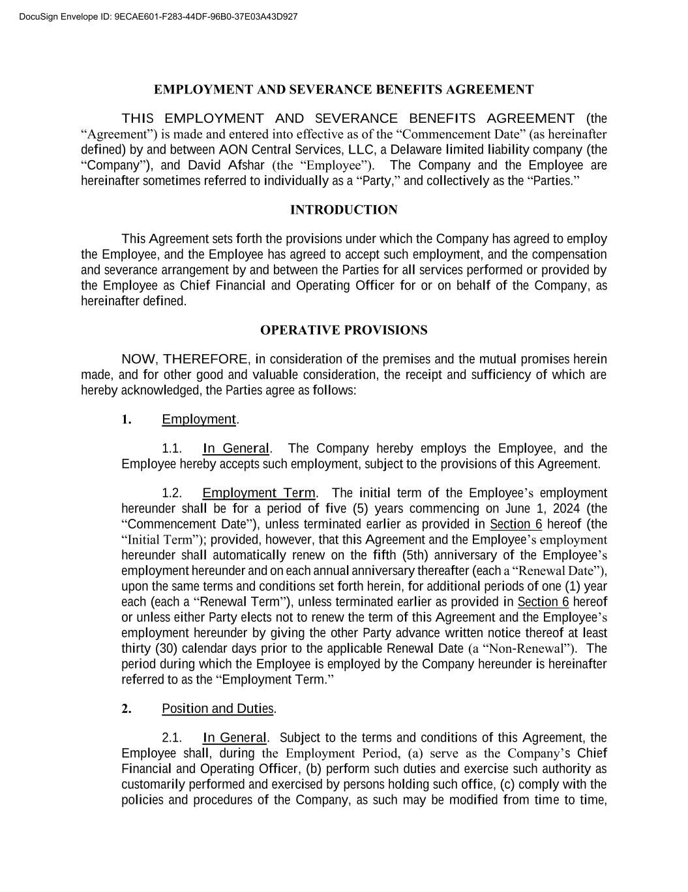
64
EMPLOYMENT AND SEVERANCE BENEFITS AGREEMENT THIS EMPLOYMENT AND SEVERANCE BENEFITS AGREEMENT (the “Agreement”) is made and entered into effective as of the “Commencement Date” (as hereinafter defined) by and between AON Central Services, LLC, a Delaware limited liability company (the “Company”), and David Afshar (the “Employee”). The Company and the Employee are hereinafter sometimes referred to individually as a “Party,” and collectively as the “Parties.” INTRODUCTION This Agreement sets forth the provisions under which the Company has agreed to employ the Employee, and the Employee has agreed to accept such employment, and the compensation and severance arrangement by and between the Parties for all services performed or provided by the Employee as Chief Financial and Operating Officer for or on behalf of the Company, as hereinafter defined. OPERATIVE PROVISIONS NOW, THEREFORE, in consideration of the premises and the mutual promises herein made, and for other good and valuable consideration, the receipt and sufficiency of which are hereby acknowledged, the Parties agree as follows: 1. Employment. 1.1. In General. The Company hereby employs the Employee, and the Employee hereby accepts such employment, subject to the provisions of this Agreement. 1.2. Employment Term. The initial term of the Employee’s employment hereunder shall be for a period of five (5) years commencing on June 1, 2024 (the “Commencement Date”), unless terminated earlier as provided in Section 6 hereof (the “Initial Term”); provided, however, that this Agreement and the Employee’s employment hereunder shall automatically renew on the fifth (5th) anniversary of the Employee’s employment hereunder and on each annual anniversary thereafter (each a “Renewal Date”), upon the same terms and conditions set forth herein, for additional periods of one (1) year each (each a “Renewal Term”), unless terminated earlier as provided in Section 6 hereof or unless either Party elects not to renew the term of this Agreement and the Employee’s employment hereunder by giving the other Party advance written notice thereof at least thirty (30) calendar days prior to the applicable Renewal Date (a “Non-Renewal”). The period during which the Employee is employed by the Company hereunder is hereinafter referred to as the “Employment Term.” 2. Position and Duties. 2.1. In General. Subject to the terms and conditions of this Agreement, the Employee shall, during the Employment Period, (a) serve as the Company’s Chief Financial and Operating Officer, (b) perform such duties and exercise such authority as customarily performed and exercised by persons holding such office, (c) comply with the policies and procedures of the Company, as such may be modified from time to time, DocuSign Envelope ID: 9ECAE601-F283-44DF-96B0-37E03A43D927

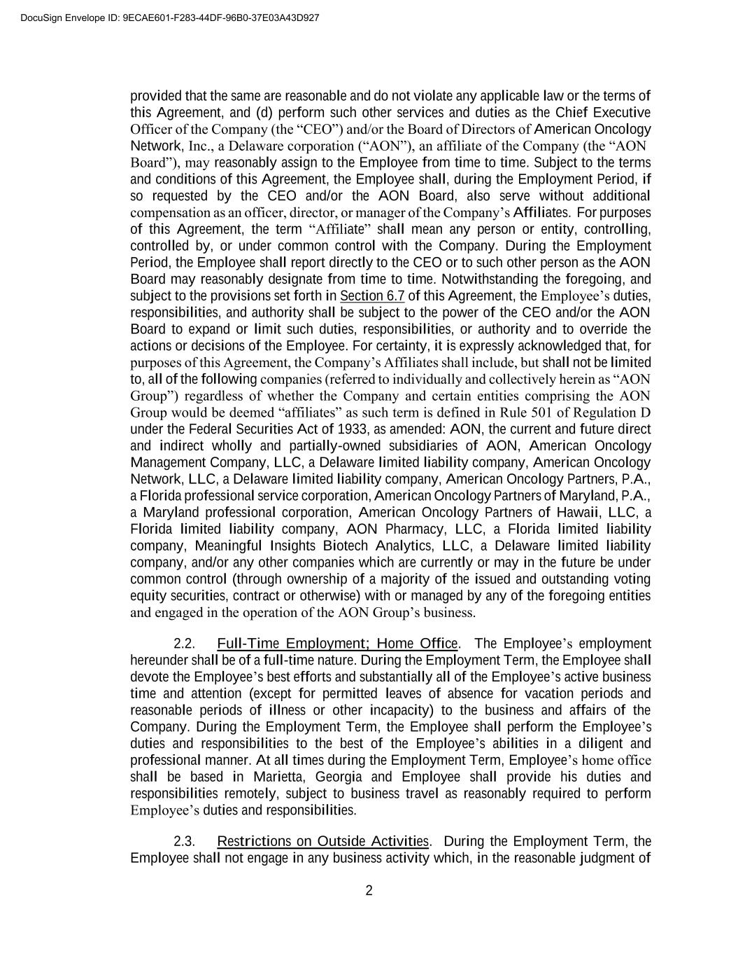
2 provided that the same are reasonable and do not violate any applicable law or the terms of this Agreement, and (d) perform such other services and duties as the Chief Executive Officer of the Company (the “CEO”) and/or the Board of Directors of American Oncology Network, Inc., a Delaware corporation (“AON”), an affiliate of the Company (the “AON Board”), may reasonably assign to the Employee from time to time. Subject to the terms and conditions of this Agreement, the Employee shall, during the Employment Period, if so requested by the CEO and/or the AON Board, also serve without additional compensation as an officer, director, or manager of the Company’s Affiliates. For purposes of this Agreement, the term “Affiliate” shall mean any person or entity, controlling, controlled by, or under common control with the Company. During the Employment Period, the Employee shall report directly to the CEO or to such other person as the AON Board may reasonably designate from time to time. Notwithstanding the foregoing, and subject to the provisions set forth in Section 6.7 of this Agreement, the Employee’s duties, responsibilities, and authority shall be subject to the power of the CEO and/or the AON Board to expand or limit such duties, responsibilities, or authority and to override the actions or decisions of the Employee. For certainty, it is expressly acknowledged that, for purposes of this Agreement, the Company’s Affiliates shall include, but shall not be limited to, all of the following companies (referred to individually and collectively herein as “AON Group”) regardless of whether the Company and certain entities comprising the AON Group would be deemed “affiliates” as such term is defined in Rule 501 of Regulation D under the Federal Securities Act of 1933, as amended: AON, the current and future direct and indirect wholly and partially-owned subsidiaries of AON, American Oncology Management Company, LLC, a Delaware limited liability company, American Oncology Network, LLC, a Delaware limited liability company, American Oncology Partners, P.A., a Florida professional service corporation, American Oncology Partners of Maryland, P.A., a Maryland professional corporation, American Oncology Partners of Hawaii, LLC, a Florida limited liability company, AON Pharmacy, LLC, a Florida limited liability company, Meaningful Insights Biotech Analytics, LLC, a Delaware limited liability company, and/or any other companies which are currently or may in the future be under common control (through ownership of a majority of the issued and outstanding voting equity securities, contract or otherwise) with or managed by any of the foregoing entities and engaged in the operation of the AON Group’s business. 2.2. Full-Time Employment; Home Office. The Employee’s employment hereunder shall be of a full-time nature. During the Employment Term, the Employee shall devote the Employee’s best efforts and substantially all of the Employee’s active business time and attention (except for permitted leaves of absence for vacation periods and reasonable periods of illness or other incapacity) to the business and affairs of the Company. During the Employment Term, the Employee shall perform the Employee’s duties and responsibilities to the best of the Employee’s abilities in a diligent and professional manner. At all times during the Employment Term, Employee’s home office shall be based in Marietta, Georgia and Employee shall provide his duties and responsibilities remotely, subject to business travel as reasonably required to perform Employee’s duties and responsibilities. 2.3. Restrictions on Outside Activities. During the Employment Term, the Employee shall not engage in any business activity which, in the reasonable judgment of DocuSign Envelope ID: 9ECAE601-F283-44DF-96B0-37E03A43D927

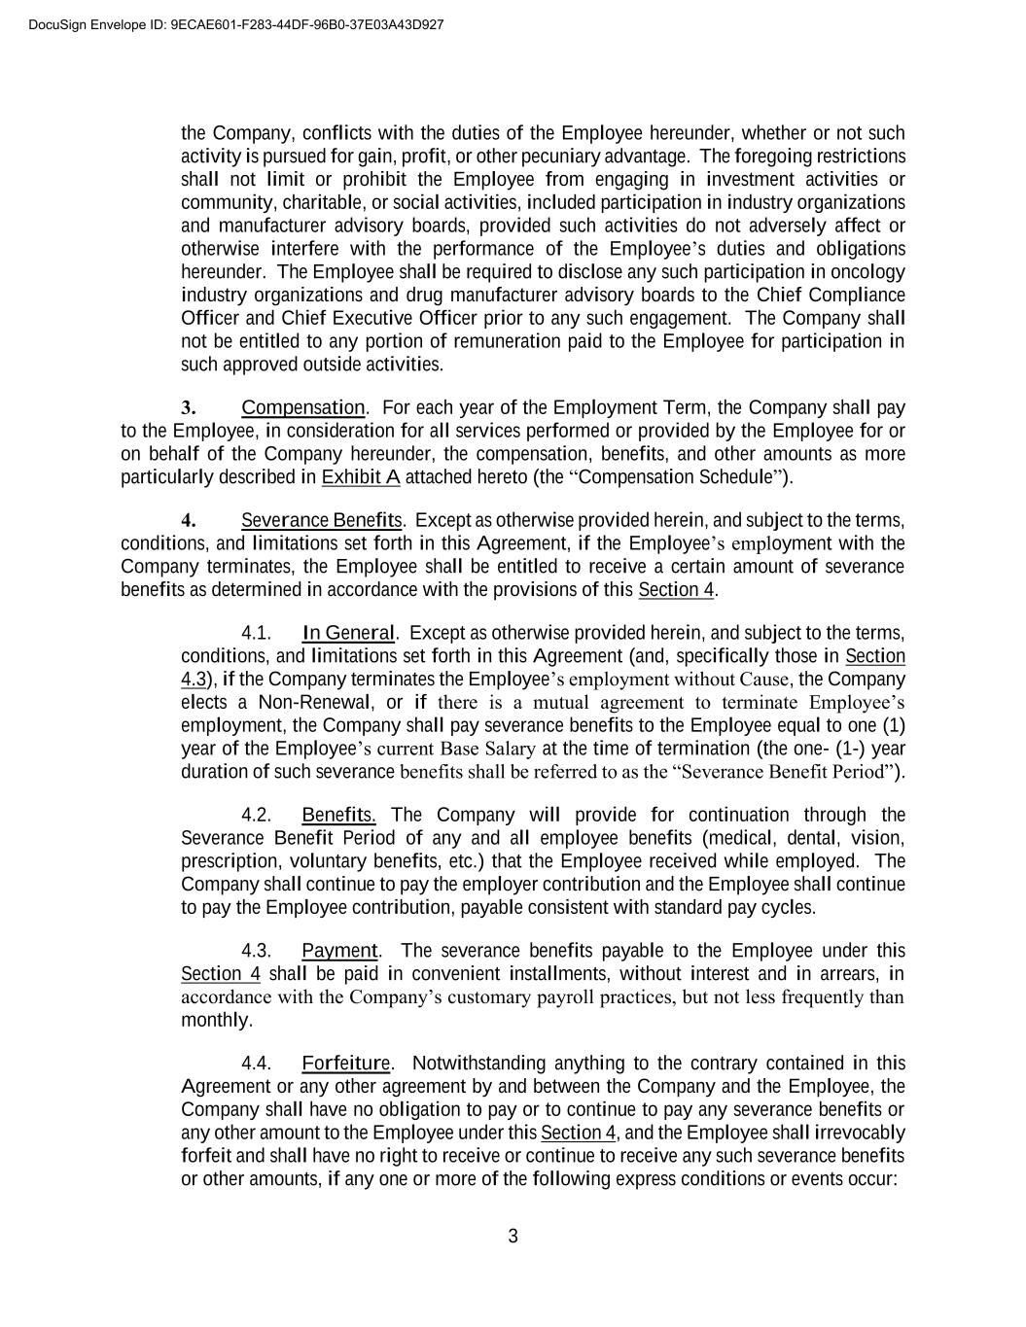
3 the Company, conflicts with the duties of the Employee hereunder, whether or not such activity is pursued for gain, profit, or other pecuniary advantage. The foregoing restrictions shall not limit or prohibit the Employee from engaging in investment activities or community, charitable, or social activities, included participation in industry organizations and manufacturer advisory boards, provided such activities do not adversely affect or otherwise interfere with the performance of the Employee’s duties and obligations hereunder. The Employee shall be required to disclose any such participation in oncology industry organizations and drug manufacturer advisory boards to the Chief Compliance Officer and Chief Executive Officer prior to any such engagement. The Company shall not be entitled to any portion of remuneration paid to the Employee for participation in such approved outside activities. 3. Compensation. For each year of the Employment Term, the Company shall pay to the Employee, in consideration for all services performed or provided by the Employee for or on behalf of the Company hereunder, the compensation, benefits, and other amounts as more particularly described in Exhibit A attached hereto (the “Compensation Schedule”). 4. Severance Benefits. Except as otherwise provided herein, and subject to the terms, conditions, and limitations set forth in this Agreement, if the Employee’s employment with the Company terminates, the Employee shall be entitled to receive a certain amount of severance benefits as determined in accordance with the provisions of this Section 4. 4.1. In General. Except as otherwise provided herein, and subject to the terms, conditions, and limitations set forth in this Agreement (and, specifically those in Section 4.3), if the Company terminates the Employee’s employment without Cause, the Company elects a Non-Renewal, or if there is a mutual agreement to terminate Employee’s employment, the Company shall pay severance benefits to the Employee equal to one (1) year of the Employee’s current Base Salary at the time of termination (the one- (1-) year duration of such severance benefits shall be referred to as the “Severance Benefit Period”). 4.2. Benefits. The Company will provide for continuation through the Severance Benefit Period of any and all employee benefits (medical, dental, vision, prescription, voluntary benefits, etc.) that the Employee received while employed. The Company shall continue to pay the employer contribution and the Employee shall continue to pay the Employee contribution, payable consistent with standard pay cycles. 4.3. Payment. The severance benefits payable to the Employee under this Section 4 shall be paid in convenient installments, without interest and in arrears, in accordance with the Company’s customary payroll practices, but not less frequently than monthly. 4.4. Forfeiture. Notwithstanding anything to the contrary contained in this Agreement or any other agreement by and between the Company and the Employee, the Company shall have no obligation to pay or to continue to pay any severance benefits or any other amount to the Employee under this Section 4, and the Employee shall irrevocably forfeit and shall have no right to receive or continue to receive any such severance benefits or other amounts, if any one or more of the following express conditions or events occur: DocuSign Envelope ID: 9ECAE601-F283-44DF-96B0-37E03A43D927

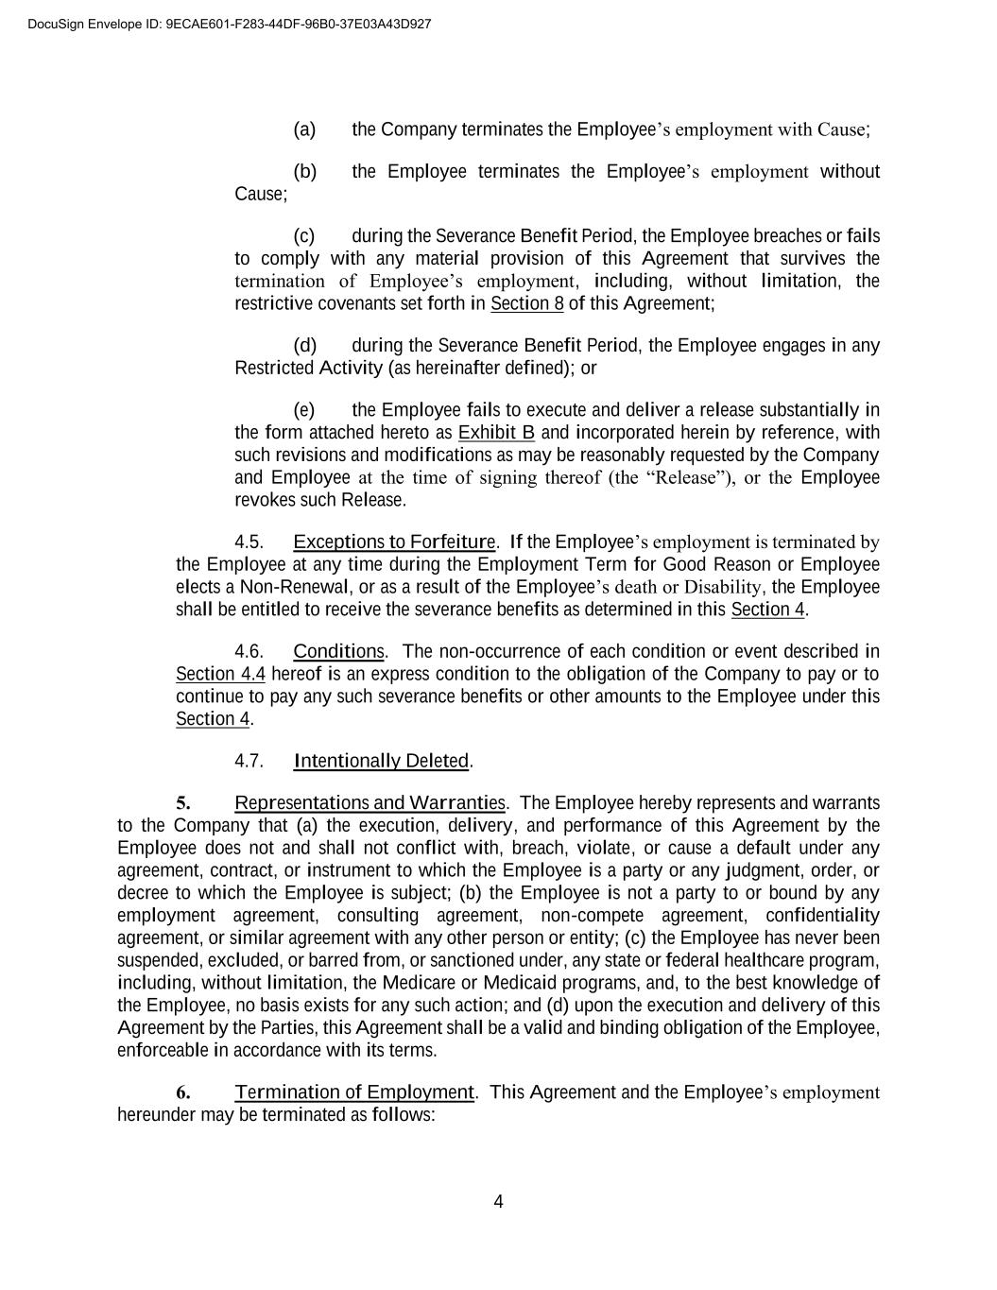
4 (a) the Company terminates the Employee’s employment with Cause; (b) the Employee terminates the Employee’s employment without Cause; (c) during the Severance Benefit Period, the Employee breaches or fails to comply with any material provision of this Agreement that survives the termination of Employee’s employment, including, without limitation, the restrictive covenants set forth in Section 8 of this Agreement; (d) during the Severance Benefit Period, the Employee engages in any Restricted Activity (as hereinafter defined); or (e) the Employee fails to execute and deliver a release substantially in the form attached hereto as Exhibit B and incorporated herein by reference, with such revisions and modifications as may be reasonably requested by the Company and Employee at the time of signing thereof (the “Release”), or the Employee revokes such Release. 4.5. Exceptions to Forfeiture. If the Employee’s employment is terminated by the Employee at any time during the Employment Term for Good Reason or Employee elects a Non-Renewal, or as a result of the Employee’s death or Disability, the Employee shall be entitled to receive the severance benefits as determined in this Section 4. 4.6. Conditions. The non-occurrence of each condition or event described in Section 4.4 hereof is an express condition to the obligation of the Company to pay or to continue to pay any such severance benefits or other amounts to the Employee under this Section 4. 4.7. Intentionally Deleted. 5. Representations and Warranties. The Employee hereby represents and warrants to the Company that (a) the execution, delivery, and performance of this Agreement by the Employee does not and shall not conflict with, breach, violate, or cause a default under any agreement, contract, or instrument to which the Employee is a party or any judgment, order, or decree to which the Employee is subject; (b) the Employee is not a party to or bound by any employment agreement, consulting agreement, non-compete agreement, confidentiality agreement, or similar agreement with any other person or entity; (c) the Employee has never been suspended, excluded, or barred from, or sanctioned under, any state or federal healthcare program, including, without limitation, the Medicare or Medicaid programs, and, to the best knowledge of the Employee, no basis exists for any such action; and (d) upon the execution and delivery of this Agreement by the Parties, this Agreement shall be a valid and binding obligation of the Employee, enforceable in accordance with its terms. 6. Termination of Employment. This Agreement and the Employee’s employment hereunder may be terminated as follows: DocuSign Envelope ID: 9ECAE601-F283-44DF-96B0-37E03A43D927

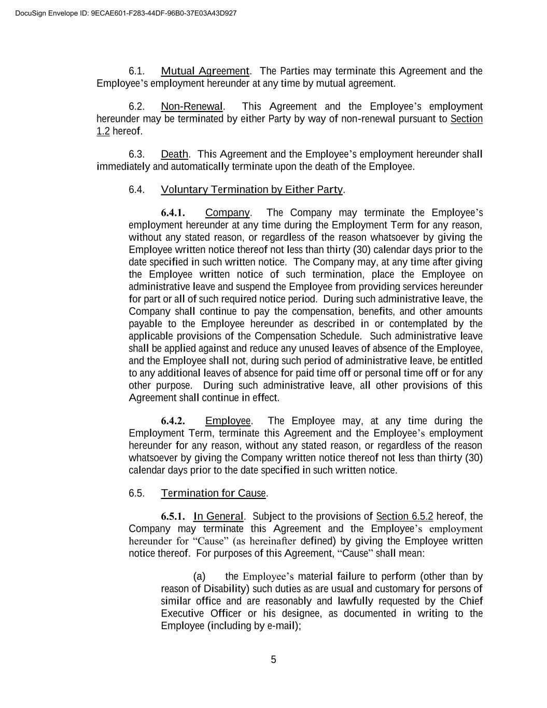
5 6.1. Mutual Agreement. The Parties may terminate this Agreement and the Employee’s employment hereunder at any time by mutual agreement. 6.2. Non-Renewal. This Agreement and the Employee’s employment hereunder may be terminated by either Party by way of non-renewal pursuant to Section 1.2 hereof. 6.3. Death. This Agreement and the Employee’s employment hereunder shall immediately and automatically terminate upon the death of the Employee. 6.4. Voluntary Termination by Either Party. 6.4.1. Company. The Company may terminate the Employee’s employment hereunder at any time during the Employment Term for any reason, without any stated reason, or regardless of the reason whatsoever by giving the Employee written notice thereof not less than thirty (30) calendar days prior to the date specified in such written notice. The Company may, at any time after giving the Employee written notice of such termination, place the Employee on administrative leave and suspend the Employee from providing services hereunder for part or all of such required notice period. During such administrative leave, the Company shall continue to pay the compensation, benefits, and other amounts payable to the Employee hereunder as described in or contemplated by the applicable provisions of the Compensation Schedule. Such administrative leave shall be applied against and reduce any unused leaves of absence of the Employee, and the Employee shall not, during such period of administrative leave, be entitled to any additional leaves of absence for paid time off or personal time off or for any other purpose. During such administrative leave, all other provisions of this Agreement shall continue in effect. 6.4.2. Employee. The Employee may, at any time during the Employment Term, terminate this Agreement and the Employee’s employment hereunder for any reason, without any stated reason, or regardless of the reason whatsoever by giving the Company written notice thereof not less than thirty (30) calendar days prior to the date specified in such written notice. 6.5. Termination for Cause. 6.5.1. In General. Subject to the provisions of Section 6.5.2 hereof, the Company may terminate this Agreement and the Employee’s employment hereunder for “Cause” (as hereinafter defined) by giving the Employee written notice thereof. For purposes of this Agreement, “Cause” shall mean: (a) the Employee’s material failure to perform (other than by reason of Disability) such duties as are usual and customary for persons of similar office and are reasonably and lawfully requested by the Chief Executive Officer or his designee, as documented in writing to the Employee (including by e-mail); DocuSign Envelope ID: 9ECAE601-F283-44DF-96B0-37E03A43D927

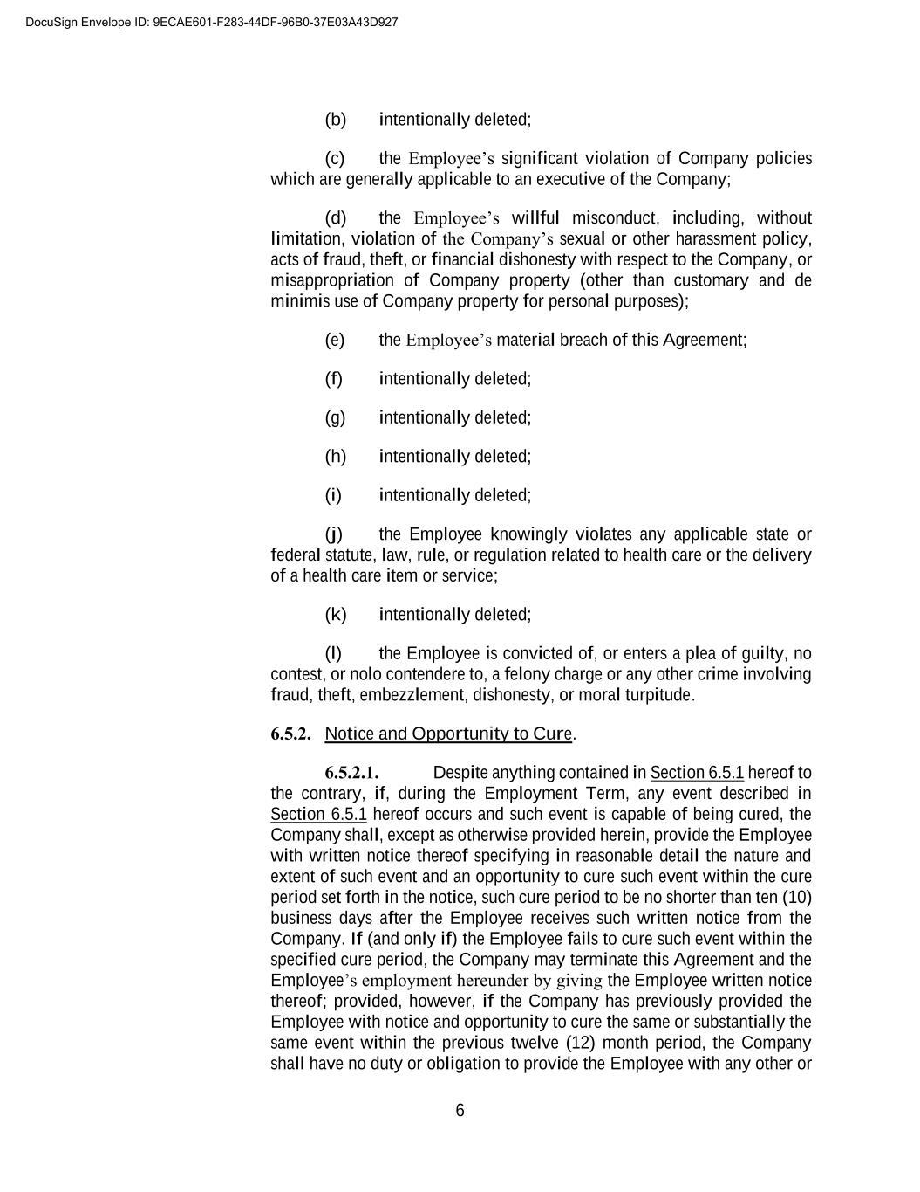
6 (b) intentionally deleted; (c) the Employee’s significant violation of Company policies which are generally applicable to an executive of the Company; (d) the Employee’s willful misconduct, including, without limitation, violation of the Company’s sexual or other harassment policy, acts of fraud, theft, or financial dishonesty with respect to the Company, or misappropriation of Company property (other than customary and de minimis use of Company property for personal purposes); (e) the Employee’s material breach of this Agreement; (f) intentionally deleted; (g) intentionally deleted; (h) intentionally deleted; (i) intentionally deleted; (j) the Employee knowingly violates any applicable state or federal statute, law, rule, or regulation related to health care or the delivery of a health care item or service; (k) intentionally deleted; (l) the Employee is convicted of, or enters a plea of guilty, no contest, or nolo contendere to, a felony charge or any other crime involving fraud, theft, embezzlement, dishonesty, or moral turpitude. 6.5.2. Notice and Opportunity to Cure. 6.5.2.1. Despite anything contained in Section 6.5.1 hereof to the contrary, if, during the Employment Term, any event described in Section 6.5.1 hereof occurs and such event is capable of being cured, the Company shall, except as otherwise provided herein, provide the Employee with written notice thereof specifying in reasonable detail the nature and extent of such event and an opportunity to cure such event within the cure period set forth in the notice, such cure period to be no shorter than ten (10) business days after the Employee receives such written notice from the Company. If (and only if) the Employee fails to cure such event within the specified cure period, the Company may terminate this Agreement and the Employee’s employment hereunder by giving the Employee written notice thereof; provided, however, if the Company has previously provided the Employee with notice and opportunity to cure the same or substantially the same event within the previous twelve (12) month period, the Company shall have no duty or obligation to provide the Employee with any other or DocuSign Envelope ID: 9ECAE601-F283-44DF-96B0-37E03A43D927

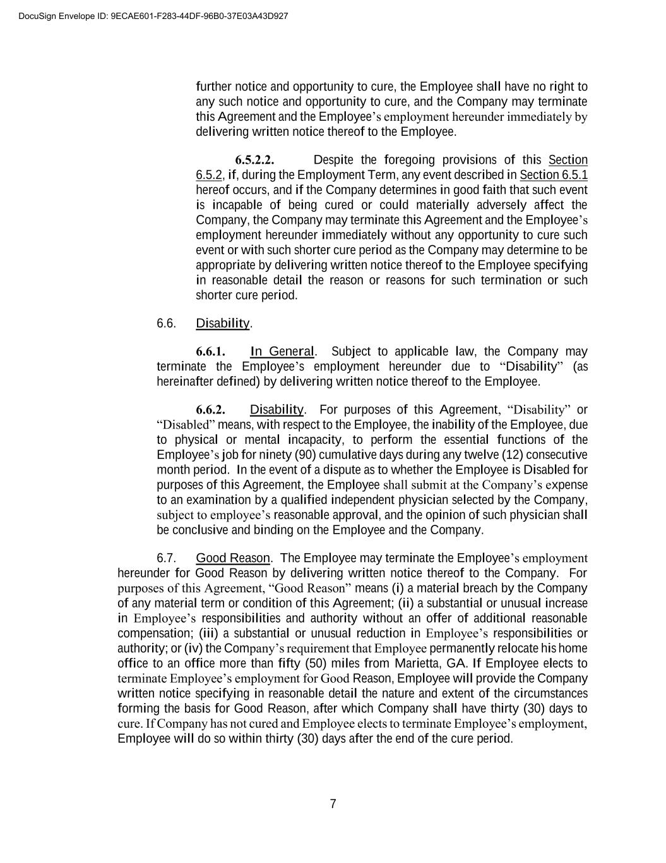
7 further notice and opportunity to cure, the Employee shall have no right to any such notice and opportunity to cure, and the Company may terminate this Agreement and the Employee’s employment hereunder immediately by delivering written notice thereof to the Employee. 6.5.2.2. Despite the foregoing provisions of this Section 6.5.2, if, during the Employment Term, any event described in Section 6.5.1 hereof occurs, and if the Company determines in good faith that such event is incapable of being cured or could materially adversely affect the Company, the Company may terminate this Agreement and the Employee’s employment hereunder immediately without any opportunity to cure such event or with such shorter cure period as the Company may determine to be appropriate by delivering written notice thereof to the Employee specifying in reasonable detail the reason or reasons for such termination or such shorter cure period. 6.6. Disability. 6.6.1. In General. Subject to applicable law, the Company may terminate the Employee’s employment hereunder due to “Disability” (as hereinafter defined) by delivering written notice thereof to the Employee. 6.6.2. Disability. For purposes of this Agreement, “Disability” or “Disabled” means, with respect to the Employee, the inability of the Employee, due to physical or mental incapacity, to perform the essential functions of the Employee’s job for ninety (90) cumulative days during any twelve (12) consecutive month period. In the event of a dispute as to whether the Employee is Disabled for purposes of this Agreement, the Employee shall submit at the Company’s expense to an examination by a qualified independent physician selected by the Company, subject to employee’s reasonable approval, and the opinion of such physician shall be conclusive and binding on the Employee and the Company. 6.7. Good Reason. The Employee may terminate the Employee’s employment hereunder for Good Reason by delivering written notice thereof to the Company. For purposes of this Agreement, “Good Reason” means (i) a material breach by the Company of any material term or condition of this Agreement; (ii) a substantial or unusual increase in Employee’s responsibilities and authority without an offer of additional reasonable compensation; (iii) a substantial or unusual reduction in Employee’s responsibilities or authority; or (iv) the Company’s requirement that Employee permanently relocate his home office to an office more than fifty (50) miles from Marietta, GA. If Employee elects to terminate Employee’s employment for Good Reason, Employee will provide the Company written notice specifying in reasonable detail the nature and extent of the circumstances forming the basis for Good Reason, after which Company shall have thirty (30) days to cure. If Company has not cured and Employee elects to terminate Employee’s employment, Employee will do so within thirty (30) days after the end of the cure period. DocuSign Envelope ID: 9ECAE601-F283-44DF-96B0-37E03A43D927

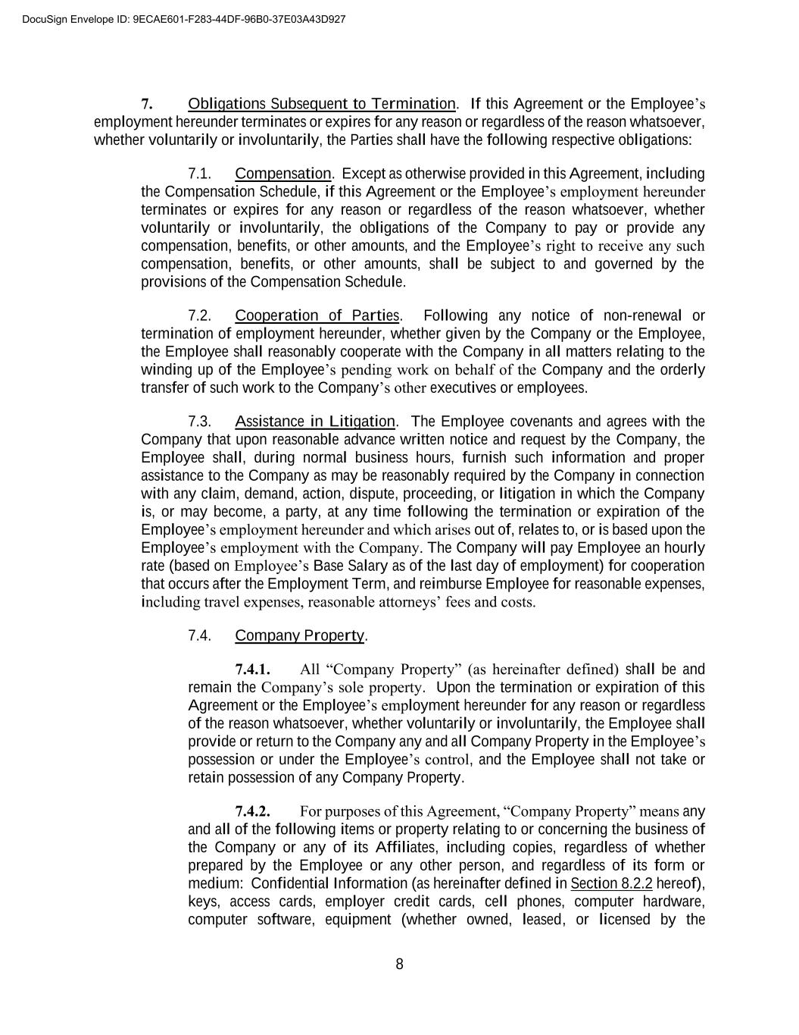
8 7. Obligations Subsequent to Termination. If this Agreement or the Employee’s employment hereunder terminates or expires for any reason or regardless of the reason whatsoever, whether voluntarily or involuntarily, the Parties shall have the following respective obligations: 7.1. Compensation. Except as otherwise provided in this Agreement, including the Compensation Schedule, if this Agreement or the Employee’s employment hereunder terminates or expires for any reason or regardless of the reason whatsoever, whether voluntarily or involuntarily, the obligations of the Company to pay or provide any compensation, benefits, or other amounts, and the Employee’s right to receive any such compensation, benefits, or other amounts, shall be subject to and governed by the provisions of the Compensation Schedule. 7.2. Cooperation of Parties. Following any notice of non-renewal or termination of employment hereunder, whether given by the Company or the Employee, the Employee shall reasonably cooperate with the Company in all matters relating to the winding up of the Employee’s pending work on behalf of the Company and the orderly transfer of such work to the Company’s other executives or employees. 7.3. Assistance in Litigation. The Employee covenants and agrees with the Company that upon reasonable advance written notice and request by the Company, the Employee shall, during normal business hours, furnish such information and proper assistance to the Company as may be reasonably required by the Company in connection with any claim, demand, action, dispute, proceeding, or litigation in which the Company is, or may become, a party, at any time following the termination or expiration of the Employee’s employment hereunder and which arises out of, relates to, or is based upon the Employee’s employment with the Company. The Company will pay Employee an hourly rate (based on Employee’s Base Salary as of the last day of employment) for cooperation that occurs after the Employment Term, and reimburse Employee for reasonable expenses, including travel expenses, reasonable attorneys’ fees and costs. 7.4. Company Property. 7.4.1. All “Company Property” (as hereinafter defined) shall be and remain the Company’s sole property. Upon the termination or expiration of this Agreement or the Employee’s employment hereunder for any reason or regardless of the reason whatsoever, whether voluntarily or involuntarily, the Employee shall provide or return to the Company any and all Company Property in the Employee’s possession or under the Employee’s control, and the Employee shall not take or retain possession of any Company Property. 7.4.2. For purposes of this Agreement, “Company Property” means any and all of the following items or property relating to or concerning the business of the Company or any of its Affiliates, including copies, regardless of whether prepared by the Employee or any other person, and regardless of its form or medium: Confidential Information (as hereinafter defined in Section 8.2.2 hereof), keys, access cards, employer credit cards, cell phones, computer hardware, computer software, equipment (whether owned, leased, or licensed by the DocuSign Envelope ID: 9ECAE601-F283-44DF-96B0-37E03A43D927

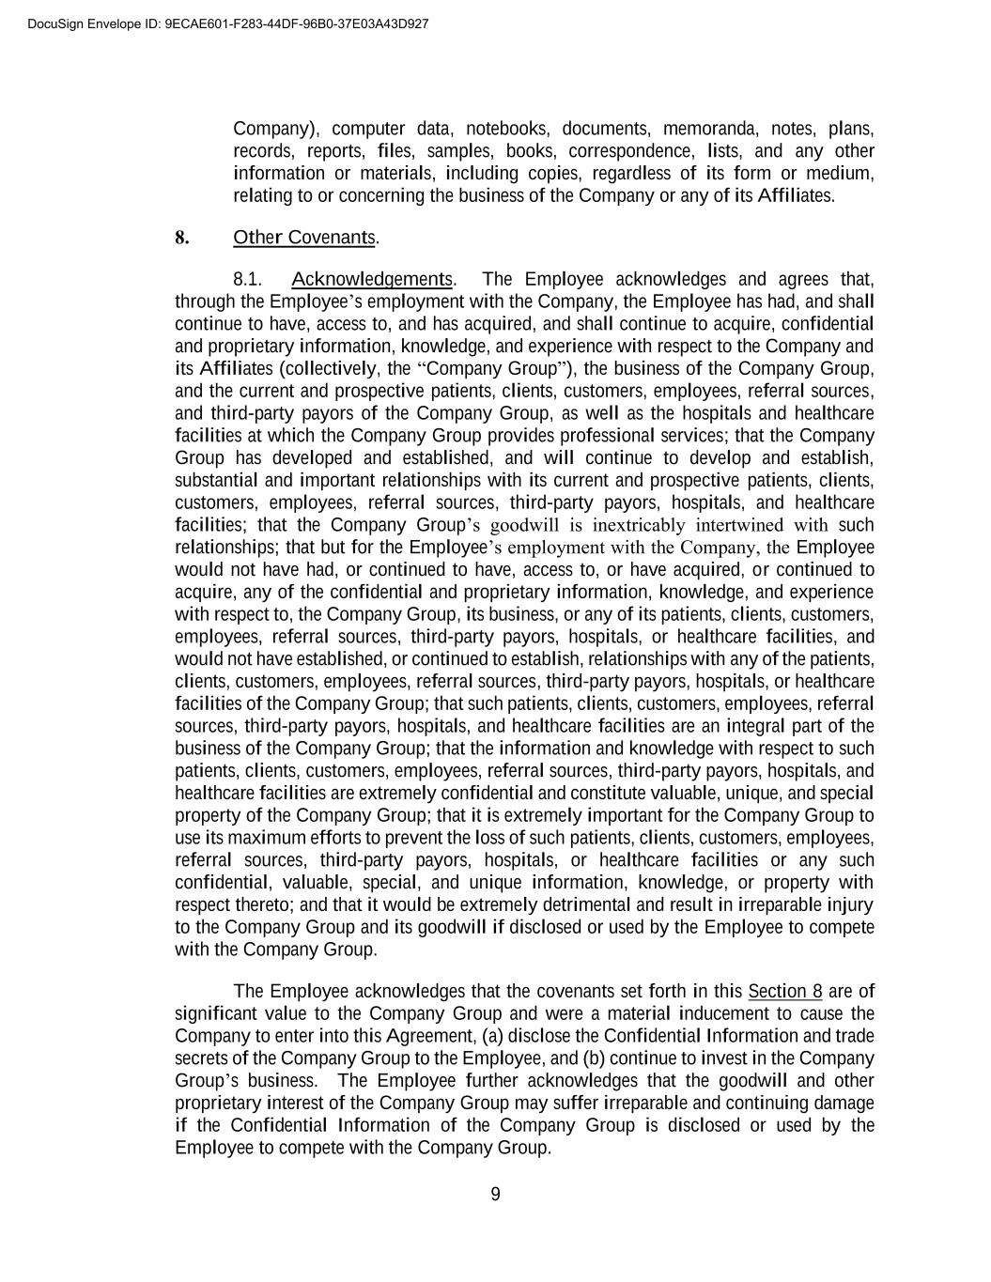
9 Company), computer data, notebooks, documents, memoranda, notes, plans, records, reports, files, samples, books, correspondence, lists, and any other information or materials, including copies, regardless of its form or medium, relating to or concerning the business of the Company or any of its Affiliates. 8. Other Covenants. 8.1. Acknowledgements. The Employee acknowledges and agrees that, through the Employee’s employment with the Company, the Employee has had, and shall continue to have, access to, and has acquired, and shall continue to acquire, confidential and proprietary information, knowledge, and experience with respect to the Company and its Affiliates (collectively, the “Company Group”), the business of the Company Group, and the current and prospective patients, clients, customers, employees, referral sources, and third-party payors of the Company Group, as well as the hospitals and healthcare facilities at which the Company Group provides professional services; that the Company Group has developed and established, and will continue to develop and establish, substantial and important relationships with its current and prospective patients, clients, customers, employees, referral sources, third-party payors, hospitals, and healthcare facilities; that the Company Group’s goodwill is inextricably intertwined with such relationships; that but for the Employee’s employment with the Company, the Employee would not have had, or continued to have, access to, or have acquired, or continued to acquire, any of the confidential and proprietary information, knowledge, and experience with respect to, the Company Group, its business, or any of its patients, clients, customers, employees, referral sources, third-party payors, hospitals, or healthcare facilities, and would not have established, or continued to establish, relationships with any of the patients, clients, customers, employees, referral sources, third-party payors, hospitals, or healthcare facilities of the Company Group; that such patients, clients, customers, employees, referral sources, third-party payors, hospitals, and healthcare facilities are an integral part of the business of the Company Group; that the information and knowledge with respect to such patients, clients, customers, employees, referral sources, third-party payors, hospitals, and healthcare facilities are extremely confidential and constitute valuable, unique, and special property of the Company Group; that it is extremely important for the Company Group to use its maximum efforts to prevent the loss of such patients, clients, customers, employees, referral sources, third-party payors, hospitals, or healthcare facilities or any such confidential, valuable, special, and unique information, knowledge, or property with respect thereto; and that it would be extremely detrimental and result in irreparable injury to the Company Group and its goodwill if disclosed or used by the Employee to compete with the Company Group. The Employee acknowledges that the covenants set forth in this Section 8 are of significant value to the Company Group and were a material inducement to cause the Company to enter into this Agreement, (a) disclose the Confidential Information and trade secrets of the Company Group to the Employee, and (b) continue to invest in the Company Group’s business. The Employee further acknowledges that the goodwill and other proprietary interest of the Company Group may suffer irreparable and continuing damage if the Confidential Information of the Company Group is disclosed or used by the Employee to compete with the Company Group. DocuSign Envelope ID: 9ECAE601-F283-44DF-96B0-37E03A43D927

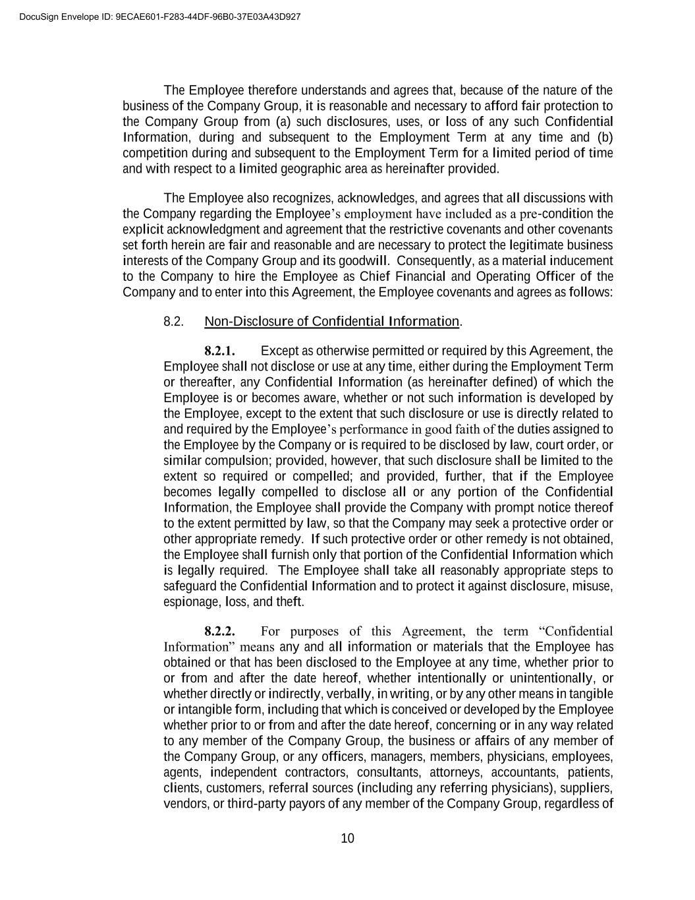
10 The Employee therefore understands and agrees that, because of the nature of the business of the Company Group, it is reasonable and necessary to afford fair protection to the Company Group from (a) such disclosures, uses, or loss of any such Confidential Information, during and subsequent to the Employment Term at any time and (b) competition during and subsequent to the Employment Term for a limited period of time and with respect to a limited geographic area as hereinafter provided. The Employee also recognizes, acknowledges, and agrees that all discussions with the Company regarding the Employee’s employment have included as a pre-condition the explicit acknowledgment and agreement that the restrictive covenants and other covenants set forth herein are fair and reasonable and are necessary to protect the legitimate business interests of the Company Group and its goodwill. Consequently, as a material inducement to the Company to hire the Employee as Chief Financial and Operating Officer of the Company and to enter into this Agreement, the Employee covenants and agrees as follows: 8.2. Non-Disclosure of Confidential Information. 8.2.1. Except as otherwise permitted or required by this Agreement, the Employee shall not disclose or use at any time, either during the Employment Term or thereafter, any Confidential Information (as hereinafter defined) of which the Employee is or becomes aware, whether or not such information is developed by the Employee, except to the extent that such disclosure or use is directly related to and required by the Employee’s performance in good faith of the duties assigned to the Employee by the Company or is required to be disclosed by law, court order, or similar compulsion; provided, however, that such disclosure shall be limited to the extent so required or compelled; and provided, further, that if the Employee becomes legally compelled to disclose all or any portion of the Confidential Information, the Employee shall provide the Company with prompt notice thereof to the extent permitted by law, so that the Company may seek a protective order or other appropriate remedy. If such protective order or other remedy is not obtained, the Employee shall furnish only that portion of the Confidential Information which is legally required. The Employee shall take all reasonably appropriate steps to safeguard the Confidential Information and to protect it against disclosure, misuse, espionage, loss, and theft. 8.2.2. For purposes of this Agreement, the term “Confidential Information” means any and all information or materials that the Employee has obtained or that has been disclosed to the Employee at any time, whether prior to or from and after the date hereof, whether intentionally or unintentionally, or whether directly or indirectly, verbally, in writing, or by any other means in tangible or intangible form, including that which is conceived or developed by the Employee whether prior to or from and after the date hereof, concerning or in any way related to any member of the Company Group, the business or affairs of any member of the Company Group, or any officers, managers, members, physicians, employees, agents, independent contractors, consultants, attorneys, accountants, patients, clients, customers, referral sources (including any referring physicians), suppliers, vendors, or third-party payors of any member of the Company Group, regardless of DocuSign Envelope ID: 9ECAE601-F283-44DF-96B0-37E03A43D927

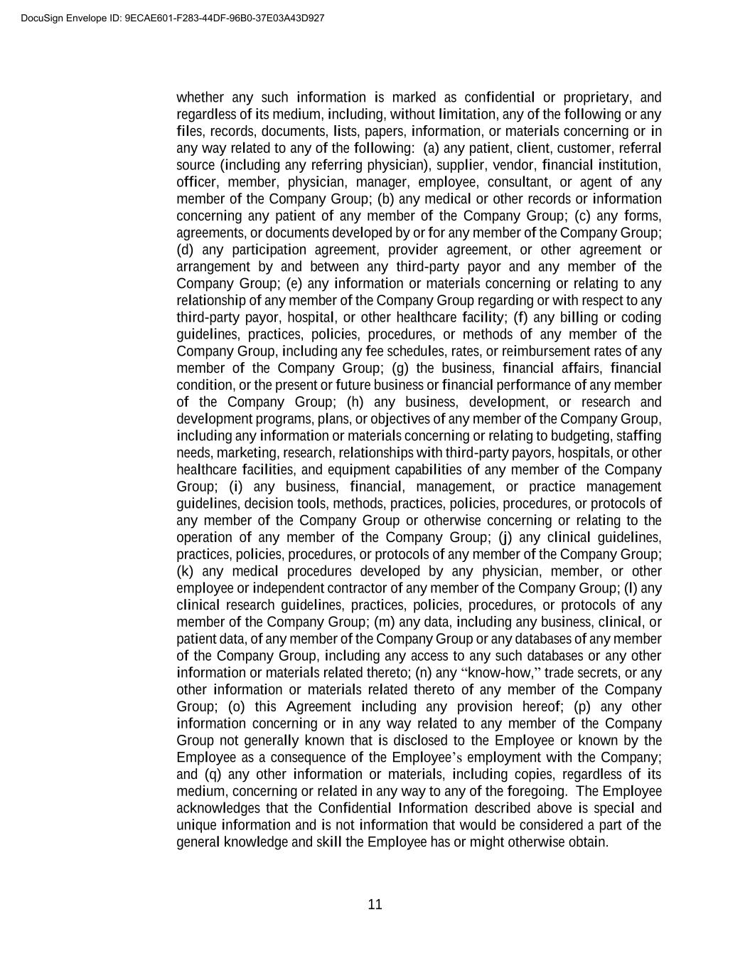
11 whether any such information is marked as confidential or proprietary, and regardless of its medium, including, without limitation, any of the following or any files, records, documents, lists, papers, information, or materials concerning or in any way related to any of the following: (a) any patient, client, customer, referral source (including any referring physician), supplier, vendor, financial institution, officer, member, physician, manager, employee, consultant, or agent of any member of the Company Group; (b) any medical or other records or information concerning any patient of any member of the Company Group; (c) any forms, agreements, or documents developed by or for any member of the Company Group; (d) any participation agreement, provider agreement, or other agreement or arrangement by and between any third-party payor and any member of the Company Group; (e) any information or materials concerning or relating to any relationship of any member of the Company Group regarding or with respect to any third-party payor, hospital, or other healthcare facility; (f) any billing or coding guidelines, practices, policies, procedures, or methods of any member of the Company Group, including any fee schedules, rates, or reimbursement rates of any member of the Company Group; (g) the business, financial affairs, financial condition, or the present or future business or financial performance of any member of the Company Group; (h) any business, development, or research and development programs, plans, or objectives of any member of the Company Group, including any information or materials concerning or relating to budgeting, staffing needs, marketing, research, relationships with third-party payors, hospitals, or other healthcare facilities, and equipment capabilities of any member of the Company Group; (i) any business, financial, management, or practice management guidelines, decision tools, methods, practices, policies, procedures, or protocols of any member of the Company Group or otherwise concerning or relating to the operation of any member of the Company Group; (j) any clinical guidelines, practices, policies, procedures, or protocols of any member of the Company Group; (k) any medical procedures developed by any physician, member, or other employee or independent contractor of any member of the Company Group; (l) any clinical research guidelines, practices, policies, procedures, or protocols of any member of the Company Group; (m) any data, including any business, clinical, or patient data, of any member of the Company Group or any databases of any member of the Company Group, including any access to any such databases or any other information or materials related thereto; (n) any “know-how,” trade secrets, or any other information or materials related thereto of any member of the Company Group; (o) this Agreement including any provision hereof; (p) any other information concerning or in any way related to any member of the Company Group not generally known that is disclosed to the Employee or known by the Employee as a consequence of the Employee’s employment with the Company; and (q) any other information or materials, including copies, regardless of its medium, concerning or related in any way to any of the foregoing. The Employee acknowledges that the Confidential Information described above is special and unique information and is not information that would be considered a part of the general knowledge and skill the Employee has or might otherwise obtain. DocuSign Envelope ID: 9ECAE601-F283-44DF-96B0-37E03A43D927

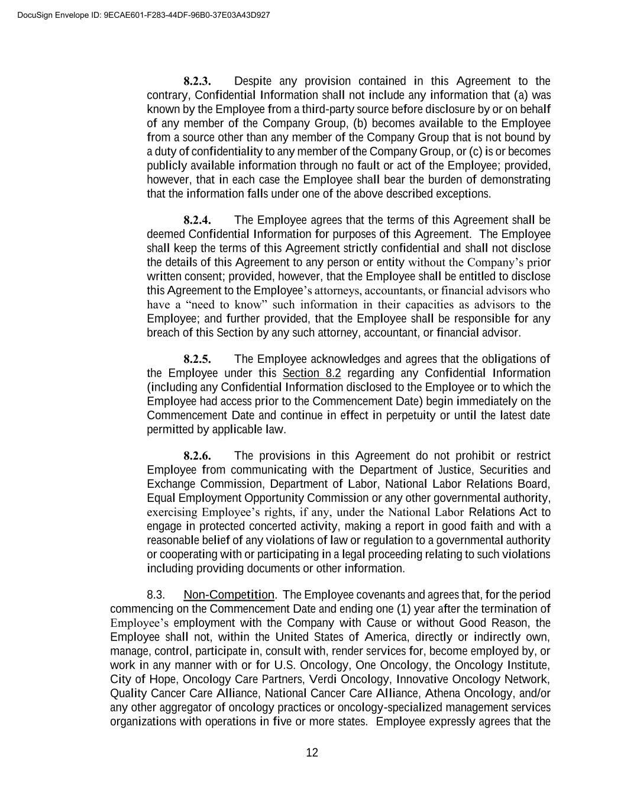
12 8.2.3. Despite any provision contained in this Agreement to the contrary, Confidential Information shall not include any information that (a) was known by the Employee from a third-party source before disclosure by or on behalf of any member of the Company Group, (b) becomes available to the Employee from a source other than any member of the Company Group that is not bound by a duty of confidentiality to any member of the Company Group, or (c) is or becomes publicly available information through no fault or act of the Employee; provided, however, that in each case the Employee shall bear the burden of demonstrating that the information falls under one of the above described exceptions. 8.2.4. The Employee agrees that the terms of this Agreement shall be deemed Confidential Information for purposes of this Agreement. The Employee shall keep the terms of this Agreement strictly confidential and shall not disclose the details of this Agreement to any person or entity without the Company’s prior written consent; provided, however, that the Employee shall be entitled to disclose this Agreement to the Employee’s attorneys, accountants, or financial advisors who have a “need to know” such information in their capacities as advisors to the Employee; and further provided, that the Employee shall be responsible for any breach of this Section by any such attorney, accountant, or financial advisor. 8.2.5. The Employee acknowledges and agrees that the obligations of the Employee under this Section 8.2 regarding any Confidential Information (including any Confidential Information disclosed to the Employee or to which the Employee had access prior to the Commencement Date) begin immediately on the Commencement Date and continue in effect in perpetuity or until the latest date permitted by applicable law. 8.2.6. The provisions in this Agreement do not prohibit or restrict Employee from communicating with the Department of Justice, Securities and Exchange Commission, Department of Labor, National Labor Relations Board, Equal Employment Opportunity Commission or any other governmental authority, exercising Employee’s rights, if any, under the National Labor Relations Act to engage in protected concerted activity, making a report in good faith and with a reasonable belief of any violations of law or regulation to a governmental authority or cooperating with or participating in a legal proceeding relating to such violations including providing documents or other information. 8.3. Non-Competition. The Employee covenants and agrees that, for the period commencing on the Commencement Date and ending one (1) year after the termination of Employee’s employment with the Company with Cause or without Good Reason, the Employee shall not, within the United States of America, directly or indirectly own, manage, control, participate in, consult with, render services for, become employed by, or work in any manner with or for U.S. Oncology, One Oncology, the Oncology Institute, City of Hope, Oncology Care Partners, Verdi Oncology, Innovative Oncology Network, Quality Cancer Care Alliance, National Cancer Care Alliance, Athena Oncology, and/or any other aggregator of oncology practices or oncology-specialized management services organizations with operations in five or more states. Employee expressly agrees that the DocuSign Envelope ID: 9ECAE601-F283-44DF-96B0-37E03A43D927

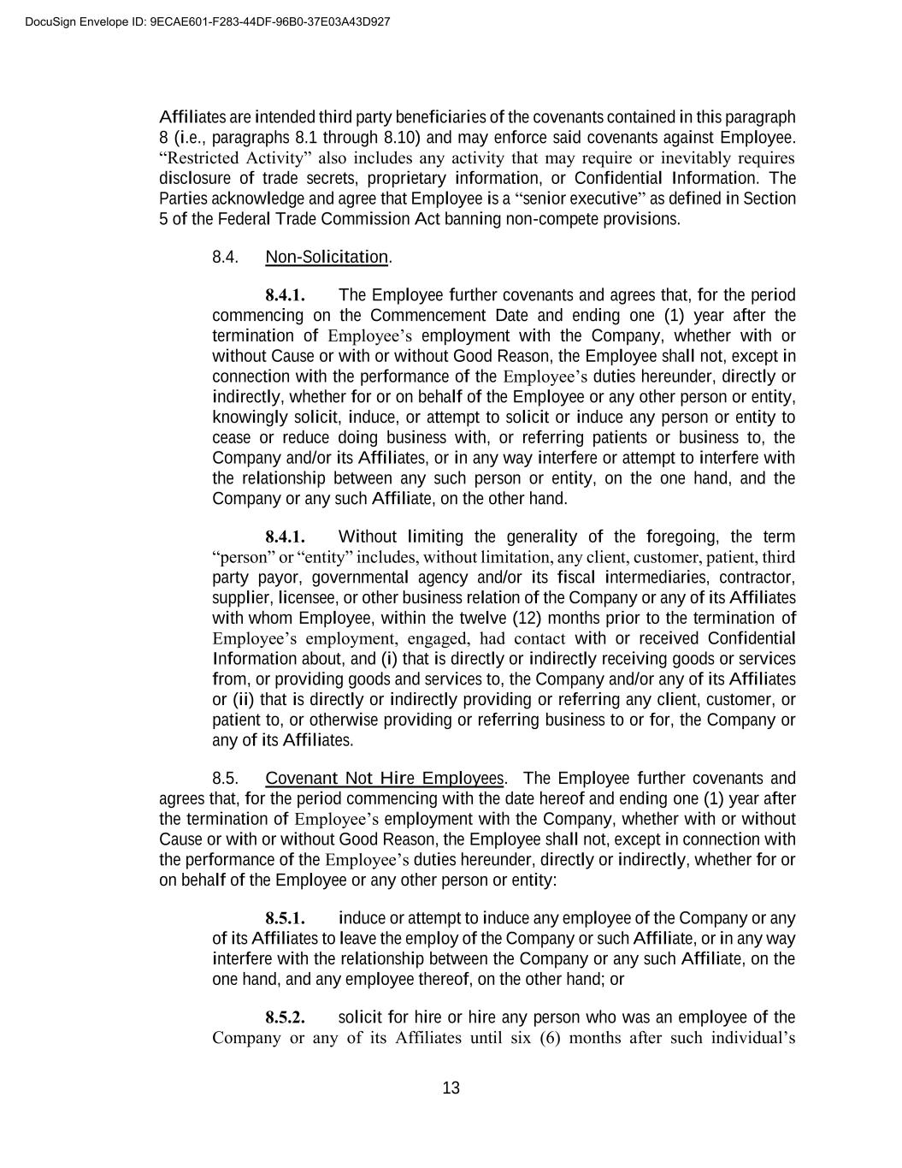
13 Affiliates are intended third party beneficiaries of the covenants contained in this paragraph 8 (i.e., paragraphs 8.1 through 8.10) and may enforce said covenants against Employee. “Restricted Activity” also includes any activity that may require or inevitably requires disclosure of trade secrets, proprietary information, or Confidential Information. The Parties acknowledge and agree that Employee is a “senior executive” as defined in Section 5 of the Federal Trade Commission Act banning non-compete provisions. 8.4. Non-Solicitation. 8.4.1. The Employee further covenants and agrees that, for the period commencing on the Commencement Date and ending one (1) year after the termination of Employee’s employment with the Company, whether with or without Cause or with or without Good Reason, the Employee shall not, except in connection with the performance of the Employee’s duties hereunder, directly or indirectly, whether for or on behalf of the Employee or any other person or entity, knowingly solicit, induce, or attempt to solicit or induce any person or entity to cease or reduce doing business with, or referring patients or business to, the Company and/or its Affiliates, or in any way interfere or attempt to interfere with the relationship between any such person or entity, on the one hand, and the Company or any such Affiliate, on the other hand. 8.4.1. Without limiting the generality of the foregoing, the term “person” or “entity” includes, without limitation, any client, customer, patient, third party payor, governmental agency and/or its fiscal intermediaries, contractor, supplier, licensee, or other business relation of the Company or any of its Affiliates with whom Employee, within the twelve (12) months prior to the termination of Employee’s employment, engaged, had contact with or received Confidential Information about, and (i) that is directly or indirectly receiving goods or services from, or providing goods and services to, the Company and/or any of its Affiliates or (ii) that is directly or indirectly providing or referring any client, customer, or patient to, or otherwise providing or referring business to or for, the Company or any of its Affiliates. 8.5. Covenant Not Hire Employees. The Employee further covenants and agrees that, for the period commencing with the date hereof and ending one (1) year after the termination of Employee’s employment with the Company, whether with or without Cause or with or without Good Reason, the Employee shall not, except in connection with the performance of the Employee’s duties hereunder, directly or indirectly, whether for or on behalf of the Employee or any other person or entity: 8.5.1. induce or attempt to induce any employee of the Company or any of its Affiliates to leave the employ of the Company or such Affiliate, or in any way interfere with the relationship between the Company or any such Affiliate, on the one hand, and any employee thereof, on the other hand; or 8.5.2. solicit for hire or hire any person who was an employee of the Company or any of its Affiliates until six (6) months after such individual’s DocuSign Envelope ID: 9ECAE601-F283-44DF-96B0-37E03A43D927

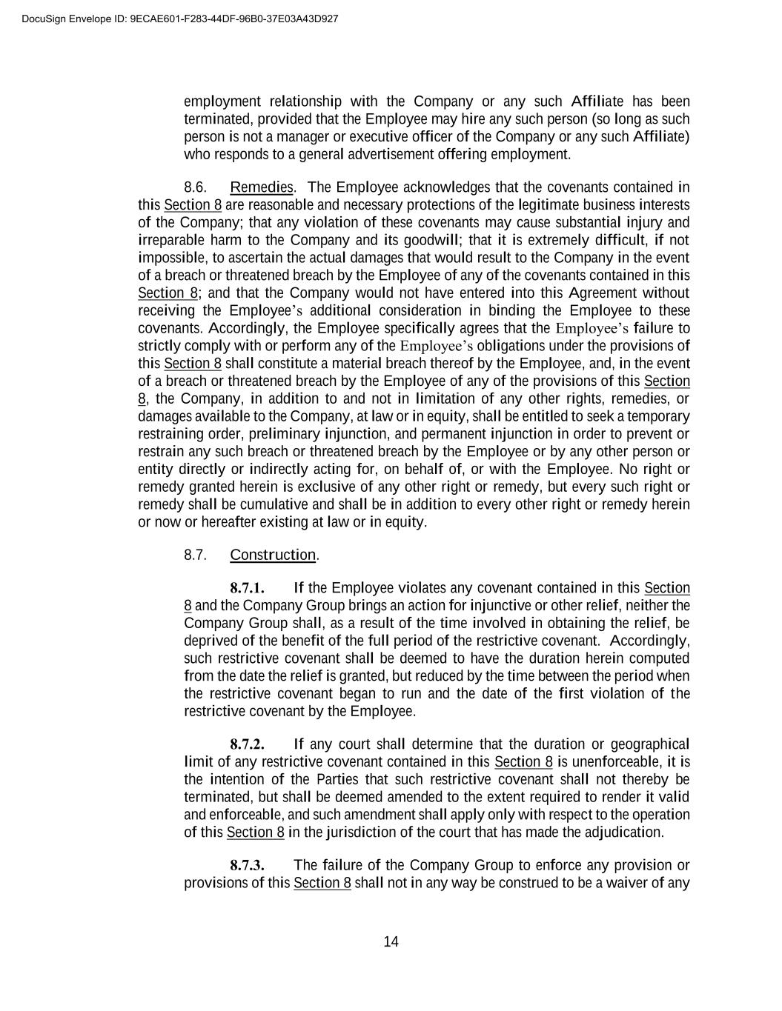
14 employment relationship with the Company or any such Affiliate has been terminated, provided that the Employee may hire any such person (so long as such person is not a manager or executive officer of the Company or any such Affiliate) who responds to a general advertisement offering employment. 8.6. Remedies. The Employee acknowledges that the covenants contained in this Section 8 are reasonable and necessary protections of the legitimate business interests of the Company; that any violation of these covenants may cause substantial injury and irreparable harm to the Company and its goodwill; that it is extremely difficult, if not impossible, to ascertain the actual damages that would result to the Company in the event of a breach or threatened breach by the Employee of any of the covenants contained in this Section 8; and that the Company would not have entered into this Agreement without receiving the Employee’s additional consideration in binding the Employee to these covenants. Accordingly, the Employee specifically agrees that the Employee’s failure to strictly comply with or perform any of the Employee’s obligations under the provisions of this Section 8 shall constitute a material breach thereof by the Employee, and, in the event of a breach or threatened breach by the Employee of any of the provisions of this Section 8, the Company, in addition to and not in limitation of any other rights, remedies, or damages available to the Company, at law or in equity, shall be entitled to seek a temporary restraining order, preliminary injunction, and permanent injunction in order to prevent or restrain any such breach or threatened breach by the Employee or by any other person or entity directly or indirectly acting for, on behalf of, or with the Employee. No right or remedy granted herein is exclusive of any other right or remedy, but every such right or remedy shall be cumulative and shall be in addition to every other right or remedy herein or now or hereafter existing at law or in equity. 8.7. Construction. 8.7.1. If the Employee violates any covenant contained in this Section 8 and the Company Group brings an action for injunctive or other relief, neither the Company Group shall, as a result of the time involved in obtaining the relief, be deprived of the benefit of the full period of the restrictive covenant. Accordingly, such restrictive covenant shall be deemed to have the duration herein computed from the date the relief is granted, but reduced by the time between the period when the restrictive covenant began to run and the date of the first violation of the restrictive covenant by the Employee. 8.7.2. If any court shall determine that the duration or geographical limit of any restrictive covenant contained in this Section 8 is unenforceable, it is the intention of the Parties that such restrictive covenant shall not thereby be terminated, but shall be deemed amended to the extent required to render it valid and enforceable, and such amendment shall apply only with respect to the operation of this Section 8 in the jurisdiction of the court that has made the adjudication. 8.7.3. The failure of the Company Group to enforce any provision or provisions of this Section 8 shall not in any way be construed to be a waiver of any DocuSign Envelope ID: 9ECAE601-F283-44DF-96B0-37E03A43D927

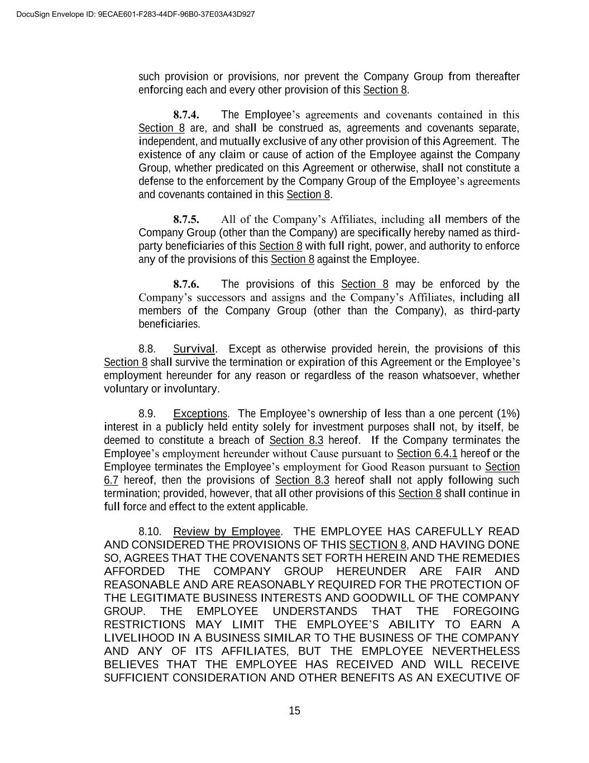
15 such provision or provisions, nor prevent the Company Group from thereafter enforcing each and every other provision of this Section 8. 8.7.4. The Employee’s agreements and covenants contained in this Section 8 are, and shall be construed as, agreements and covenants separate, independent, and mutually exclusive of any other provision of this Agreement. The existence of any claim or cause of action of the Employee against the Company Group, whether predicated on this Agreement or otherwise, shall not constitute a defense to the enforcement by the Company Group of the Employee’s agreements and covenants contained in this Section 8. 8.7.5. All of the Company’s Affiliates, including all members of the Company Group (other than the Company) are specifically hereby named as third- party beneficiaries of this Section 8 with full right, power, and authority to enforce any of the provisions of this Section 8 against the Employee. 8.7.6. The provisions of this Section 8 may be enforced by the Company’s successors and assigns and the Company’s Affiliates, including all members of the Company Group (other than the Company), as third-party beneficiaries. 8.8. Survival. Except as otherwise provided herein, the provisions of this Section 8 shall survive the termination or expiration of this Agreement or the Employee’s employment hereunder for any reason or regardless of the reason whatsoever, whether voluntary or involuntary. 8.9. Exceptions. The Employee’s ownership of less than a one percent (1%) interest in a publicly held entity solely for investment purposes shall not, by itself, be deemed to constitute a breach of Section 8.3 hereof. If the Company terminates the Employee’s employment hereunder without Cause pursuant to Section 6.4.1 hereof or the Employee terminates the Employee’s employment for Good Reason pursuant to Section 6.7 hereof, then the provisions of Section 8.3 hereof shall not apply following such termination; provided, however, that all other provisions of this Section 8 shall continue in full force and effect to the extent applicable. 8.10. Review by Employee. THE EMPLOYEE HAS CAREFULLY READ AND CONSIDERED THE PROVISIONS OF THIS SECTION 8, AND HAVING DONE SO, AGREES THAT THE COVENANTS SET FORTH HEREIN AND THE REMEDIES AFFORDED THE COMPANY GROUP HEREUNDER ARE FAIR AND REASONABLE AND ARE REASONABLY REQUIRED FOR THE PROTECTION OF THE LEGITIMATE BUSINESS INTERESTS AND GOODWILL OF THE COMPANY GROUP. THE EMPLOYEE UNDERSTANDS THAT THE FOREGOING RESTRICTIONS MAY LIMIT THE EMPLOYEE’S ABILITY TO EARN A LIVELIHOOD IN A BUSINESS SIMILAR TO THE BUSINESS OF THE COMPANY AND ANY OF ITS AFFILIATES, BUT THE EMPLOYEE NEVERTHELESS BELIEVES THAT THE EMPLOYEE HAS RECEIVED AND WILL RECEIVE SUFFICIENT CONSIDERATION AND OTHER BENEFITS AS AN EXECUTIVE OF DocuSign Envelope ID: 9ECAE601-F283-44DF-96B0-37E03A43D927

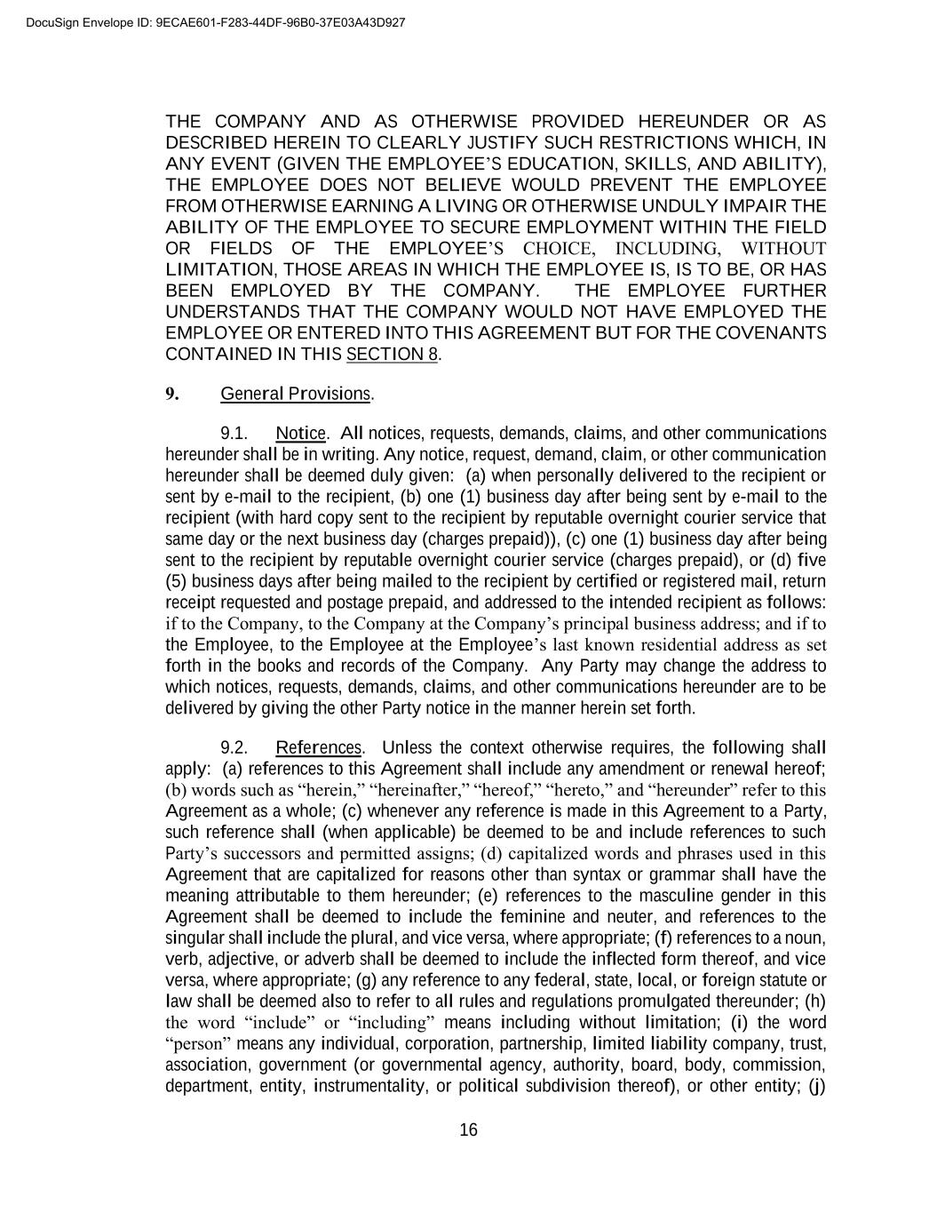
16 THE COMPANY AND AS OTHERWISE PROVIDED HEREUNDER OR AS DESCRIBED HEREIN TO CLEARLY JUSTIFY SUCH RESTRICTIONS WHICH, IN ANY EVENT (GIVEN THE EMPLOYEE’S EDUCATION, SKILLS, AND ABILITY), THE EMPLOYEE DOES NOT BELIEVE WOULD PREVENT THE EMPLOYEE FROM OTHERWISE EARNING A LIVING OR OTHERWISE UNDULY IMPAIR THE ABILITY OF THE EMPLOYEE TO SECURE EMPLOYMENT WITHIN THE FIELD OR FIELDS OF THE EMPLOYEE’S CHOICE, INCLUDING, WITHOUT LIMITATION, THOSE AREAS IN WHICH THE EMPLOYEE IS, IS TO BE, OR HAS BEEN EMPLOYED BY THE COMPANY. THE EMPLOYEE FURTHER UNDERSTANDS THAT THE COMPANY WOULD NOT HAVE EMPLOYED THE EMPLOYEE OR ENTERED INTO THIS AGREEMENT BUT FOR THE COVENANTS CONTAINED IN THIS SECTION 8. 9. General Provisions. 9.1. Notice. All notices, requests, demands, claims, and other communications hereunder shall be in writing. Any notice, request, demand, claim, or other communication hereunder shall be deemed duly given: (a) when personally delivered to the recipient or sent by e-mail to the recipient, (b) one (1) business day after being sent by e-mail to the recipient (with hard copy sent to the recipient by reputable overnight courier service that same day or the next business day (charges prepaid)), (c) one (1) business day after being sent to the recipient by reputable overnight courier service (charges prepaid), or (d) five (5) business days after being mailed to the recipient by certified or registered mail, return receipt requested and postage prepaid, and addressed to the intended recipient as follows: if to the Company, to the Company at the Company’s principal business address; and if to the Employee, to the Employee at the Employee’s last known residential address as set forth in the books and records of the Company. Any Party may change the address to which notices, requests, demands, claims, and other communications hereunder are to be delivered by giving the other Party notice in the manner herein set forth. 9.2. References. Unless the context otherwise requires, the following shall apply: (a) references to this Agreement shall include any amendment or renewal hereof; (b) words such as “herein,” “hereinafter,” “hereof,” “hereto,” and “hereunder” refer to this Agreement as a whole; (c) whenever any reference is made in this Agreement to a Party, such reference shall (when applicable) be deemed to be and include references to such Party’s successors and permitted assigns; (d) capitalized words and phrases used in this Agreement that are capitalized for reasons other than syntax or grammar shall have the meaning attributable to them hereunder; (e) references to the masculine gender in this Agreement shall be deemed to include the feminine and neuter, and references to the singular shall include the plural, and vice versa, where appropriate; (f) references to a noun, verb, adjective, or adverb shall be deemed to include the inflected form thereof, and vice versa, where appropriate; (g) any reference to any federal, state, local, or foreign statute or law shall be deemed also to refer to all rules and regulations promulgated thereunder; (h) the word “include” or “including” means including without limitation; (i) the word “person” means any individual, corporation, partnership, limited liability company, trust, association, government (or governmental agency, authority, board, body, commission, department, entity, instrumentality, or political subdivision thereof), or other entity; (j) DocuSign Envelope ID: 9ECAE601-F283-44DF-96B0-37E03A43D927

17 where any provision in this Agreement refers to any action to be taken by any person or entity, or which such person or entity is prohibited from taking, such provision shall be applicable whether such action is taken directly or indirectly by such person or entity; (k) “or” is used in the inclusive sense of “and/or”; (l) whenever any reference is made in this Agreement to the phrase “calendar year,” such reference is intended to be a reference to the twelve (12) month period beginning as of January 1 and ending as of December 31; (m) whenever any reference is made in this Agreement to the phrase “year of the Employment Term” or similar phrase without any qualification to “calendar year,” such reference is intended to be a reference to (i) the twelve (12) month period beginning on the Commencement Date of the Employee’s employment hereunder, or (ii) any subsequent twelve (12) month period during the Employment Term commencing on each anniversary of such Commencement Date; and (n) the term “business day” or any variation thereof means a day other than a Saturday, Sunday, or legal holiday in the state of Florida. 9.3. Entire Agreement. Except as otherwise specifically provided or incorporated herein, this Agreement constitutes the entire agreement of the Parties regarding the subject matter hereof and supersedes (a) any express or implied prior or contemporaneous statement, representation, warranty, understanding, agreement, or arrangement, whether oral, written, or otherwise, and (b) any omission to state or disclose a fact, material or otherwise, in each case made or omitted by any Party or by and between the Parties with respect to such subject matter hereof. 9.4. Binding Effect; Benefit. This Agreement shall be binding upon, and inure to the benefit of, the Parties and their respective successors and permitted assigns. 9.5. Assignment. This Agreement is personal to the Employee, and the Employee may not assign this Agreement or any of the Employee’s rights, interests, or obligations hereunder. The Company may (a) assign this Agreement or any of the Company’s rights or interests hereunder to any person or entity as collateral or security for any indebtedness of the Company; (b) assign any or all of the Company’s rights or interest hereunder, or delegate any or all of the Company’s obligations hereunder, to one or more of the Company’s Affiliates or successor entities, or (c) assign this Agreement or any or all of the Company’s rights, interests, or obligations hereunder to any person or entity in connection with or with respect to a transfer, sale, exchange, or other disposition of the Company or all or substantially all of its business or assets, whether directly or indirectly, or whether by way of purchase, sale, reorganization, merger, or consolidation, or whether by operation of law or otherwise. 9.6. No Third-Party Beneficiaries. Except as otherwise provided herein, this Agreement shall not confer any rights or remedies upon any person or entity other than the Parties and their respective successors and permitted assigns. 9.7. Amendment. No provision of this Agreement may be modified or amended unless such modification or amendment is agreed to in writing and signed by the Parties. DocuSign Envelope ID: 9ECAE601-F283-44DF-96B0-37E03A43D927

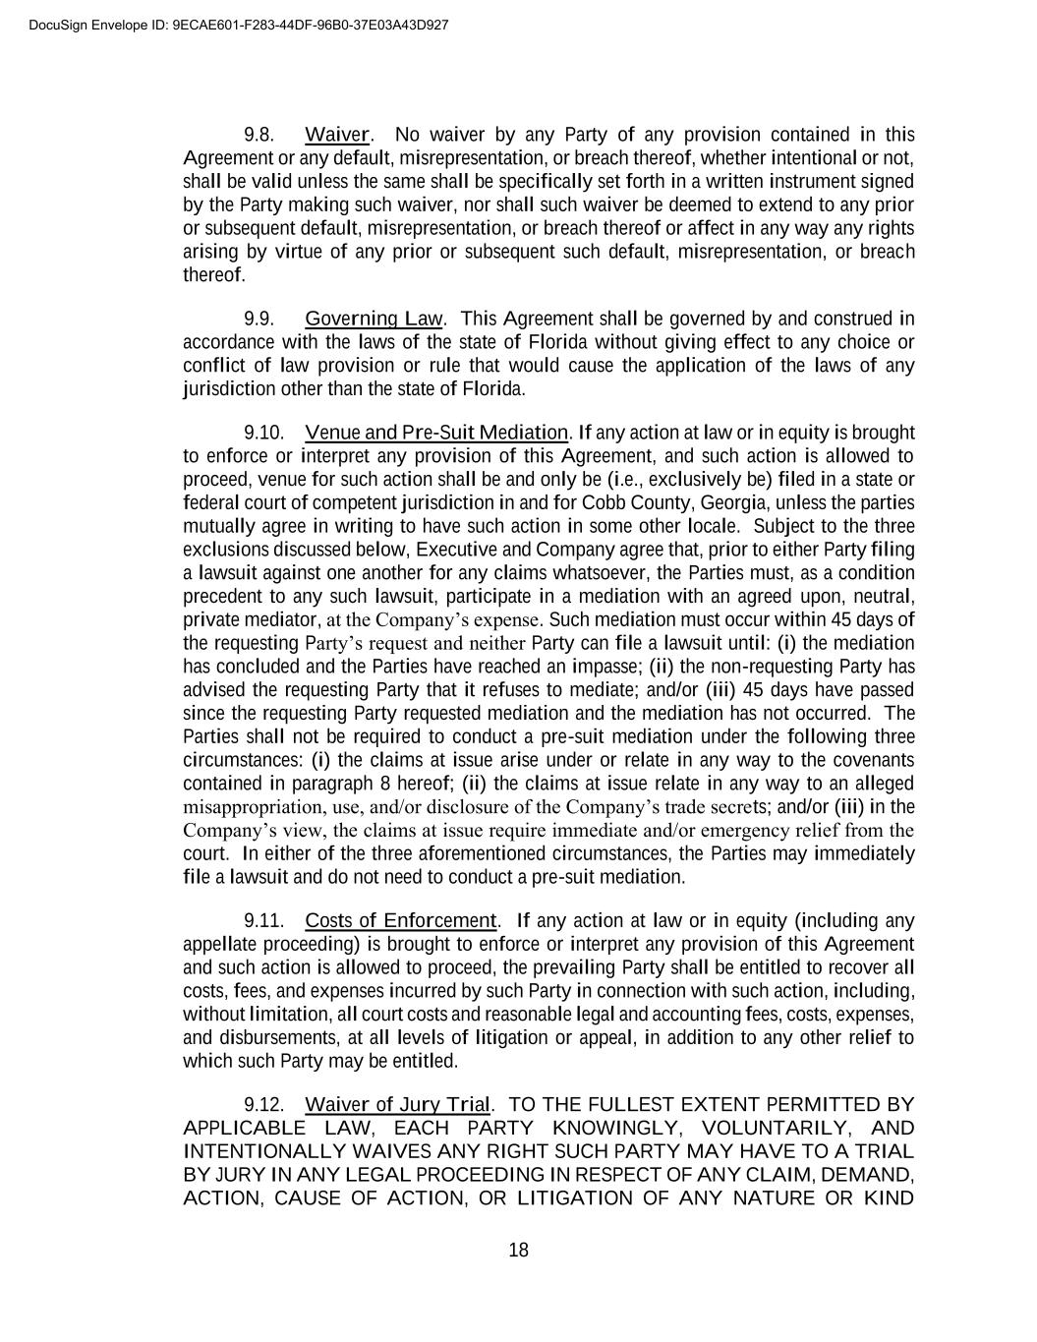
18 9.8. Waiver. No waiver by any Party of any provision contained in this Agreement or any default, misrepresentation, or breach thereof, whether intentional or not, shall be valid unless the same shall be specifically set forth in a written instrument signed by the Party making such waiver, nor shall such waiver be deemed to extend to any prior or subsequent default, misrepresentation, or breach thereof or affect in any way any rights arising by virtue of any prior or subsequent such default, misrepresentation, or breach thereof. 9.9. Governing Law. This Agreement shall be governed by and construed in accordance with the laws of the state of Florida without giving effect to any choice or conflict of law provision or rule that would cause the application of the laws of any jurisdiction other than the state of Florida. 9.10. Venue and Pre-Suit Mediation. If any action at law or in equity is brought to enforce or interpret any provision of this Agreement, and such action is allowed to proceed, venue for such action shall be and only be (i.e., exclusively be) filed in a state or federal court of competent jurisdiction in and for Cobb County, Georgia, unless the parties mutually agree in writing to have such action in some other locale. Subject to the three exclusions discussed below, Executive and Company agree that, prior to either Party filing a lawsuit against one another for any claims whatsoever, the Parties must, as a condition precedent to any such lawsuit, participate in a mediation with an agreed upon, neutral, private mediator, at the Company’s expense. Such mediation must occur within 45 days of the requesting Party’s request and neither Party can file a lawsuit until: (i) the mediation has concluded and the Parties have reached an impasse; (ii) the non-requesting Party has advised the requesting Party that it refuses to mediate; and/or (iii) 45 days have passed since the requesting Party requested mediation and the mediation has not occurred. The Parties shall not be required to conduct a pre-suit mediation under the following three circumstances: (i) the claims at issue arise under or relate in any way to the covenants contained in paragraph 8 hereof; (ii) the claims at issue relate in any way to an alleged misappropriation, use, and/or disclosure of the Company’s trade secrets; and/or (iii) in the Company’s view, the claims at issue require immediate and/or emergency relief from the court. In either of the three aforementioned circumstances, the Parties may immediately file a lawsuit and do not need to conduct a pre-suit mediation. 9.11. Costs of Enforcement. If any action at law or in equity (including any appellate proceeding) is brought to enforce or interpret any provision of this Agreement and such action is allowed to proceed, the prevailing Party shall be entitled to recover all costs, fees, and expenses incurred by such Party in connection with such action, including, without limitation, all court costs and reasonable legal and accounting fees, costs, expenses, and disbursements, at all levels of litigation or appeal, in addition to any other relief to which such Party may be entitled. 9.12. Waiver of Jury Trial. TO THE FULLEST EXTENT PERMITTED BY APPLICABLE LAW, EACH PARTY KNOWINGLY, VOLUNTARILY, AND INTENTIONALLY WAIVES ANY RIGHT SUCH PARTY MAY HAVE TO A TRIAL BY JURY IN ANY LEGAL PROCEEDING IN RESPECT OF ANY CLAIM, DEMAND, ACTION, CAUSE OF ACTION, OR LITIGATION OF ANY NATURE OR KIND DocuSign Envelope ID: 9ECAE601-F283-44DF-96B0-37E03A43D927

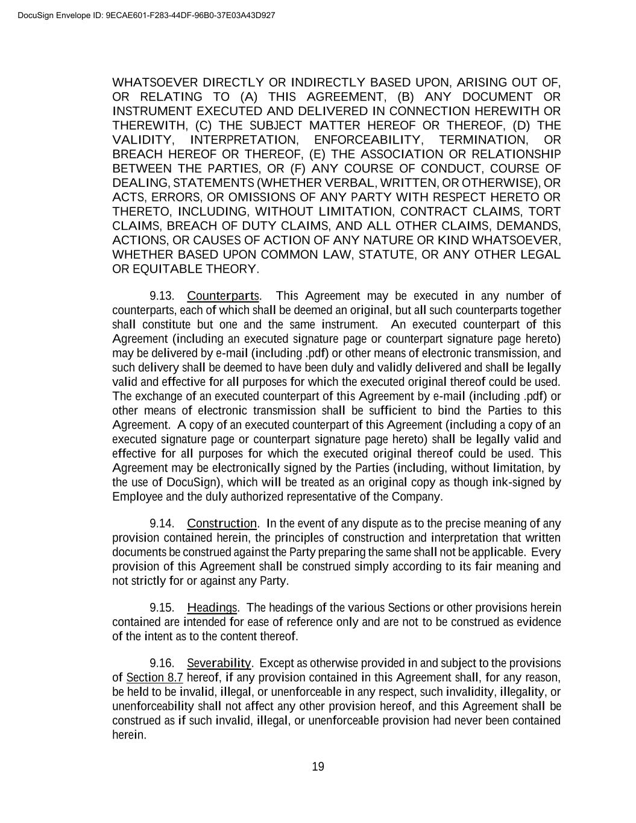
19 WHATSOEVER DIRECTLY OR INDIRECTLY BASED UPON, ARISING OUT OF, OR RELATING TO (A) THIS AGREEMENT, (B) ANY DOCUMENT OR INSTRUMENT EXECUTED AND DELIVERED IN CONNECTION HEREWITH OR THEREWITH, (C) THE SUBJECT MATTER HEREOF OR THEREOF, (D) THE VALIDITY, INTERPRETATION, ENFORCEABILITY, TERMINATION, OR BREACH HEREOF OR THEREOF, (E) THE ASSOCIATION OR RELATIONSHIP BETWEEN THE PARTIES, OR (F) ANY COURSE OF CONDUCT, COURSE OF DEALING, STATEMENTS (WHETHER VERBAL, WRITTEN, OR OTHERWISE), OR ACTS, ERRORS, OR OMISSIONS OF ANY PARTY WITH RESPECT HERETO OR THERETO, INCLUDING, WITHOUT LIMITATION, CONTRACT CLAIMS, TORT CLAIMS, BREACH OF DUTY CLAIMS, AND ALL OTHER CLAIMS, DEMANDS, ACTIONS, OR CAUSES OF ACTION OF ANY NATURE OR KIND WHATSOEVER, WHETHER BASED UPON COMMON LAW, STATUTE, OR ANY OTHER LEGAL OR EQUITABLE THEORY. 9.13. Counterparts. This Agreement may be executed in any number of counterparts, each of which shall be deemed an original, but all such counterparts together shall constitute but one and the same instrument. An executed counterpart of this Agreement (including an executed signature page or counterpart signature page hereto) may be delivered by e-mail (including .pdf) or other means of electronic transmission, and such delivery shall be deemed to have been duly and validly delivered and shall be legally valid and effective for all purposes for which the executed original thereof could be used. The exchange of an executed counterpart of this Agreement by e-mail (including .pdf) or other means of electronic transmission shall be sufficient to bind the Parties to this Agreement. A copy of an executed counterpart of this Agreement (including a copy of an executed signature page or counterpart signature page hereto) shall be legally valid and effective for all purposes for which the executed original thereof could be used. This Agreement may be electronically signed by the Parties (including, without limitation, by the use of DocuSign), which will be treated as an original copy as though ink-signed by Employee and the duly authorized representative of the Company. 9.14. Construction. In the event of any dispute as to the precise meaning of any provision contained herein, the principles of construction and interpretation that written documents be construed against the Party preparing the same shall not be applicable. Every provision of this Agreement shall be construed simply according to its fair meaning and not strictly for or against any Party. 9.15. Headings. The headings of the various Sections or other provisions herein contained are intended for ease of reference only and are not to be construed as evidence of the intent as to the content thereof. 9.16. Severability. Except as otherwise provided in and subject to the provisions of Section 8.7 hereof, if any provision contained in this Agreement shall, for any reason, be held to be invalid, illegal, or unenforceable in any respect, such invalidity, illegality, or unenforceability shall not affect any other provision hereof, and this Agreement shall be construed as if such invalid, illegal, or unenforceable provision had never been contained herein. DocuSign Envelope ID: 9ECAE601-F283-44DF-96B0-37E03A43D927

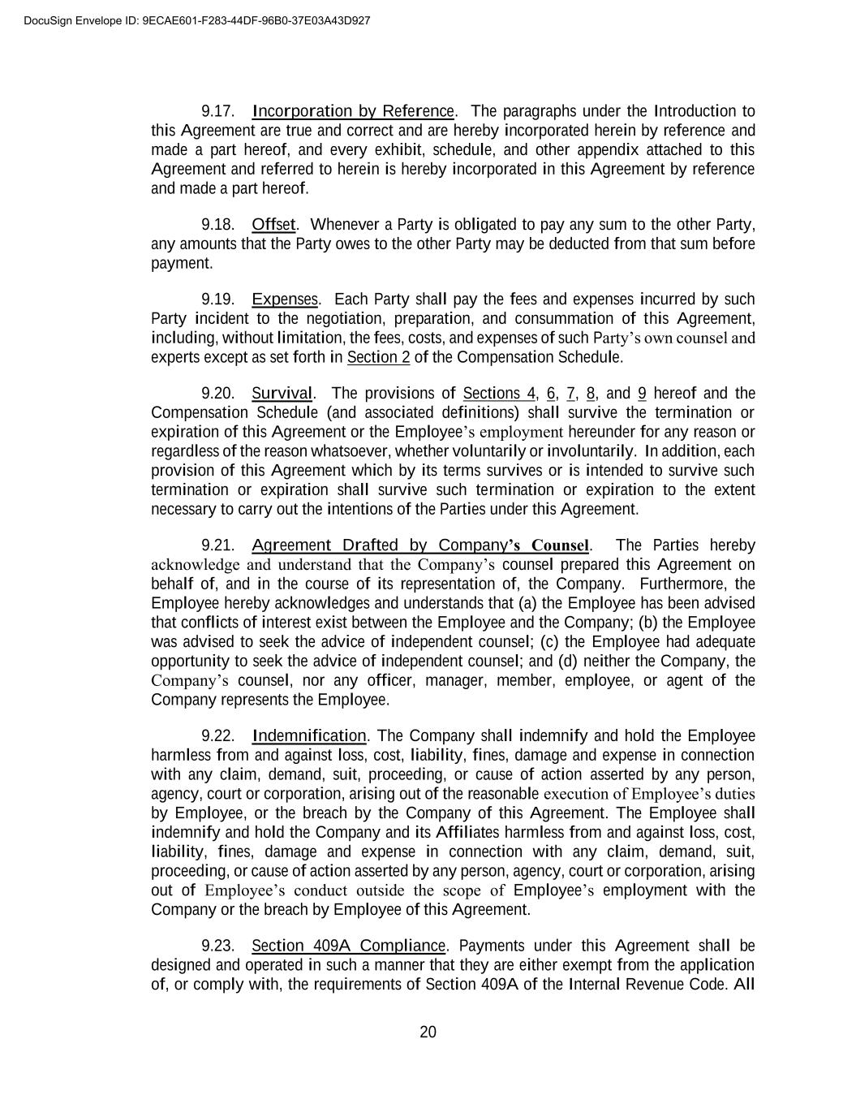
20 9.17. Incorporation by Reference. The paragraphs under the Introduction to this Agreement are true and correct and are hereby incorporated herein by reference and made a part hereof, and every exhibit, schedule, and other appendix attached to this Agreement and referred to herein is hereby incorporated in this Agreement by reference and made a part hereof. 9.18. Offset. Whenever a Party is obligated to pay any sum to the other Party, any amounts that the Party owes to the other Party may be deducted from that sum before payment. 9.19. Expenses. Each Party shall pay the fees and expenses incurred by such Party incident to the negotiation, preparation, and consummation of this Agreement, including, without limitation, the fees, costs, and expenses of such Party’s own counsel and experts except as set forth in Section 2 of the Compensation Schedule. 9.20. Survival. The provisions of Sections 4, 6, 7, 8, and 9 hereof and the Compensation Schedule (and associated definitions) shall survive the termination or expiration of this Agreement or the Employee’s employment hereunder for any reason or regardless of the reason whatsoever, whether voluntarily or involuntarily. In addition, each provision of this Agreement which by its terms survives or is intended to survive such termination or expiration shall survive such termination or expiration to the extent necessary to carry out the intentions of the Parties under this Agreement. 9.21. Agreement Drafted by Company’s Counsel. The Parties hereby acknowledge and understand that the Company’s counsel prepared this Agreement on behalf of, and in the course of its representation of, the Company. Furthermore, the Employee hereby acknowledges and understands that (a) the Employee has been advised that conflicts of interest exist between the Employee and the Company; (b) the Employee was advised to seek the advice of independent counsel; (c) the Employee had adequate opportunity to seek the advice of independent counsel; and (d) neither the Company, the Company’s counsel, nor any officer, manager, member, employee, or agent of the Company represents the Employee. 9.22. Indemnification. The Company shall indemnify and hold the Employee harmless from and against loss, cost, liability, fines, damage and expense in connection with any claim, demand, suit, proceeding, or cause of action asserted by any person, agency, court or corporation, arising out of the reasonable execution of Employee’s duties by Employee, or the breach by the Company of this Agreement. The Employee shall indemnify and hold the Company and its Affiliates harmless from and against loss, cost, liability, fines, damage and expense in connection with any claim, demand, suit, proceeding, or cause of action asserted by any person, agency, court or corporation, arising out of Employee’s conduct outside the scope of Employee’s employment with the Company or the breach by Employee of this Agreement. 9.23. Section 409A Compliance. Payments under this Agreement shall be designed and operated in such a manner that they are either exempt from the application of, or comply with, the requirements of Section 409A of the Internal Revenue Code. All DocuSign Envelope ID: 9ECAE601-F283-44DF-96B0-37E03A43D927


21 payments shall be, under all circumstances, deemed to come from an unfunded plan. All payments subject to Section 409A will not be accelerated in time or schedule. [Signature Page Follows] DocuSign Envelope ID: 9ECAE601-F283-44DF-96B0-37E03A43D927

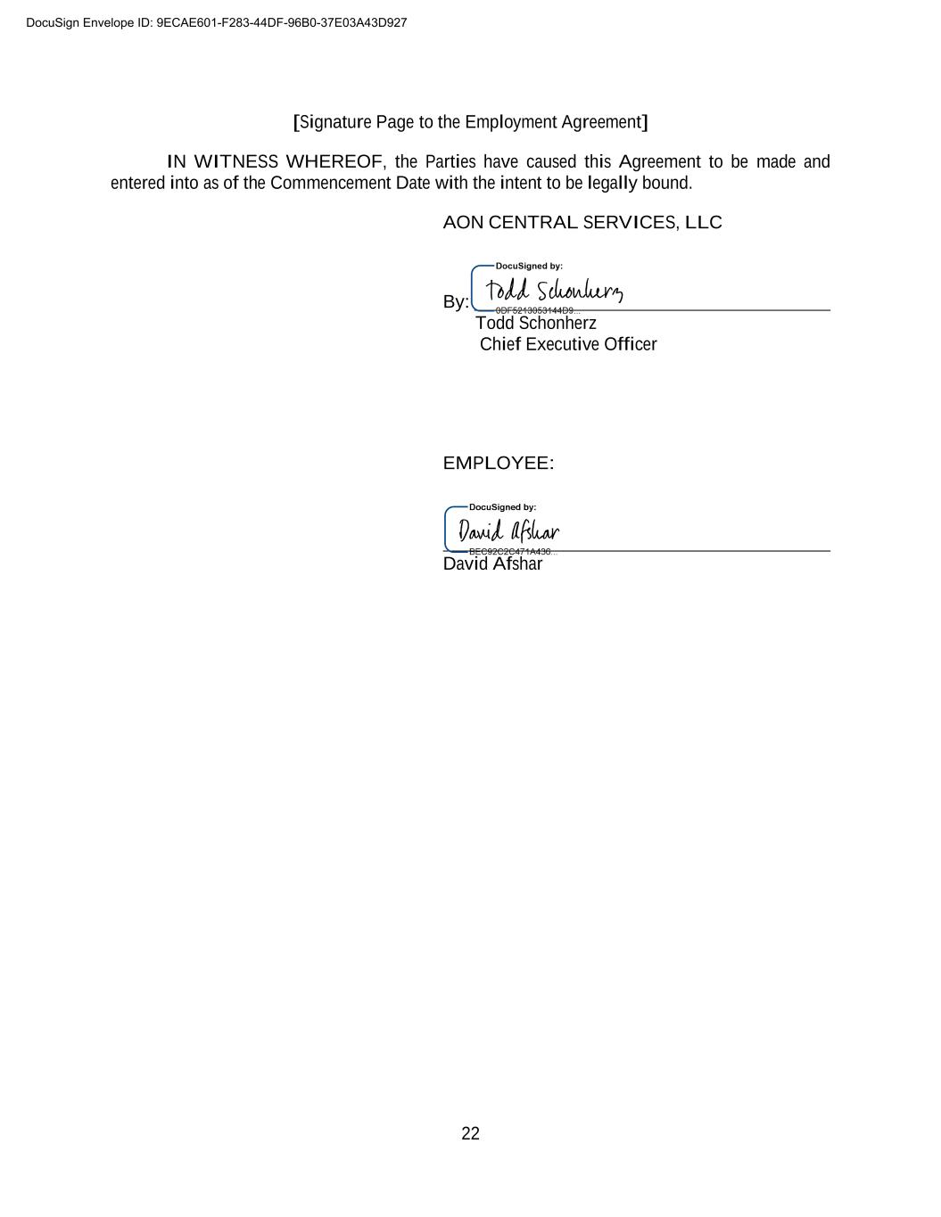
22 [Signature Page to the Employment Agreement] IN WITNESS WHEREOF, the Parties have caused this Agreement to be made and entered into as of the Commencement Date with the intent to be legally bound. AON CENTRAL SERVICES, LLC By: Todd Schonherz Chief Executive Officer EMPLOYEE: David Afshar DocuSign Envelope ID: 9ECAE601-F283-44DF-96B0-37E03A43D927

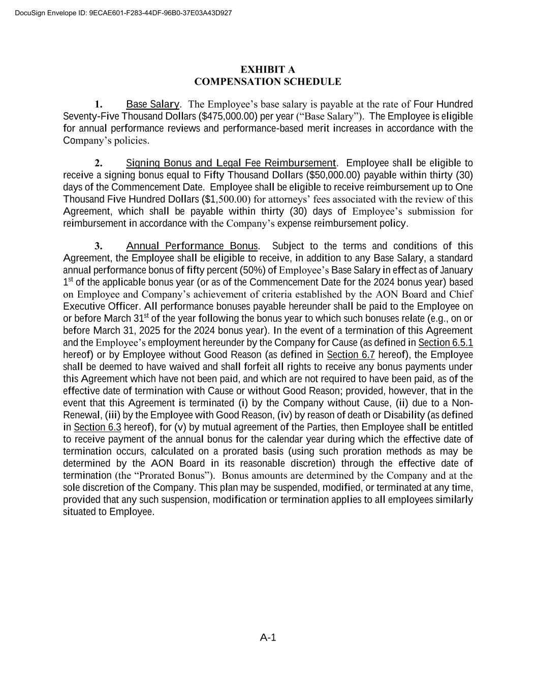
A-1 EXHIBIT A COMPENSATION SCHEDULE 1. Base Salary. The Employee’s base salary is payable at the rate of Four Hundred Seventy-Five Thousand Dollars ($475,000.00) per year (“Base Salary”). The Employee is eligible for annual performance reviews and performance-based merit increases in accordance with the Company’s policies. 2. Signing Bonus and Legal Fee Reimbursement. Employee shall be eligible to receive a signing bonus equal to Fifty Thousand Dollars ($50,000.00) payable within thirty (30) days of the Commencement Date. Employee shall be eligible to receive reimbursement up to One Thousand Five Hundred Dollars ($1,500.00) for attorneys’ fees associated with the review of this Agreement, which shall be payable within thirty (30) days of Employee’s submission for reimbursement in accordance with the Company’s expense reimbursement policy. 3. Annual Performance Bonus. Subject to the terms and conditions of this Agreement, the Employee shall be eligible to receive, in addition to any Base Salary, a standard annual performance bonus of fifty percent (50%) of Employee’s Base Salary in effect as of January 1st of the applicable bonus year (or as of the Commencement Date for the 2024 bonus year) based on Employee and Company’s achievement of criteria established by the AON Board and Chief Executive Officer. All performance bonuses payable hereunder shall be paid to the Employee on or before March 31st of the year following the bonus year to which such bonuses relate (e.g., on or before March 31, 2025 for the 2024 bonus year). In the event of a termination of this Agreement and the Employee’s employment hereunder by the Company for Cause (as defined in Section 6.5.1 hereof) or by Employee without Good Reason (as defined in Section 6.7 hereof), the Employee shall be deemed to have waived and shall forfeit all rights to receive any bonus payments under this Agreement which have not been paid, and which are not required to have been paid, as of the effective date of termination with Cause or without Good Reason; provided, however, that in the event that this Agreement is terminated (i) by the Company without Cause, (ii) due to a Non- Renewal, (iii) by the Employee with Good Reason, (iv) by reason of death or Disability (as defined in Section 6.3 hereof), for (v) by mutual agreement of the Parties, then Employee shall be entitled to receive payment of the annual bonus for the calendar year during which the effective date of termination occurs, calculated on a prorated basis (using such proration methods as may be determined by the AON Board in its reasonable discretion) through the effective date of termination (the “Prorated Bonus”). Bonus amounts are determined by the Company and at the sole discretion of the Company. This plan may be suspended, modified, or terminated at any time, provided that any such suspension, modification or termination applies to all employees similarly situated to Employee. DocuSign Envelope ID: 9ECAE601-F283-44DF-96B0-37E03A43D927

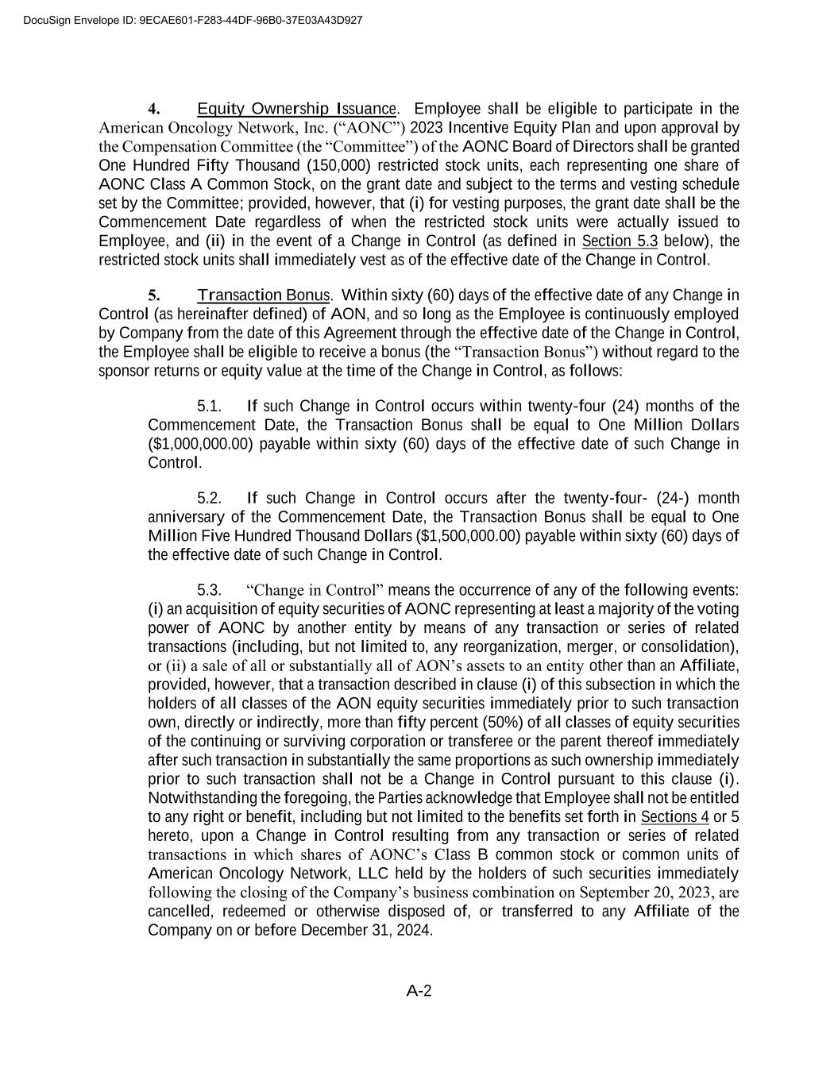
A-2 4. Equity Ownership Issuance. Employee shall be eligible to participate in the American Oncology Network, Inc. (“AONC”) 2023 Incentive Equity Plan and upon approval by the Compensation Committee (the “Committee”) of the AONC Board of Directors shall be granted One Hundred Fifty Thousand (150,000) restricted stock units, each representing one share of AONC Class A Common Stock, on the grant date and subject to the terms and vesting schedule set by the Committee; provided, however, that (i) for vesting purposes, the grant date shall be the Commencement Date regardless of when the restricted stock units were actually issued to Employee, and (ii) in the event of a Change in Control (as defined in Section 5.3 below), the restricted stock units shall immediately vest as of the effective date of the Change in Control. 5. Transaction Bonus. Within sixty (60) days of the effective date of any Change in Control (as hereinafter defined) of AON, and so long as the Employee is continuously employed by Company from the date of this Agreement through the effective date of the Change in Control, the Employee shall be eligible to receive a bonus (the “Transaction Bonus”) without regard to the sponsor returns or equity value at the time of the Change in Control, as follows: 5.1. If such Change in Control occurs within twenty-four (24) months of the Commencement Date, the Transaction Bonus shall be equal to One Million Dollars ($1,000,000.00) payable within sixty (60) days of the effective date of such Change in Control. 5.2. If such Change in Control occurs after the twenty-four- (24-) month anniversary of the Commencement Date, the Transaction Bonus shall be equal to One Million Five Hundred Thousand Dollars ($1,500,000.00) payable within sixty (60) days of the effective date of such Change in Control. 5.3. “Change in Control” means the occurrence of any of the following events: (i) an acquisition of equity securities of AONC representing at least a majority of the voting power of AONC by another entity by means of any transaction or series of related transactions (including, but not limited to, any reorganization, merger, or consolidation), or (ii) a sale of all or substantially all of AON’s assets to an entity other than an Affiliate, provided, however, that a transaction described in clause (i) of this subsection in which the holders of all classes of the AON equity securities immediately prior to such transaction own, directly or indirectly, more than fifty percent (50%) of all classes of equity securities of the continuing or surviving corporation or transferee or the parent thereof immediately after such transaction in substantially the same proportions as such ownership immediately prior to such transaction shall not be a Change in Control pursuant to this clause (i). Notwithstanding the foregoing, the Parties acknowledge that Employee shall not be entitled to any right or benefit, including but not limited to the benefits set forth in Sections 4 or 5 hereto, upon a Change in Control resulting from any transaction or series of related transactions in which shares of AONC’s Class B common stock or common units of American Oncology Network, LLC held by the holders of such securities immediately following the closing of the Company’s business combination on September 20, 2023, are cancelled, redeemed or otherwise disposed of, or transferred to any Affiliate of the Company on or before December 31, 2024. DocuSign Envelope ID: 9ECAE601-F283-44DF-96B0-37E03A43D927

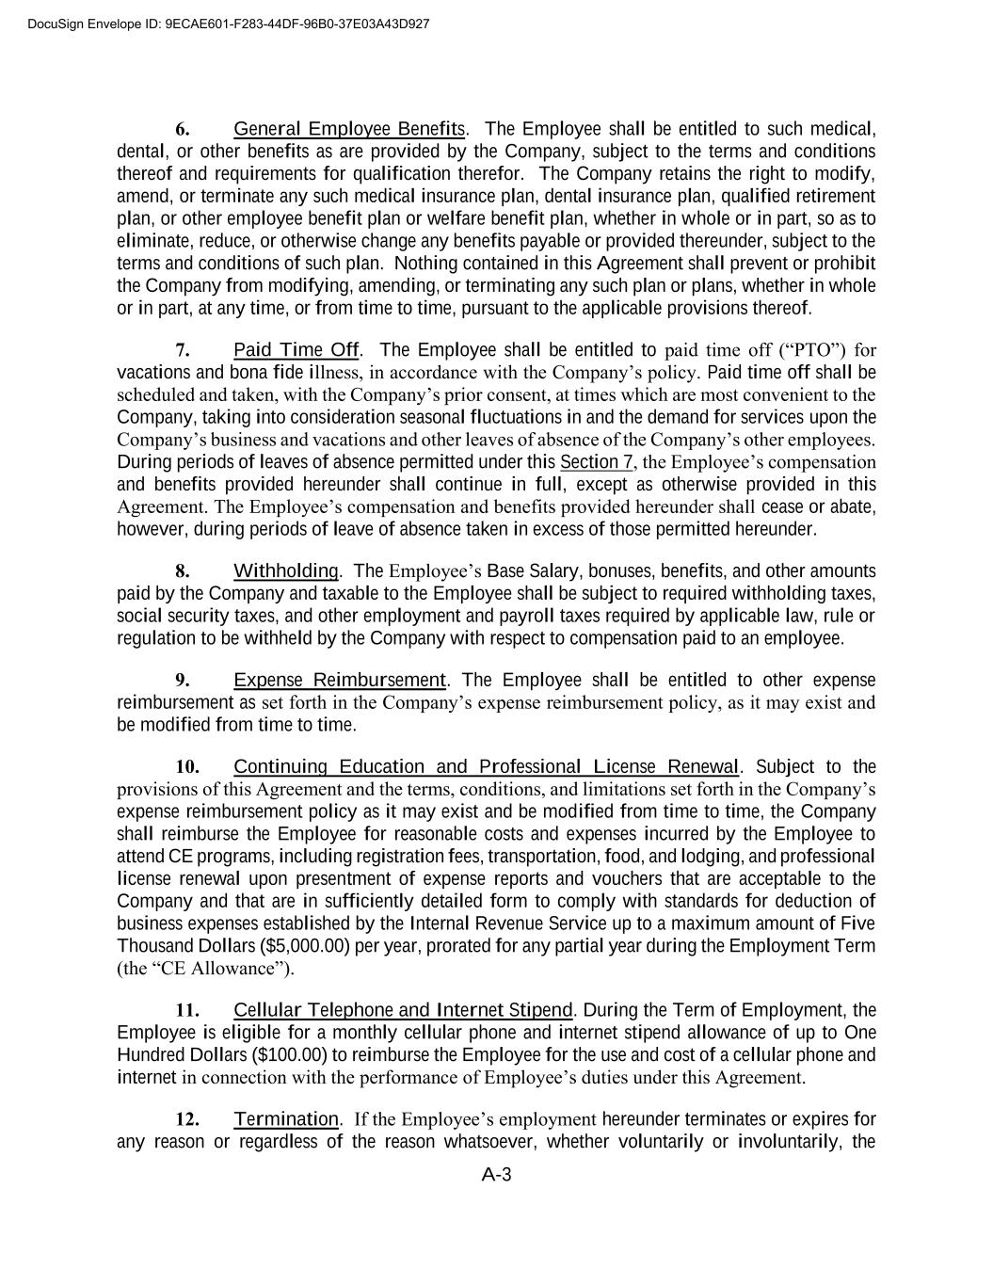
A-3 6. General Employee Benefits. The Employee shall be entitled to such medical, dental, or other benefits as are provided by the Company, subject to the terms and conditions thereof and requirements for qualification therefor. The Company retains the right to modify, amend, or terminate any such medical insurance plan, dental insurance plan, qualified retirement plan, or other employee benefit plan or welfare benefit plan, whether in whole or in part, so as to eliminate, reduce, or otherwise change any benefits payable or provided thereunder, subject to the terms and conditions of such plan. Nothing contained in this Agreement shall prevent or prohibit the Company from modifying, amending, or terminating any such plan or plans, whether in whole or in part, at any time, or from time to time, pursuant to the applicable provisions thereof. 7. Paid Time Off. The Employee shall be entitled to paid time off (“PTO”) for vacations and bona fide illness, in accordance with the Company’s policy. Paid time off shall be scheduled and taken, with the Company’s prior consent, at times which are most convenient to the Company, taking into consideration seasonal fluctuations in and the demand for services upon the Company’s business and vacations and other leaves of absence of the Company’s other employees. During periods of leaves of absence permitted under this Section 7, the Employee’s compensation and benefits provided hereunder shall continue in full, except as otherwise provided in this Agreement. The Employee’s compensation and benefits provided hereunder shall cease or abate, however, during periods of leave of absence taken in excess of those permitted hereunder. 8. Withholding. The Employee’s Base Salary, bonuses, benefits, and other amounts paid by the Company and taxable to the Employee shall be subject to required withholding taxes, social security taxes, and other employment and payroll taxes required by applicable law, rule or regulation to be withheld by the Company with respect to compensation paid to an employee. 9. Expense Reimbursement. The Employee shall be entitled to other expense reimbursement as set forth in the Company’s expense reimbursement policy, as it may exist and be modified from time to time. 10. Continuing Education and Professional License Renewal. Subject to the provisions of this Agreement and the terms, conditions, and limitations set forth in the Company’s expense reimbursement policy as it may exist and be modified from time to time, the Company shall reimburse the Employee for reasonable costs and expenses incurred by the Employee to attend CE programs, including registration fees, transportation, food, and lodging, and professional license renewal upon presentment of expense reports and vouchers that are acceptable to the Company and that are in sufficiently detailed form to comply with standards for deduction of business expenses established by the Internal Revenue Service up to a maximum amount of Five Thousand Dollars ($5,000.00) per year, prorated for any partial year during the Employment Term (the “CE Allowance”). 11. Cellular Telephone and Internet Stipend. During the Term of Employment, the Employee is eligible for a monthly cellular phone and internet stipend allowance of up to One Hundred Dollars ($100.00) to reimburse the Employee for the use and cost of a cellular phone and internet in connection with the performance of Employee’s duties under this Agreement. 12. Termination. If the Employee’s employment hereunder terminates or expires for any reason or regardless of the reason whatsoever, whether voluntarily or involuntarily, the DocuSign Envelope ID: 9ECAE601-F283-44DF-96B0-37E03A43D927


A-4 Company will pay the following to the Employee: (a) the accrued, but unpaid portion of the Base Salary payable (if any) to the Employee hereunder and (b) the Employee’s accrued, but unpaid or unused PTO, in each case prorated through the Employee’s effective date of termination or expiration of employment. Such amounts will be paid to the Employee as soon as administratively reasonable after such effective date of termination or expiration. Except as otherwise provided in this Compensation Schedule, any Base Salary, bonus, PTO benefits, or other amounts that would have accrued subsequent to such effective date of termination or expiration will abate. DocuSign Envelope ID: 9ECAE601-F283-44DF-96B0-37E03A43D927

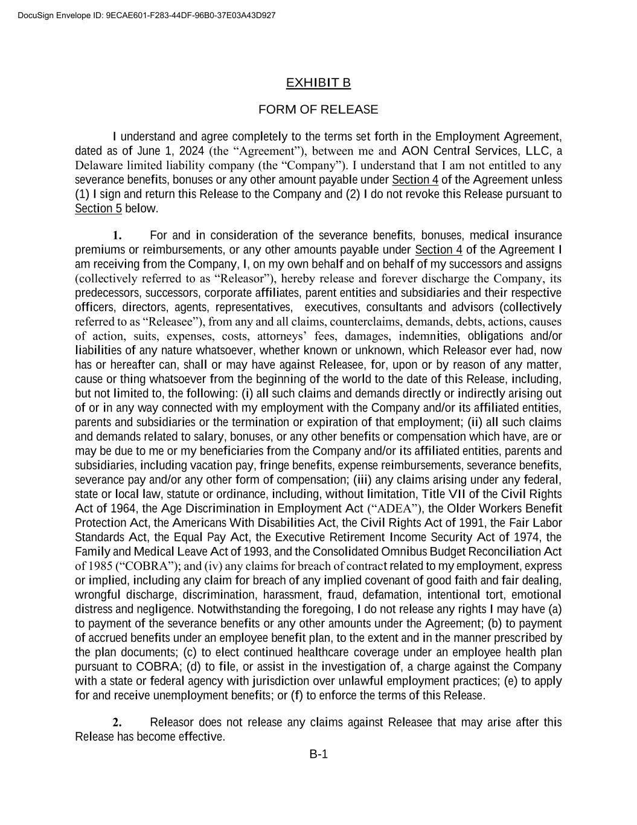
B-1 EXHIBIT B FORM OF RELEASE I understand and agree completely to the terms set forth in the Employment Agreement, dated as of June 1, 2024 (the “Agreement”), between me and AON Central Services, LLC, a Delaware limited liability company (the “Company”). I understand that I am not entitled to any severance benefits, bonuses or any other amount payable under Section 4 of the Agreement unless (1) I sign and return this Release to the Company and (2) I do not revoke this Release pursuant to Section 5 below. 1. For and in consideration of the severance benefits, bonuses, medical insurance premiums or reimbursements, or any other amounts payable under Section 4 of the Agreement I am receiving from the Company, I, on my own behalf and on behalf of my successors and assigns (collectively referred to as “Releasor”), hereby release and forever discharge the Company, its predecessors, successors, corporate affiliates, parent entities and subsidiaries and their respective officers, directors, agents, representatives, executives, consultants and advisors (collectively referred to as “Releasee”), from any and all claims, counterclaims, demands, debts, actions, causes of action, suits, expenses, costs, attorneys’ fees, damages, indemnities, obligations and/or liabilities of any nature whatsoever, whether known or unknown, which Releasor ever had, now has or hereafter can, shall or may have against Releasee, for, upon or by reason of any matter, cause or thing whatsoever from the beginning of the world to the date of this Release, including, but not limited to, the following: (i) all such claims and demands directly or indirectly arising out of or in any way connected with my employment with the Company and/or its affiliated entities, parents and subsidiaries or the termination or expiration of that employment; (ii) all such claims and demands related to salary, bonuses, or any other benefits or compensation which have, are or may be due to me or my beneficiaries from the Company and/or its affiliated entities, parents and subsidiaries, including vacation pay, fringe benefits, expense reimbursements, severance benefits, severance pay and/or any other form of compensation; (iii) any claims arising under any federal, state or local law, statute or ordinance, including, without limitation, Title VII of the Civil Rights Act of 1964, the Age Discrimination in Employment Act (“ADEA”), the Older Workers Benefit Protection Act, the Americans With Disabilities Act, the Civil Rights Act of 1991, the Fair Labor Standards Act, the Equal Pay Act, the Executive Retirement Income Security Act of 1974, the Family and Medical Leave Act of 1993, and the Consolidated Omnibus Budget Reconciliation Act of 1985 (“COBRA”); and (iv) any claims for breach of contract related to my employment, express or implied, including any claim for breach of any implied covenant of good faith and fair dealing, wrongful discharge, discrimination, harassment, fraud, defamation, intentional tort, emotional distress and negligence. Notwithstanding the foregoing, I do not release any rights I may have (a) to payment of the severance benefits or any other amounts under the Agreement; (b) to payment of accrued benefits under an employee benefit plan, to the extent and in the manner prescribed by the plan documents; (c) to elect continued healthcare coverage under an employee health plan pursuant to COBRA; (d) to file, or assist in the investigation of, a charge against the Company with a state or federal agency with jurisdiction over unlawful employment practices; (e) to apply for and receive unemployment benefits; or (f) to enforce the terms of this Release. 2. Releasor does not release any claims against Releasee that may arise after this Release has become effective. DocuSign Envelope ID: 9ECAE601-F283-44DF-96B0-37E03A43D927

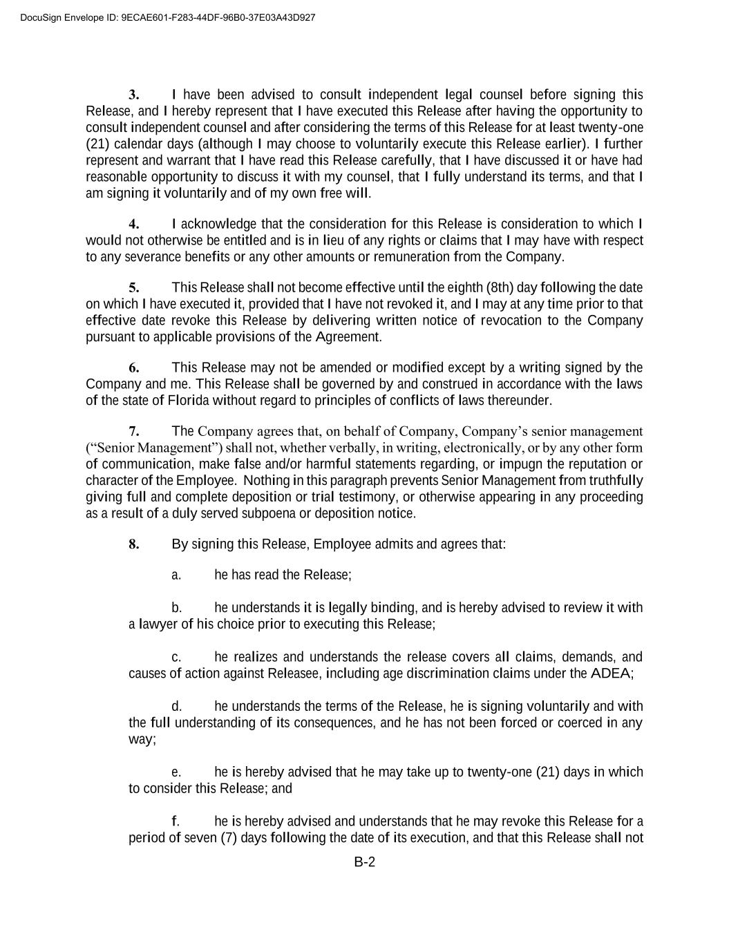
B-2 3. I have been advised to consult independent legal counsel before signing this Release, and I hereby represent that I have executed this Release after having the opportunity to consult independent counsel and after considering the terms of this Release for at least twenty-one (21) calendar days (although I may choose to voluntarily execute this Release earlier). I further represent and warrant that I have read this Release carefully, that I have discussed it or have had reasonable opportunity to discuss it with my counsel, that I fully understand its terms, and that I am signing it voluntarily and of my own free will. 4. I acknowledge that the consideration for this Release is consideration to which I would not otherwise be entitled and is in lieu of any rights or claims that I may have with respect to any severance benefits or any other amounts or remuneration from the Company. 5. This Release shall not become effective until the eighth (8th) day following the date on which I have executed it, provided that I have not revoked it, and I may at any time prior to that effective date revoke this Release by delivering written notice of revocation to the Company pursuant to applicable provisions of the Agreement. 6. This Release may not be amended or modified except by a writing signed by the Company and me. This Release shall be governed by and construed in accordance with the laws of the state of Florida without regard to principles of conflicts of laws thereunder. 7. The Company agrees that, on behalf of Company, Company’s senior management (“Senior Management”) shall not, whether verbally, in writing, electronically, or by any other form of communication, make false and/or harmful statements regarding, or impugn the reputation or character of the Employee. Nothing in this paragraph prevents Senior Management from truthfully giving full and complete deposition or trial testimony, or otherwise appearing in any proceeding as a result of a duly served subpoena or deposition notice. 8. By signing this Release, Employee admits and agrees that: a. he has read the Release; b. he understands it is legally binding, and is hereby advised to review it with a lawyer of his choice prior to executing this Release; c. he realizes and understands the release covers all claims, demands, and causes of action against Releasee, including age discrimination claims under the ADEA; d. he understands the terms of the Release, he is signing voluntarily and with the full understanding of its consequences, and he has not been forced or coerced in any way; e. he is hereby advised that he may take up to twenty-one (21) days in which to consider this Release; and f. he is hereby advised and understands that he may revoke this Release for a period of seven (7) days following the date of its execution, and that this Release shall not DocuSign Envelope ID: 9ECAE601-F283-44DF-96B0-37E03A43D927


B-3 become effective or enforceable until the revocation period has expired without its being revoked. Any such revocation under this Section must be in writing and delivered to Erica Mallon, General Counsel, by overnight delivery within seven (7) days following the date of execution of this Release. [Signature Page Follows] DocuSign Envelope ID: 9ECAE601-F283-44DF-96B0-37E03A43D927


B-4 Dated this _____ day of _______________20__. WITNESSES: Print Name: Print Name: ACKNOWLEDGEMENT STATE OF COUNTY OF On this ________ day of ___________________, 20__ before me, the undersigned officer, personally appeared _______________________, known to me (or satisfactorily proven) to be the person whose name is subscribed to the within instrument and acknowledged that he has executed the same for the purposes therein contained and acknowledged the same to be his free act and deed. In witness whereof, I have hereunto set my hand. Notary Public (Type/Print Name of Notary) My Commission Expires: Commission No.: DocuSign Envelope ID: 9ECAE601-F283-44DF-96B0-37E03A43D927

Exhibit 31.1

CERTIFICATION PURSUANT TO RULES 13a-14(a) AND 15d-14(a) UNDER THE SECURITIES EXCHANGE ACT OF 1934, AS ADOPTED PURSUANT TO SECTION 302 OF THE SARBANES-OXLEY ACT OF 2002

I, Todd Schonherz, certify that:

1.I have reviewed this Quarterly Report on Form 10-Q of American Oncology Network, Inc.;

2.Based on my knowledge, this report does not contain any untrue statement of a material fact or omit to state a material fact necessary to make the statements made, in light of the circumstances under which such statements were made, not misleading with respect to the period covered by this report;

3.Based on my knowledge, the financial statements, and other financial information included in this report, fairly present in all material respects the financial condition, results of operations and cash flows of the registrant as of, and for, the periods presented in this report;

4.The registrant’s other certifying officer(s) and I are responsible for establishing and maintaining disclosure controls and procedures (as defined in Exchange Act Rules 13a-15(e) and 15d-15(e)) and internal control over financial reporting (as defined in Exchange Act Rules 13a-15(f) and 15d-15(f)) for the registrant and have:
a)Designed such disclosure controls and procedures, or caused such disclosure controls and procedures to be designed under our supervision, to ensure that material information relating to the registrant, including its consolidated subsidiaries, is made known to us by others within those entities, particularly during the period in which this report is being prepared;
b)Designed such internal control over financial reporting, or caused such internal control over financial reporting to be designed under our supervision, to provide reasonable assurance regarding the reliability of financial reporting and the preparation of financial statements for external purposes in accordance with generally accepted accounting principles;
c)Evaluated the effectiveness of the registrant’s disclosure controls and procedures and presented in this report our conclusions about the effectiveness of the disclosure controls and procedures, as of the end of the period covered by this report based on such evaluation; and
d)Disclosed in this report any change in the registrant’s internal control over financial reporting that occurred during the registrant’s most recent fiscal quarter (the registrant’s fourth fiscal quarter in the case of an annual report) that has materially affected or is reasonably likely to materially affect, the registrant’s internal control over financial reporting; and

5. The registrant’s other certifying officer(s) and I have disclosed, based on our most recent evaluation of internal control over financial reporting, to the registrant’s auditors and the audit committee of the registrant’s board of directors (or persons performing the equivalent functions):
a)All significant deficiencies and material weaknesses in the design or operation of internal control over financial reporting which are reasonably likely to adversely affect the registrant’s ability to record, process, summarize and report financial information; and
b)Any fraud, whether or not material, that involves management or other employees who have a significant role in the registrant’s internal control over financial reporting

August 14, 2024

By: /s/ Todd Schonherz

Todd Schonherz
Chief Executive Officer

Exhibit 31.2

CERTIFICATION PURSUANT TO RULES 13a-14(a) AND 15d-14(a) UNDER THE SECURITIES EXCHANGE ACT OF 1934, AS ADOPTED PURSUANT TO SECTION 302 OF THE SARBANES-OXLEY ACT OF 2002

I, David Afshar, certify that:

1.I have reviewed this Quarterly Report on Form 10-Q of American Oncology Network, Inc.;

2.Based on my knowledge, this report does not contain any untrue statement of a material fact or omit to state a material fact necessary to make the statements made, in light of the circumstances under which such statements were made, not misleading with respect to the period covered by this report;

3.Based on my knowledge, the financial statements, and other financial information included in this report, fairly present in all material respects the financial condition, results of operations and cash flows of the registrant as of, and for, the periods presented in this report;

4.The registrant’s other certifying officer(s) and I are responsible for establishing and maintaining disclosure controls and procedures (as defined in Exchange Act Rules 13a-15(e) and 15d-15(e)) and internal control over financial reporting (as defined in Exchange Act Rules 13a-15(f) and 15d-15(f)) for the registrant and have:
a)Designed such disclosure controls and procedures, or caused such disclosure controls and procedures to be designed under our supervision, to ensure that material information relating to the registrant, including its consolidated subsidiaries, is made known to us by others within those entities, particularly during the period in which this report is being prepared;
b)Designed such internal control over financial reporting, or caused such internal control over financial reporting to be designed under our supervision, to provide reasonable assurance regarding the reliability of financial reporting and the preparation of financial statements for external purposes in accordance with generally accepted accounting principles;
c)Evaluated the effectiveness of the registrant’s disclosure controls and procedures and presented in this report our conclusions about the effectiveness of the disclosure controls and procedures, as of the end of the period covered by this report based on such evaluation; and
d)Disclosed in this report any change in the registrant’s internal control over financial reporting that occurred during the registrant’s most recent fiscal quarter (the registrant’s fourth fiscal quarter in the case of an annual report) that has materially affected or is reasonably likely to materially affect, the registrant’s internal control over financial reporting; and

5. The registrant’s other certifying officer(s) and I have disclosed, based on our most recent evaluation of internal control over financial reporting, to the registrant’s auditors and the audit committee of the registrant’s board of directors (or persons performing the equivalent functions):
a)All significant deficiencies and material weaknesses in the design or operation of internal control over financial reporting which are reasonably likely to adversely affect the registrant’s ability to record, process, summarize and report financial information; and
b)Any fraud, whether or not material, that involves management or other employees who have a significant role in the registrant’s internal control over financial reporting

August 14, 2024

By: /s/ David Afshar

David Afshar
Chief Financial Officer

Exhibit 32.1

CERTIFICATION PURSUANT TO 18 U.S.C. SECTION 1350 UNDER THE SECURITIES EXCHANGE ACT OF 1934, AS ADOPTED PURSUANT TO SECTION 906 OF THE SARBANES-OXLEY ACT OF 2002

I, Todd Schonherz, certify that:

To my knowledge, the Quarterly Report on Form 10-Q for the quarter ended June 30, 2024 (the “Report”) fully complies with the requirements of Section 13(a) or 15(d), as applicable, of the Securities Exchange Act of 1934 and that the information contained in the Report fairly presents, in all material respects, the financial condition and results of operations of American Oncology Network, Inc.

August 14, 2024

By: /s/ Todd Schonherz

Todd Schonherz
Chief Executive Officer

Exhibit 32.2

CERTIFICATION PURSUANT TO 18 U.S.C. SECTION 1350 UNDER THE SECURITIES EXCHANGE ACT OF 1934, AS ADOPTED PURSUANT TO SECTION 906 OF THE SARBANES-OXLEY ACT OF 2002

I, David Afshar, certify that:

To my knowledge, the Quarterly Report on Form 10-Q for the quarter ended June 30, 2024 (the “Report”) fully complies with the requirements of Section 13(a) or 15(d), as applicable, of the Securities Exchange Act of 1934 and that the information contained in the Report fairly presents, in all material respects, the financial condition and results of operations of American Oncology Network, Inc.

August 14, 2024

By: /s/ David Afshar

David Afshar
Chief Financial Officer

